

UN Working on Discrimination against Women and Girls
  - Questionnaire on girls’ and young women’s activism
Table of Contents
UN Working on Discrimination against Women and Girls 1
Nature, modalities and trends of your activism 4
1. What issues are you working on? How did you choose them, why is this important to you? 4
2. Are you part of any organization or network? What type of organization or network are you part of? How are you organized? 7
3. Does some of your activist actions require financial support? How are you financed? 7
4. What are your main spaces and levels of engagement (local communities, national level or international), who are the political actors and authorities you mostly engage with? What influenced your choice of actors and spaces and do you consider expanding your engagement to different levels? 7
5. Is your activism mainly conducted online or offline or both? What influenced your choice? 7
6. Do you cooperate with other individuals and organizations, how and why? 8
I. Motivations and impact of your activism 8
1. What motivated you to become an activist? What was your vision, your goals? 8
2. What factors encouraged you to continue your activism? 9
3. What did your activism bring, how did it change your life? 10
4. What are some of the main successes of your activism? 18
5. To what extent is your activism influencing State authorities, including policies and legislation? Why and in which specific ways? 19
II. Enabling factors and good practices 19
1. Were there some factors/individuals/entities which have facilitated your work? How? 19
2. What/who are the main sources of support? Why and how do they support your work? 19
3. What are your solidarity and support networks? And what is the role of young and elder activists? 19
4. Are there any particular issues and platforms of your engagement that enjoy special attention and support from government institutions? Provide some concrete examples and positive practices. 20
5. Are there any state supported local structures for children and young people (e.g. child parliaments, youth leagues, etc.)? To what extent do you take part in these structures and why? 20
6. Do you feel that the national legal/policy/institutional frameworks adequately promote, protect and support your work? Why and in which specific ways? 20
7. Do you feel that infrastructures and technological advancements in your country have facilitated your work? How? 20
8. What positive/good practices and innovative initiatives do you see in promoting and protecting you work? 20
III. Challenges and structural barriers 20
1. What challenges did you face in your work? 20
2. Do you feel that you have been discriminated against for being girls and more particularly, girl activists? Do you see particular groups of girls and young women being most affected? 23
History of violence against AIAT women, girls, and nuns 23
Shaming of child rape victims by media 23
Shaming and sexual objectification of women and girls by media 23
Intersectional sexual abuse of AIAT nuns especially targeting those from Dalit communities 26
Image morphing deepfake technology to publicly shame women and girls 27
No Legal Recourse Available in India especially for women from a marginalized background 28
State Terrorism 30
Rapes, Sexual Assaults and Attempts to Murder 31
3. Have you faced specific barriers related to your actions? Examples of these include prejudices based on gender and age, restrictions on your freedom of expression, speech, assembly, liberty, etc., legal restrictions to your capacity to provide legal consent, legal age of marriage, etc. 37
Gang Rape on 6 September 2021 37
Character Assassination by Media Disinformation 42
2010 Attack using a Morphed Video broadcast on State-owned media 45
2012 Attacks against the AIAT monastery instigated by fake news broadcast on TV 47
Broadcast of events to humiliate and dehumanize 48
2017 Downstream Effects of False Media Stories including Judicial Prejudice and Financial Throttling of the Community 49
2019 Attack on the Women’s Monastery in Gujarat, India 49
No domestic recourse in India 52
4. Have you encountered laws, policies and practices that place obstacles to your participation, activism or collective action? 60
15 Sep 2021 – Denial of bail, and denial of the right to life for the nuns 60
5. Have you encountered any groups, institutions or technologies that place obstacles to your participation, activism or collective action? 63
6. Have you ever been threatened (in any way: directly or indirectly, anonymously, online etc.), prosecuted, or punished for your activism, participation or defense of certain issues? If so, were you able to access justice? 63
7. Have you felt that your family, your community, the State, human rights groups, and other actors do not support or respect your evolving capacities and interests? Why? 63
Attack on 13 Sep 2021 – AIAT Bala Brahmachari attacked 63
8. Has the COVID pandemic affected your work? In which particular ways the impact was felt in your work? 74
I. Hindu Multilateralism 75
II. Provide sustainable community livings with multi-layered quarantine 75
III. Educate citizens on individual pandemic management 76
IV. Leveraging best of different economic systems based on charity, barter, and money 77
V. Hindu Policies for food security 77
VI. Monitor global health 78
VII. Traditional medicine 78
Recommendations/ the way forward 79
1. What would help you in your work? 79
2. What recommendations would you have for state and other political actors? 80
3. What actions do you think are needed from different actors (States, civil society, private sector) to better enable you to influence decision-making? 81
6. Anything else you would like to share 81

Nature, modalities and trends of your activism

What issues are you working on? How did you choose them, why is this important to you?
- I, Ma Nithya Jyotikananda Swami, am an AIAT Hindu nun. I am from Rasipuram in Namakkal district. I lived in my ancestral home in a joint family of about 20 people. When I was 18, a 4-day Revival of Kailasa’s Enlightenment ecosystem orientation Program was conducted by The Supreme Pontiff of Hinduism Bhagavan Nithyananda Paramashivam and this was the turning point in my life. The stress, the unexplained grief that had been in life until then, was thus the solution to all the problems that had befallen the body. Since then I have started my life very happily and peacefully. Just 4 days meditation camp gave me so much change, and as a monk the SPH has been giving the world ideas and truths in Hinduism and making their lives conflict free and free from suferring. I was also inspired by the tireless humanitarian and charitable activities The SPH was doing . Having lived as a Hindu for 20 years without knowing anything about it, each of the SPH’s teachings made a huge difference by removing the violence within me. I clearly understood that my life’s purposewas to do the spiritual and humanitarian service I could, and that I too should live as a nun, that was the purpose of my birth.
- In the year 2010 I started my spiritual life as a volunteer in KAILASA’S Nithyananda Peetham Bangalore Aadheenam with my whole will. In 2012, I became a full-fledged nun and managed hundreds of temples and monasteries in Tamil Nadu. As a meditative therapist I have treated many thousands of people for their physical and mental problems. As a surprise I have conducted 2 day meditation camps every month in all the districts. I have trained hundreds of nuns at the Monastic Training Center. I have lived my life to the fullest by the grace of my Guru Bhagavan Nithyananda Paramasivam, the many possibilities and the many dimensions that I had.
- I have been in Thiruvannamalai Aadheenam in Tamil Nadu, Madurai Aadheenam and Chennai Aadheenam for the last 2 years. While in Chennai, I contracted the corona virus and came for treatment. At that time the doctors said that my lungs and nervous system were affected. So I came to Adi Kailash in Bangalore for treatment.
- The Sanyas Sampradaya (monastic order) was established by the spiritual leader of the AIAT monastic order – the Supreme Pontiff of Hinduism (SPH) Jagatguru Mahasannidhanam (JGM) His Divine Holiness (HDH) Bhagavan Nithyananda Paramashivam (hence referred to as “the SPH”) is unique in that it freely ordains women and allows women, including the women from the so-called backward classes like me as I belong to the Scheduled Caste category (Dalit), to perform temple rituals. Moreover, women constitute most of the senior leadership in the SPH’s mission, thereby establishing his vision of reviving authentic Hinduism which is not just orthodox, but also highly progressive and committed to gender equality. In indigenous Hindu traditions, such as the AIAT, both men and women can be initiated into the path of Sanyasa (Hindu monastic life). This is done as per the fourth verse of the Mahanarayana Upanishad during the Viraja Homa (a fire ritual performed during initiation into Hindu monastic life). The SPH has also ordained men and women from the Scheduled Caste, Scheduled Tribe, and Dalit communities which have been discriminated against and side-lined by the DK/DMK and the neo-Hindutva ideologies.
- I have been blessed and privileged to have as my mentor and guru (spiritual teacher) The SPH Bhagavan Nithyananda Paramashivam, who has been a relentless champion of the cause of true authentic feminism and hence a deep inspiration for me to be a leader of Hindu women and nuns, including from underprivileged and backward sections of Indian society, giving them the otherwise impossible opportunity to live the royal life of sanyas (monasticism).
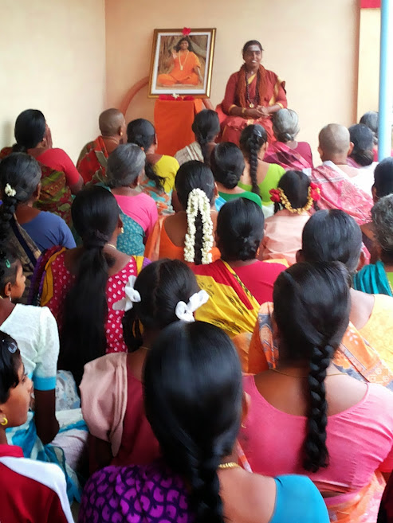  - Leading the defacto spiritual embassy of Kailasa in Tamil Nadu, and serving the people through socio-spiritual services like meditation classes  - 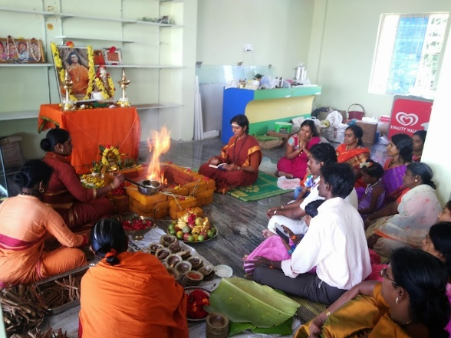  - Performing religious services like homas (fire rituals) for collective peace and harmony | 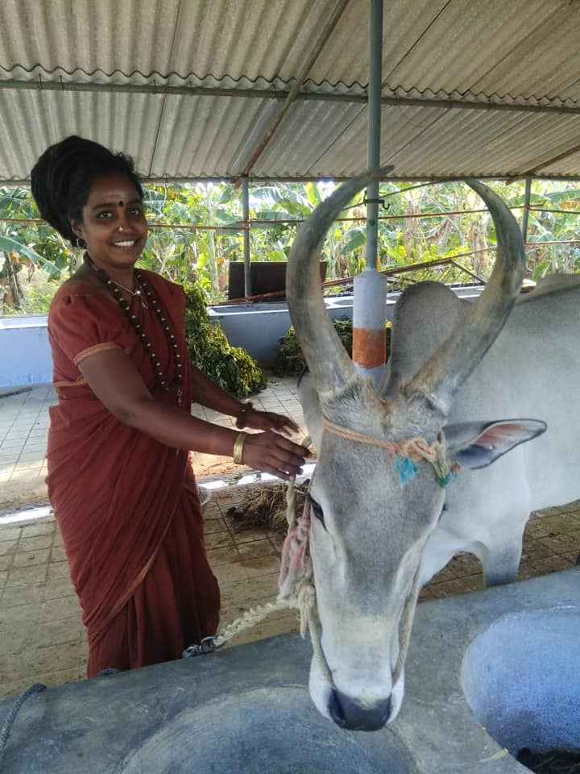  In one of Kailasa’s cow shelters (goshala) with the cow, an animal that is sacred and worshipped in Hinduism  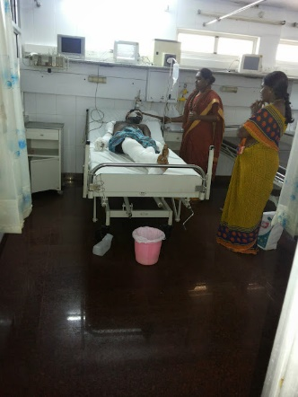  Providing spiritual healing service to terminally ill in hospitals.
- I have been leading the defacto spiritual embassy of Kailasa in Tamil Nadu, and have conducted meditation and yoga classes, spiritual counselling, mass homas (fire rituals as per Hinduism) and pujas (worship rituals), spiritual healing services, deaddiction workshops, women empowerment classes, weekend gurukul (traditional school) classes for kids, amongst other services, across thousands of villages serving lakhs of people.

Are you part of any organization or network? What type of organization or network are you part of? How are you organized?
I am a monastic member of the Sovereign Order of Kailasa which order is organized as per the oldest apex Hindu monastic order. I am also a volunteer contributor in various charitable institutions of Kailasa under the spiritual guidance of The SPH Bhagavan Nithyananda Paramashivam.

Does some of your activist actions require financial support? How are you financed?
As I am a Hindu nun, I follow the spiritual vow of poverty. I live with minimal possessions and have no money or assets, movable or immovable, in my name.
The charitable organizations for whom I work support my rudimentary needs financially and they get these funds through donations.

What are your main spaces and levels of engagement (local communities, national level or international), who are the political actors and authorities you mostly engage with? What influenced your choice of actors and spaces and do you consider expanding your engagement to different levels?
My interaction and experience with the government and State sponsored initiatives has not been an encouraging one. I have provided details of the same in the questions below under IV. We have very close tight knit relations with the local communities through the food banks, and health care camps provided free of cost by the charitable institution whom I volunteer with.

Is your activism mainly conducted online or offline or both? What influenced your choice?
I do my humanitarian and socio-religious services both online and offline.
Prior to pandemic, our preferred choice was working with grass roots and networking with the underprivileged and the marginalized sections of the society.
Offline is now more of a necessity due to the pandemic.

Do you cooperate with other individuals and organizations, how and why?
All my service activities are with other fellow nuns and volunteers of the charitable organizations and we collaborate for free food and free health care initiatives.

Motivations and impact of your activism

What motivated you to become an activist? What was your vision, your goals?
My mentor and spiritual guru, The Supreme Pontiff of Hinduism (SPH) Bhagavan Nithyananda Paramashivam has been forced by Hinduphobic terrorist forces present inside and outside India to flee His country, disconnecting Him from His people, especially the Adi Shaivite Minority Tradition (AIAT) community. This community, which is on the verge of extinction, has a rich tradition of living by the principles of Oneness (Advaita) and peaceful co-existence with humanity, living beings, and nature at large.
SPH has initiated Hindu monks and Hindu nuns into the Sovereign Order of Kailasa’s Nithyananda to serve humanity continuously charitable and humanitarian service with his constant guidance and support, listed below are few of our charitable activities
- 100+ scriptures of Hinduism) freely available for download
- 463+ extraordinary spiritual powers and abilities from Vedāgamās,scientifically revived, researched and replicated for humanity to experience a break through from Human consciousness into superconsiousness, 108+ yogic processes for diseases and disorders (Nithya Kriyās)
- Initiation of 20 million+ lives into Enlightened Eco system of non violence, peace, vegetarianism
- Research on 100+ sacred medicinal herbs and alchemy products as solution for healthy living
- 7,100+ courses on Hinduism life sciences provided for free through Kailasa’s Nithyananda Hindu University
- 200+ best meditation techniques from Hinduism offered freely
- Yoga in its authentic form as revealed in the ancient Hindu scriptures
- Free education to one and all through Hindu universities and primary education Schools (Gurukul) in 150+ countries
- Largest Hindu library available to access free housing 1 million books, 1 million palm leaf scriptures, and over 20 million digital books made available
- Restoring and reviving the 64 sacred arts of temple and temple sciences for building temples and temple based lifestyle
The SPH is a role model for millions of His disciples, seekers, and the general public, on how to handle oneself and continue to contribute to society in the most life-positive and non-violent manner, even when one is brutally attacked from all sides. His initiations and solutions have not only healed and brought inner peace to the hearts of the people but empowered us by turning their powerlessness into powers, an ancient science unique to Hinduism. Power Manifestation Science is one of His biggest contributions to modern-day humanity, through which He seeks to establish the spiritual legitimacy of Sanatana Hindu Dharma – Hinduism which He encapsulates in His vision as “My vision is to reach these great sciences and arts to one and all for free, irrespective of their age, gender, race, religion, sect, creed, etc.”

What factors encouraged you to continue your activism?
The revival of Hinduism through the civilizational nation of Kailasa globally irked vested interests of atheistic terrorist militant elements, caste supremacist terrorists and other anti-Hindu forces who executed a massive persecution and genocide on The SPH and His followers on 2 March 2010 that continued for the next whole decade and comprised of over 70 assassination attempts, over 250 sexual assaults on The SPH and his monks and disciples, lawfare of 120 false cases over 10 years, massive hate propaganda in electronic media of over 14,000 hours and print media of over 25,000 articles in 5 years, destruction of heritage properties worth over 27 million USD, and the continuing ethnocide and genocide of over 80 million Hindus worldwide since 7 centuries.
Specifically, the lawfare involved:
- Delegitimizing The SPH by hate propaganda, disenfranchising Him of His civil and human rights, prejudicing Him from fair representation and fair trial
- Repeated illegal imprisonment, with brazen torture, custodial assassination attempts, supported by system justification in various forms, including the common processes of bureaucracy, indifference, self-deception, diffused responsibility, and has resulted in continued systemic complicity with torture, murder and genocide
- Well-planned multi-layer false hate propaganda by the ‘fourth estate’ media sustained by moral disengagement, leaving the broader public in a state of willful ignorance, motivated denial, victim blaming, dehumanization and bystander apathy to even genocide.
The United Nations has recognized and published in multiple reports about the contributions and persecution of The SPH JGM Bhagavān Nithyananda Paramashivam.
Leading by example, the SPH has chosen to maintain His non-violent and compassionate stance, and instead intensify the work He has chosen to do, that is enriching the human society with the best gifts that Sanatana Hindu Dharma (Hinduism) has to offer. This is what has inspired me to continue serving humanity inspite of all the violations I am facing day in and out.

What did your activism bring, how did it change your life?
I have been working on living and spreading the life solutions based on the ancient Hindu tradition, the meditation and yoga techniques from the scriptures, the cognitions rooted in the highest truths, the lifestyle based on living and radiating the higher values of life, and the powerful way of living and realizing one’s ultimate potential, which by their inherent nature provide the foundation for peace on planet Earth.
I have been able to make a difference to people - men, women, children of all sections of society – by contributing through various means, be it in the areas of meditation, healing, health and wellness, yoga, medicine, education, lifestyle, and science and technology.
I have been able to serve humanity in various ways and means as all my activities and services are under the organized umbrella of The SPH Nithyananda Paramashivam through various initiatives of Kailasa, the revival of the ancient Hindu civilizational nation:
RED OM | KAILASA’s Humanitarian Response to Eradicate World Hunger
WHITE OM | KAILASA’S Humanitarian Response to Mental Health
BLUE OM | KAILASA’S Humanitarian Response to The Ethical Treatment of Animals
SAFFRON OM | KAILASA’S Humanitarian Response to Global Peace, Conflict Resolution and Religious Freedom
GREEN OM | KAILASA’s Humanitarian Response to Environmental Protection
YELLOW OM | KAILASA’s Humanitarian Response To Provide Knowledge Assistance to the World

A glimpse of some of my activities can be seen below.
Holistic Education for children
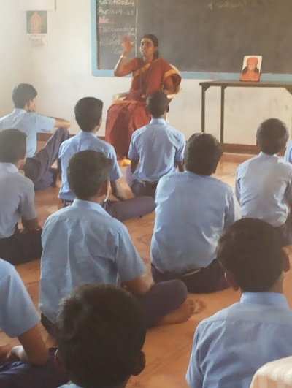 | 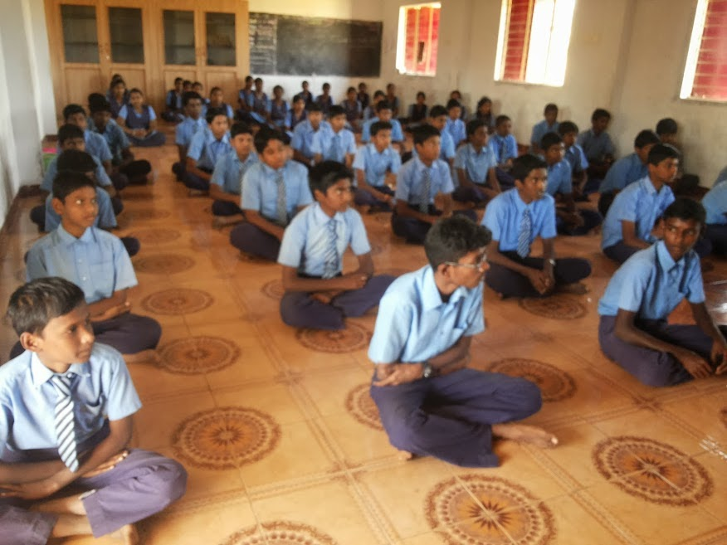
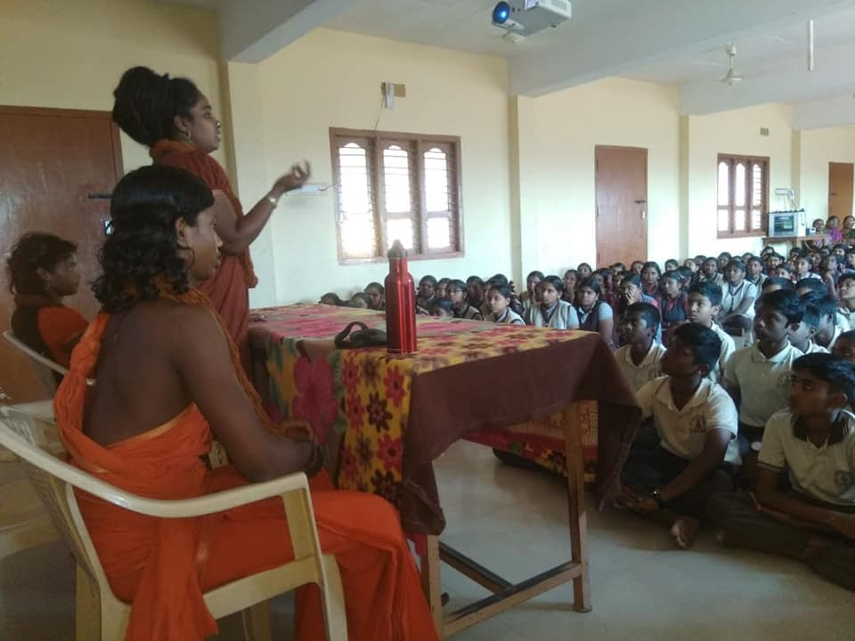 | 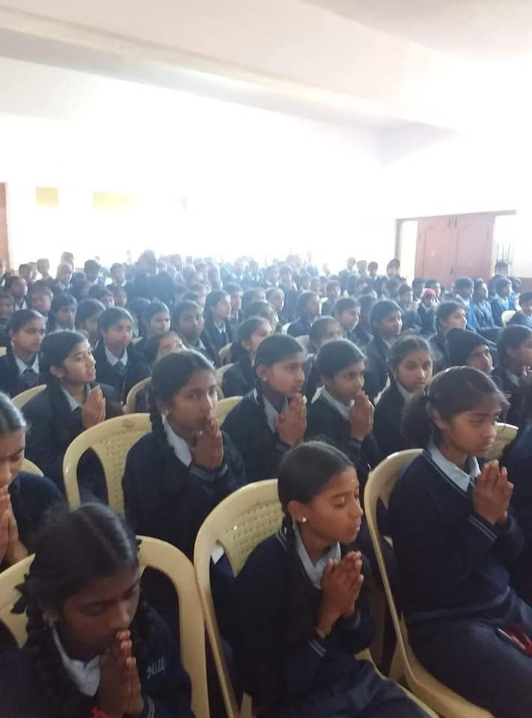
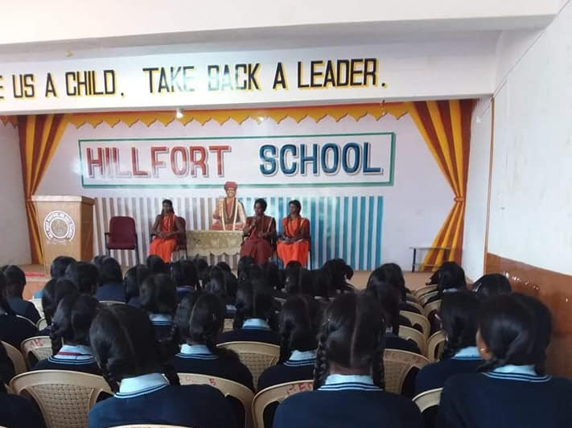 | 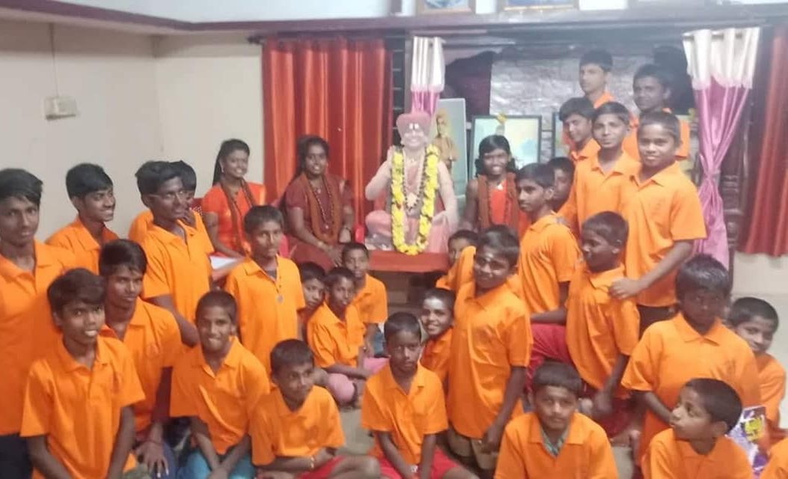

Women Empowerment classes
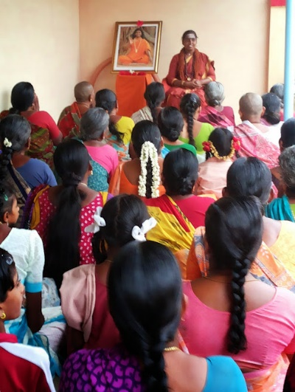 | 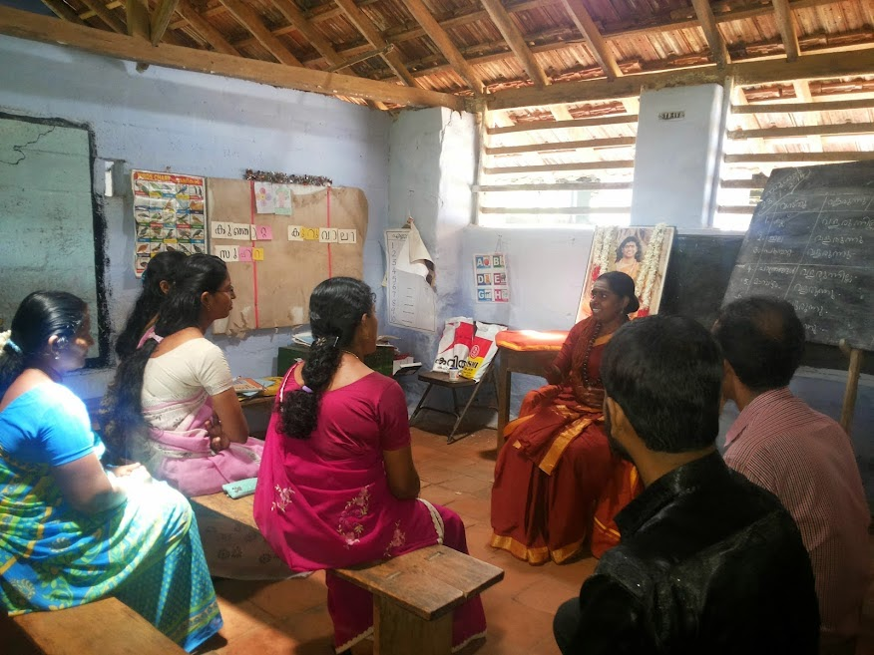
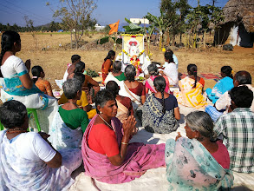 | 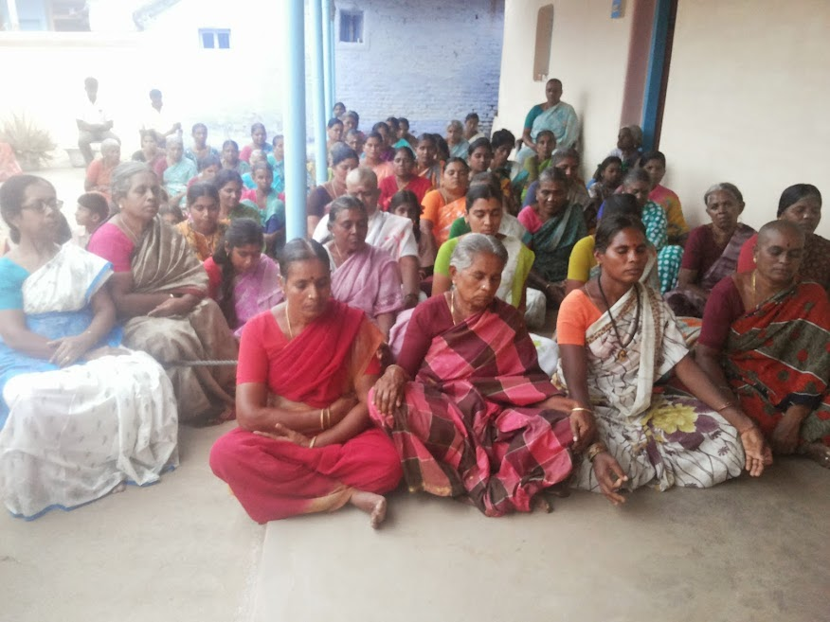
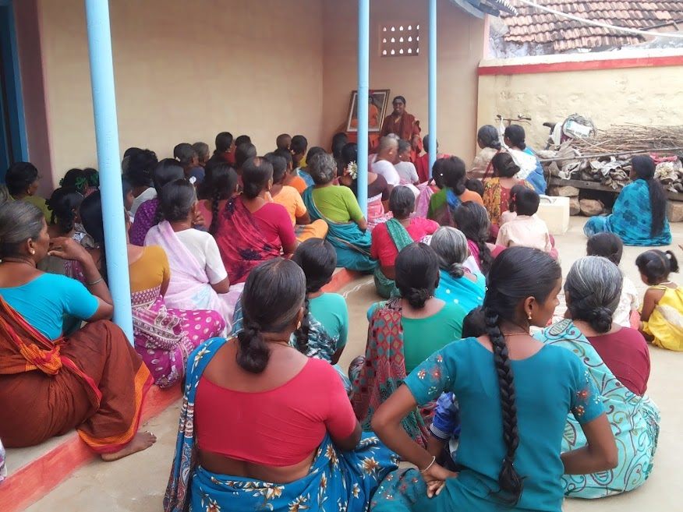 | 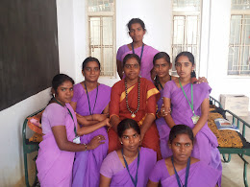
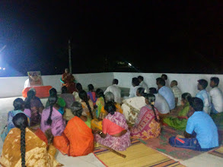 | 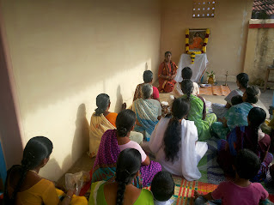

Reviving Hinduism and Bringing Global Peace through homas (fire rituals)
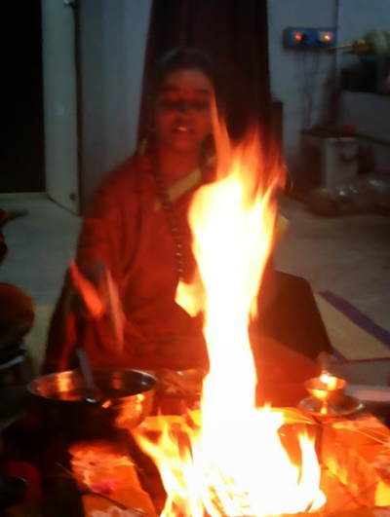 | 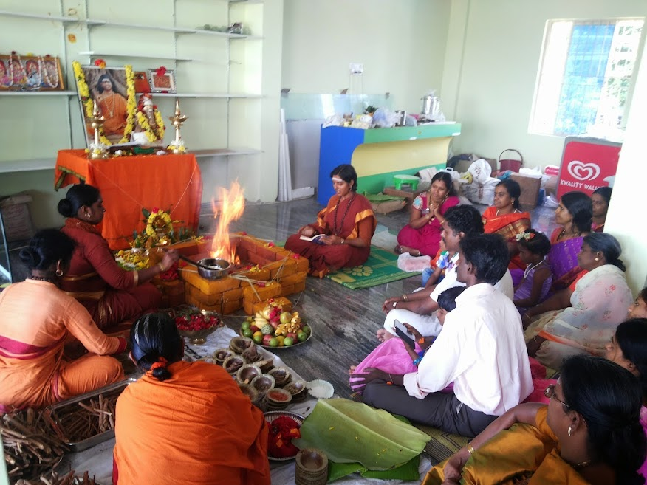
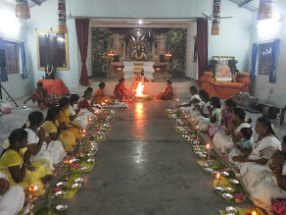 | 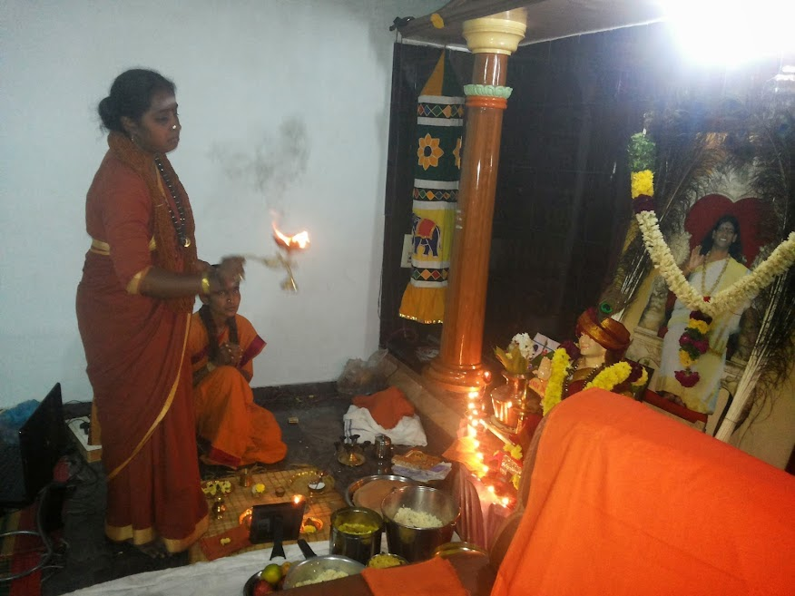
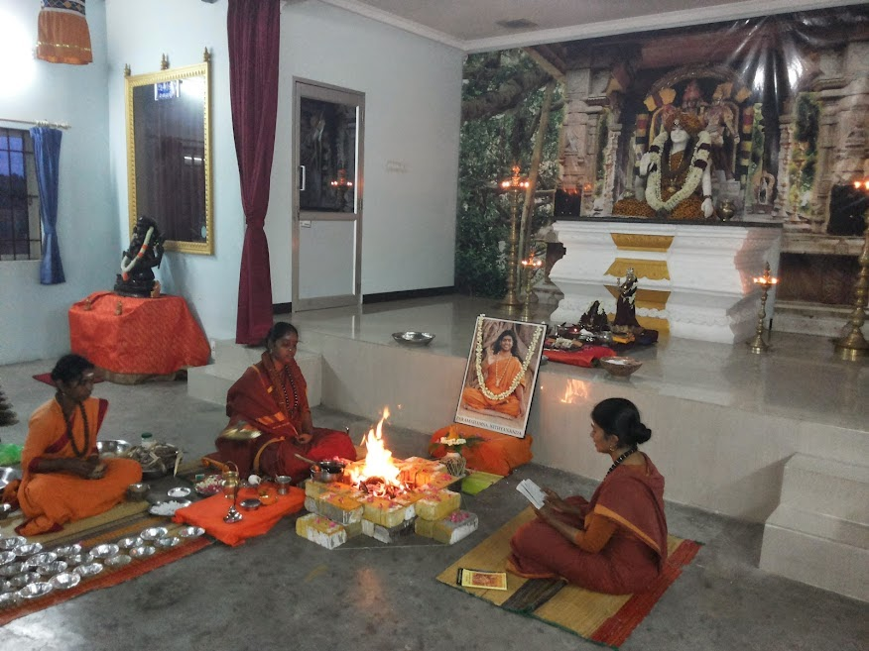 | 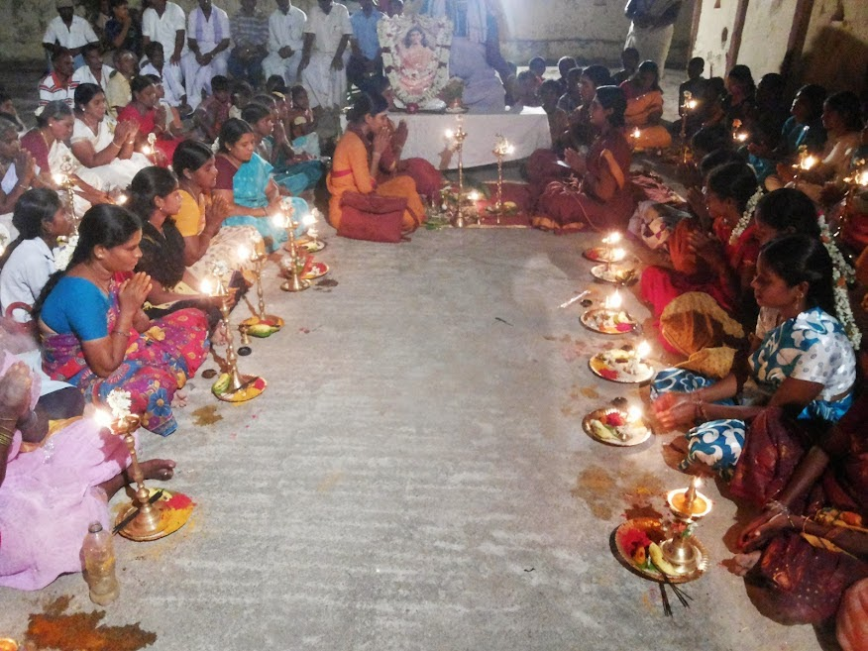
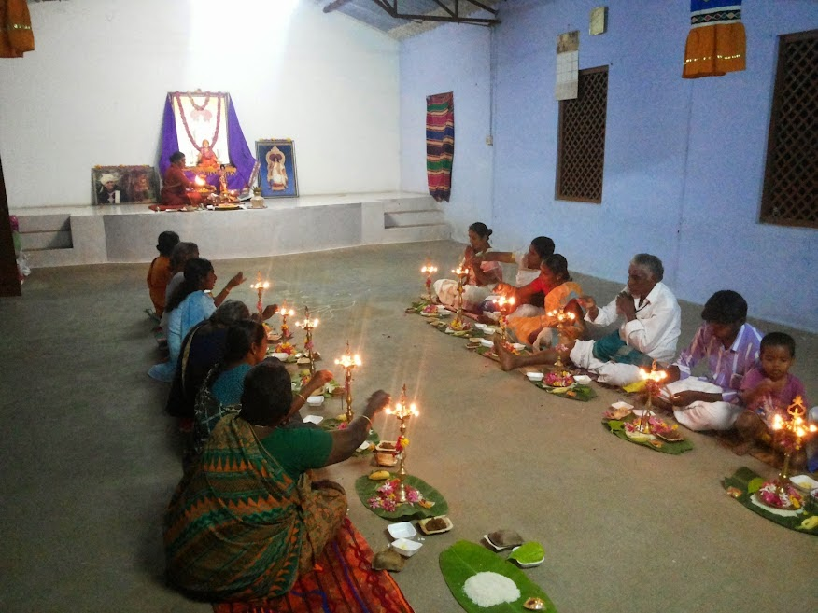 | 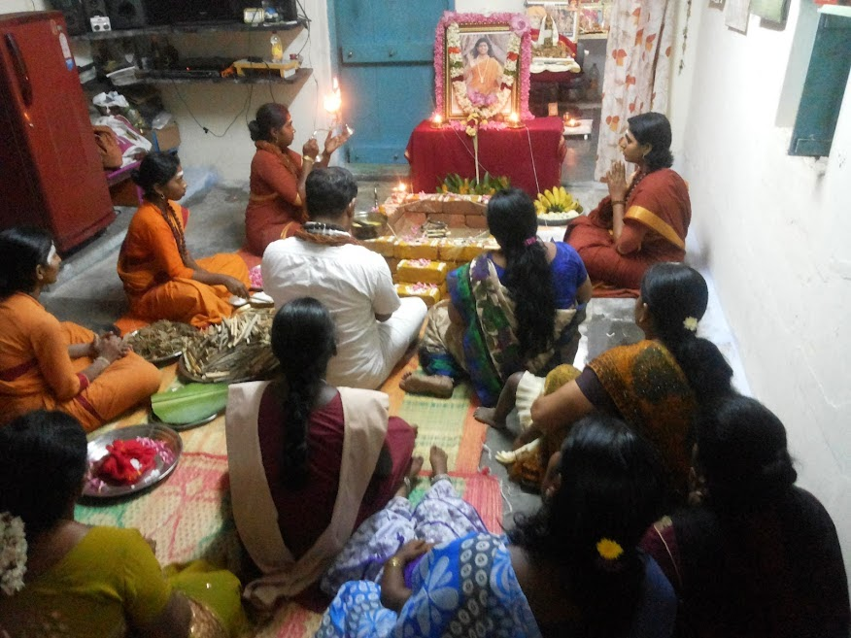
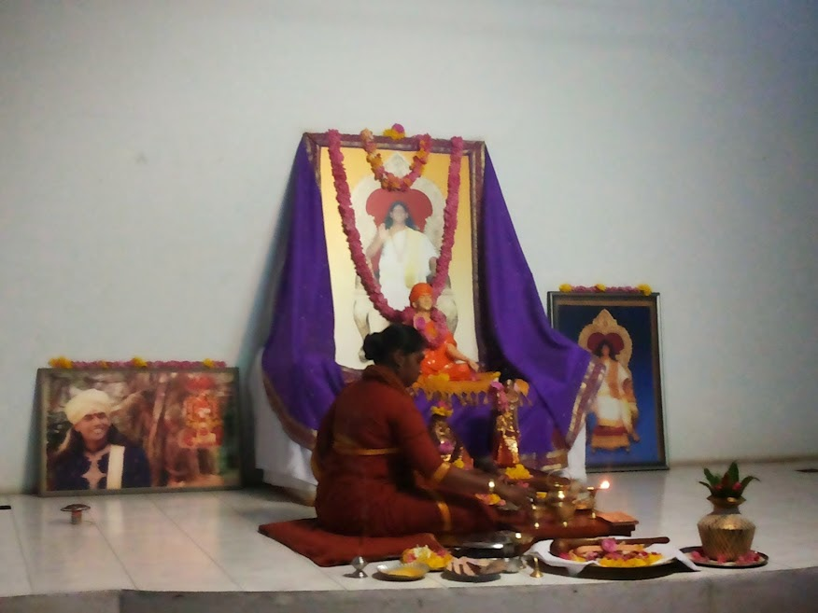 | 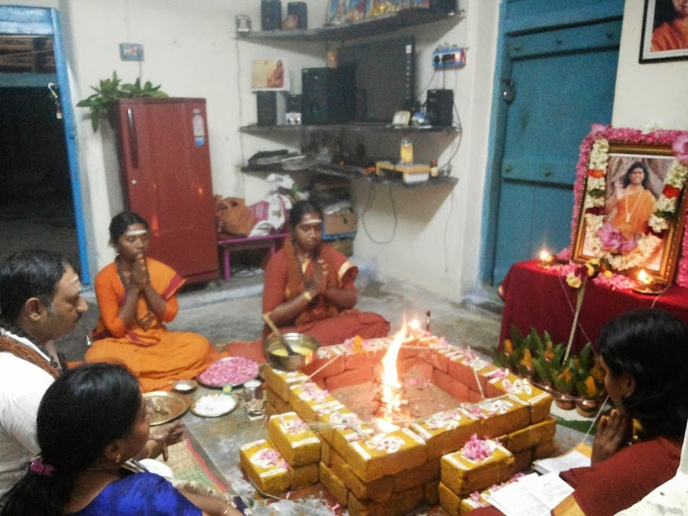

Providing service of free Spiritual Healing
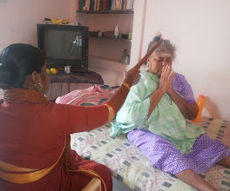 | 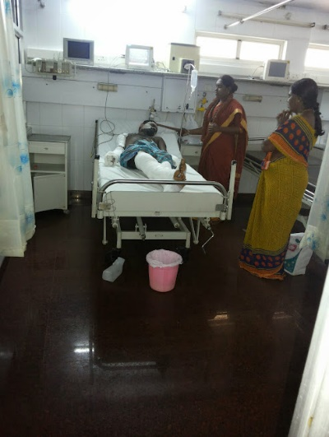
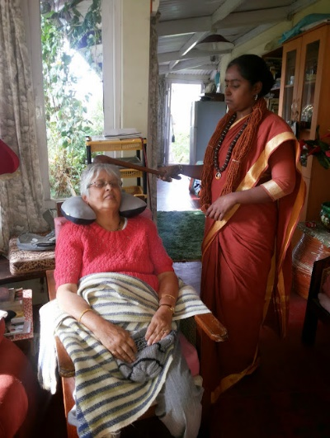 | 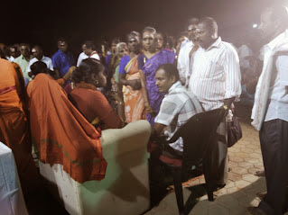

Conducting Meditation Classes & Providing Life Solutions
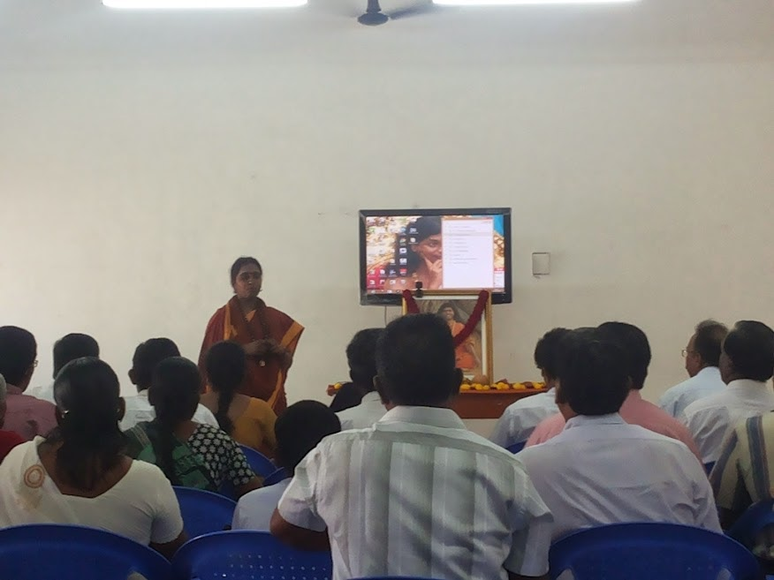
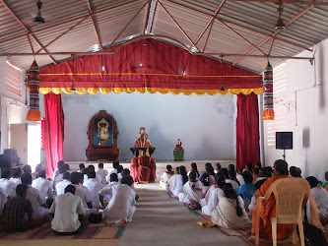 | 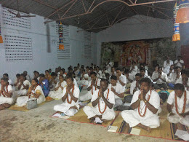
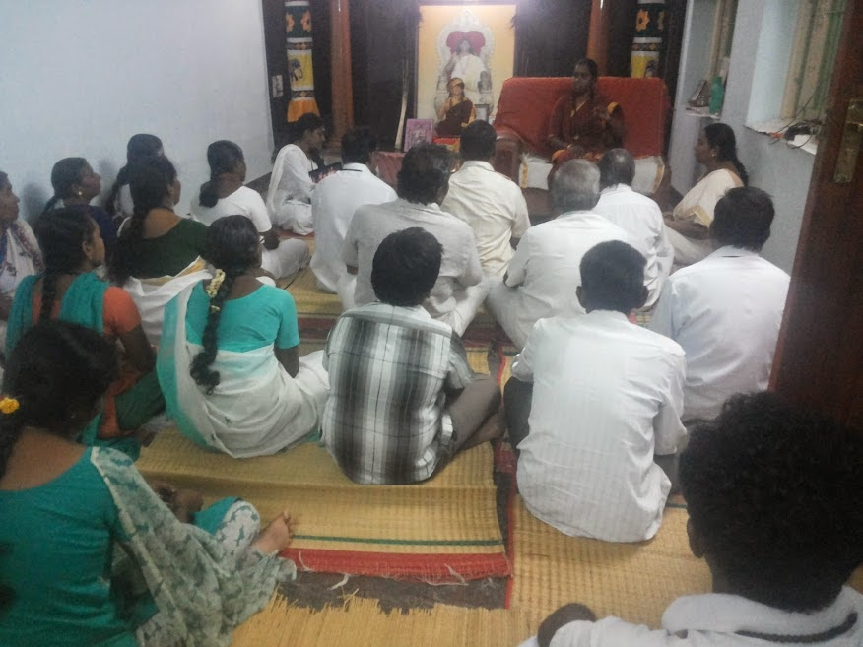 | 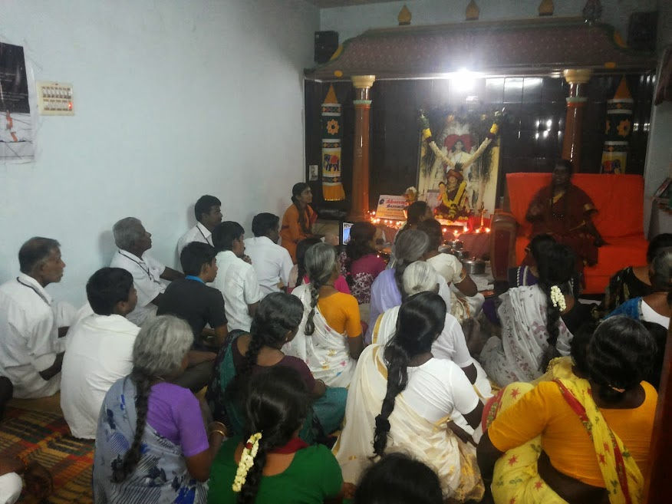
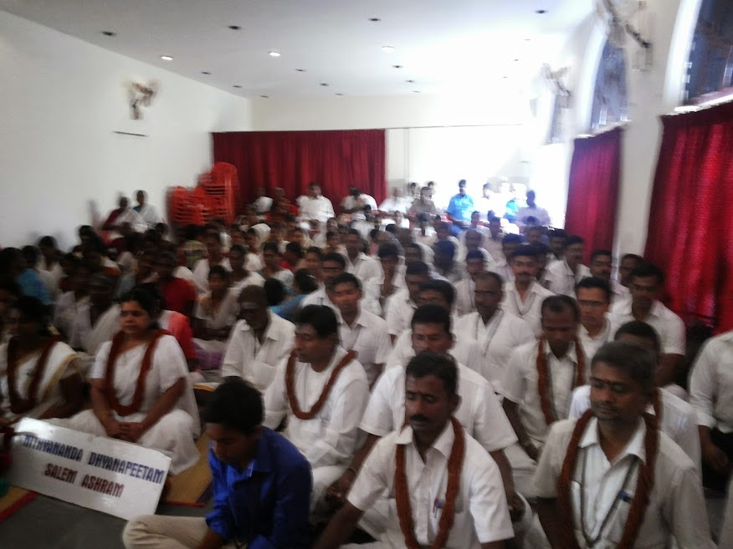 | 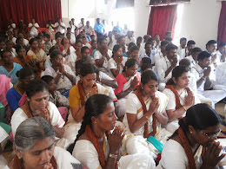

Other socio-spiritual services like free food, animal care
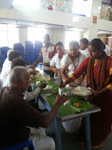 | 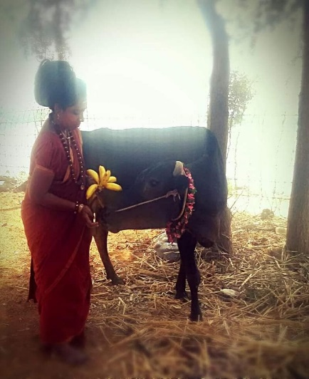

Due to the ongoing pandemic, my activities have been pre dominantly digital the last year , and as I myself contracted the Covid-19 virus and was hospitalized with the same with serious symptoms and still suffering from post-Covid symptoms including breathing difficulty, muscle weakness, weak nerves, etc, and hence not traveling as of now.

What are some of the main successes of your activism?
With the constant guidance and support of my guru The SPH Nithyananda Paramashivam and Kailasa, I have been able to effectively and tangibly contribute in various ways including:
  - Conducting over 250 deaddiction classes and helping thousands of youngsters free deaddict youngsters from substance abuse, alcohol, etc
  - Conducting over 200 life transformational programs for street children and children of prisoners, thereby bringing about global peace through peace at the individual level expanding to society, national and global levels
  - Coordinating yatras (spiritual journeys) for religious harmony and understanding every year, since last 9 years to create better understanding among the various religious practitioners in India
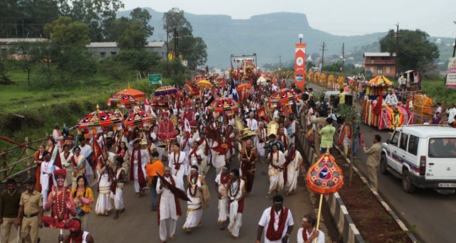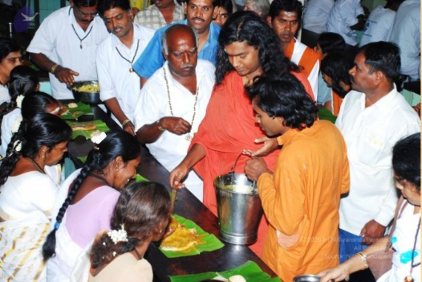
- Over 6 lakh number of free meals served as per The SPH’s vision of no hungry stomach and in association with Red Om
- Conducting classes for over 20000 kids and adults to enable higher consciousness, life, and lifestyle and providing the same by teaching the science of power manifestation and third eye awakening
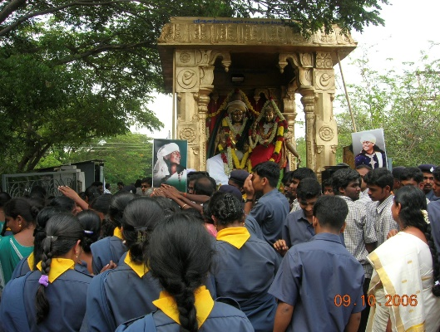
- Conducting mass meditation programs touching over 70,000 people and teaching the science of UnclutchingSM thereby reducing collective negativity in thoughts, words, actions
- Taking care of over 1000 beings like cows, bulls, goats, thereby embodying living in oneness- peaceful co-existence with humanity and nature
- Providing women empowerment by working with over 40,000 women on the grassroots level by providing them spiritual counseling, healing, meditation and yoga classes, religious rituals
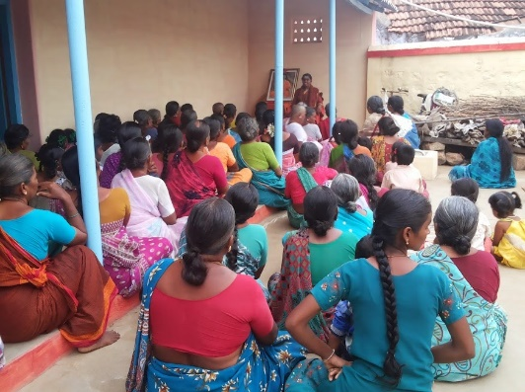
- Conducted over 100 homas (fire rituals) for collective peace and harmony
- Provided spiritual healing to over 25,000 people
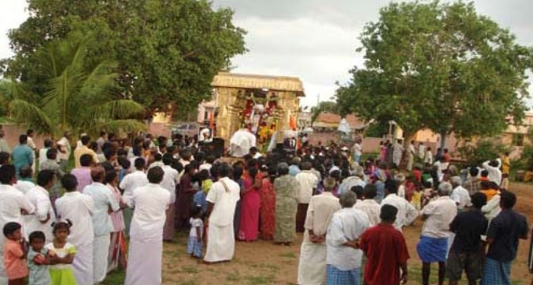
- Helped provide relief to over 1 lakh people through free disaster relief camps in Puducherry providing relief from Thane cyclone in 2012 providing free holistic medical aid, food, spiritual counseling and healing, etc
- Led and organized about 40 peace walks in Tamil Nadu and Karnataka
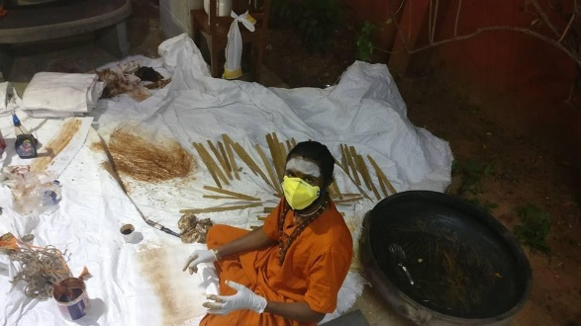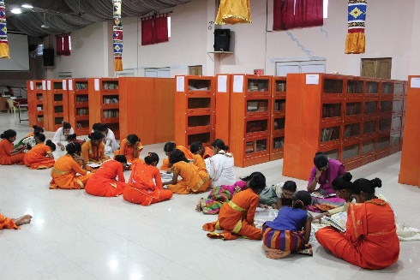
- Adding over 1 lakh books and over 10000 palm leaf scriptures on Tamil literature, Siddha and Ayurveda, temple science and arts, to the collection of books and indigenous scriptures in the KAILASA’s Nithyananda Hindu Library

To what extent is your activism influencing State authorities, including policies and legislation? Why and in which specific ways?
I am afraid the State authorities in India where I reside are against my community and our philanthropic activities as explained in detail in the following sections. I am hence not able to comment on this.

Enabling factors and good practices

Were there some factors/individuals/entities which have facilitated your work? How?
My mentor and spiritual guru, The SPH Bhagavan Nithyananda Paramashivam has been a huge inspiration and supporter in my work.
I have been blessed and privileged to have as my mentor and guru (spiritual teacher) The SPH Bhagavan Nithyananda Paramashivam, who has been a relentless champion of the cause of true authentic feminism and hence a deep inspiration for me to be a leader of Hindu women and nuns, including from underprivileged and backward sections of Indian society, giving them the otherwise impossible opportunity to live the royal life of sanyas (monasticism).
I have been leading the defacto spiritual embassy of Kailasa in Tamil Nadu, and have conducted meditation and yoga classes, spiritual counselling, mass homas (fire rituals as per Hinduism) and pujas (worship rituals), spiritual healing services, deaddiction workshops, women empowerment classes, weekend gurukul (traditional school) classes for kids, amongst other services, across thousands of villages serving lakhs of people.

What/who are the main sources of support? Why and how do they support your work?
Same as (1)

What are your solidarity and support networks? And what is the role of young and elder activists?
Same as (1)

Are there any particular issues and platforms of your engagement that enjoy special attention and support from government institutions? Provide some concrete examples and positive practices.
The government institutions in India do not provide adequate support nor protection especially for Hindu women from marginalized communities.

Are there any state supported local structures for children and young people (e.g. child parliaments, youth leagues, etc.)? To what extent do you take part in these structures and why?
I don’t feel the government institutions in India provide adequate support and protection especially for Hindu women from marginalized communities. I have not hence participated in these structures for youth, women, etc.

Do you feel that the national legal/policy/institutional frameworks adequately promote, protect and support your work? Why and in which specific ways?
I don’t feel the government frameworks in India provide adequate support and protection especially for Hindu women from marginalized communities.

Do you feel that infrastructures and technological advancements in your country have facilitated your work? How?
My work has not been dependent specifically on the infrastructures in India, in fact our charitable organizations have been growing a self-reliant structure including through doing our organic agriculture, animal husbandry for dairy products, etc.

What positive/good practices and innovative initiatives do you see in promoting and protecting you work?
Explained in III below.

Challenges and structural barriers

What challenges did you face in your work?
- The human rights situation for women and children in India is abysmal. Despite tremendous public outcry against crimes against women and children such as rape, sexual violence, gender-based harassment, and female infanticide happen unabated in India. The State of the Republic of India has been either unwilling or unable to curtail these crimes. India is the most dangerous country for sexual violence against women, according to the Thomson Reuters Foundation 2018 survey. According to the National Crimes Records Bureau, the rape of minor girls increased by 82% in the year 2016 compared with the previous year. Sexual violence and brutal rape have been weaponized against minority women and children by extremist militant elements at the highest levels of governance. This weaponization of sexual violence targeting women and children is part of a more pervasive and systematic campaign targeting certain indigenous spiritual traditions, minority communities, and their leaders, especially those from linguistic and religious minority groups, and of dark-skinned people of indigenous spiritual traditions, and of ethnic native-Hindu tribes that have existed in India for millennia. One such indigenous spiritual tradition currently targeted for extermination by the atheistic and Neo-Hindutva extremist militants is the Hindu Aboriginal Indigenous Agricultural Tribes (“AIAT”) in India. The women, children, and young girls of the AIAT community are the most vulnerable target of both atheistic militants as well as the Neo-Hindutva terrorist forces.
- I along with my sister disciple nuns have previously submitted several reports to various UN agencies and special rapporteurs detailing the violence done against us AIAT women, nuns, and girls:
  - Report to the Special Rapporteur on violence against women, in response to Call for Inputs on Femicide (30 April 2021) – Our submission – https://www.ohchr.org/Documents/Issues/Women/SR/Femicide/2021-submissions/CSOs/india-kailash-union.pdf
  - Report to CEDAW on the general discussion on "the rights of indigenous women and girls", 21 June to 1 July 2021 – Our submission – https://www.ohchr.org/Documents/HRBodies/CEDAW/DGD24June2021/51.docx
  - Report to the UN High Commissioner for Human Rights (not published by the UN office yet)
  - Report to the Special Rapporteur on the promotion and protection of the right to freedom of opinion and expression, on disinformation, dated 13 April 2021, https://www.ohchr.org/Documents/Issues/Expression/disinformation/2-Civil-society-organisations/Nithyanandeshwara-Hindu-Temple.pdf
- The AIAT explicitly rejects extremism of all types. The extremist militant elements are opposed to AIAT’s stance when it comes to the rights of women, including otherwise marginalized Dalit women. The AIAT freely ordains women into Sannyasa (the monastic order). The AIAT represents one of the most progressive ideologies and is a target of persecution by the different extremist terrorist groups.
- One of the groups of these terrorist organizations is the Dravidar Kazhagam (hence referred to as ‘DK’) and the Dravida Munnetra Kazhagam (hence referred to as ‘DMK’) who engage in various criminal activities such as assault, especially for carrying Hindu religious symbols. The DK/DMK have several criminal cases pending against them such as on 9 May 2007, terrorists of DK/DMK burnt three people alive with all 17 accused being acquitted by the court.
- The Sanyas Sampradaya (monastic order) was established by the spiritual leader of the AIAT monastic order – the Supreme Pontiff of Hinduism (SPH) Jagatguru Mahasannidhanam (JGM) His Divine Holiness (HDH) Bhagavan Nithyananda Paramashivam (hence referred to as “the SPH”) is unique in that it freely ordains women and allows women, including the women from the so-called backward classes like me as I belong to the Scheduled Caste category (Dalit), to perform temple rituals. Moreover, women constitute most of the senior leadership in the SPH’s mission, thereby establishing his vision of reviving authentic Hinduism which is not just orthodox, but also highly progressive and committed to gender equality. In indigenous Hindu traditions, such as the AIAT, both men and women can be initiated into the path of Sanyasa (Hindu monastic life). This is done as per the fourth verse of the Mahanarayana Upanishad during the Viraja Homa (a fire ritual performed during initiation into Hindu monastic life). The SPH has also ordained men and women from the Scheduled Caste, Scheduled Tribe, and Dalit communities which have been discriminated against and side-lined by the DK/DMK and the neo-Hindutva ideologies.
In the face of these challenges, I have had no recourse to justice for the discrimination women like me face for serving society and we are actively targeted including in the face of gross crimes like rape and sexual assault as explained below.

Do you feel that you have been discriminated against for being girls and more particularly, girl activists? Do you see particular groups of girls and young women being most affected?
Yes. I have faced multiple violations as a woman and have had no recourse to justice as explained below in questions below.
My fellow nuns also have faced similar discrimination.

History of violence against AIAT women, girls, and nuns
- The incidence from 6 September 2021 mentioned here is not an isolated one. Since the past two decades, more so since the past one decade the AIAT women, girls and nuns have been a prime target of extermination by Neo-Hindutva and DK/DMK terrorists in India, particularly in the State of Tamil Nadu.

Shaming of child rape victims by media
- In 2009, a twelve-year-old AIAT girl was kidnapped and sexually assaulted by a Neo-Hindutva extremist. The US courts sentenced the child rapist to 57 months imprisonment. This did not remedy the damage. The child rapist filed several vexatious litigations in India and the US. In the US, these false allegations by the child rapist, such as calling the child a “liar”, and her parents and community part of a “brainwashing”, “cult” etc., were all rejected by the court with a penalty for malicious litigation with cost. This did not deter the neo-Hindutva media from victimizing the child with hours of hate speech on television, for which State backed ,Samaya TV was penalized USD 5 Million by a US court. Even this has failed to redress the situation.

Shaming and sexual objectification of women and girls by media
- In India, the Neo-Hindutva media ran 14,000 hours of hateful programs marginalizing AIAT actress Ranjitha, AIAT nuns, AIAT women, and girls who had been raped by neo-Hindutva militants. The neo-Hindutva media publicly addressed them as “brainwashed”, “sodomized disciples”, “witches”, “prostitutes”, “cult worshippers”, (child) “sex slaves”, and also published violence-inciting prejudicial narratives such as “Hang the Sin Swamis (Hindu monks and nuns)” etc. Previously, before the sensational release of the doctored video, the senior and aged female monks who used to attend phone calls of devotees seeking spiritual counseling were faced to pick up phone calls demanding prostitution from them. Several media houses continue to publish such defamatory articles, causing marginalization of the AIAT women and girls, and dangerously inciting mob violence and rape against them.
- People have resorted to violence after reading or watching such material, as perpetrators have directly commented on the online versions of these media clips openly accepting that they have “hit one nithyananda people”, and also suggesting others should do the same by saying, “I request everyone to hit them nicely. Even don't show courtesy for women in nithyanandha ashram. They are the most dangerous.”
- On 18 Jan 2018, young female nun Ma Nithyananditha received death threats over the phone by fans of V. Ramasamy, Ma Nithyananditha had voiced out against defamatory sexualization of Hindu female saint Aandal by V. Ramasamy and politically owned media. Several obscene morphed videos depicting Ma Nithyananditha and other AIAT children were uploaded on social media by followers of Ramasamy.
- AIAT as a tribe fundamentally respects women as embodiments of divine mother Goddess, and it is extremely painful for the community to witness this smear campaign, on AIAT women. This smear campaign is not just limited to AIAT women, AIAT female monks, but the most vulnerable target of this persecution, are the AIAT girls, especially those minor girls who pursue religious studies to become nuns.
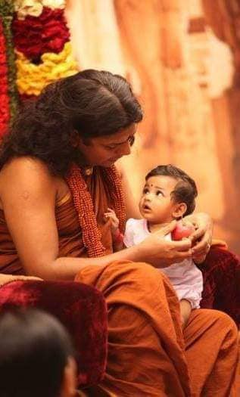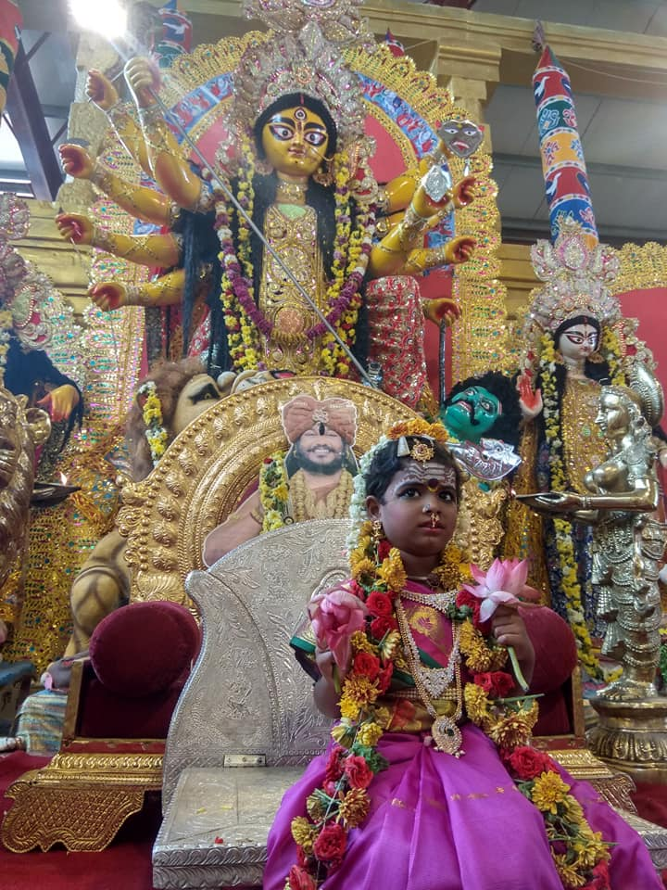
(LEFT) The SPH Nithyananda Paramashivam, with a girl child of a pre-monastic family member.
(RIGHT) 17 Oct 2018: As part of the festival of Navaratri, a young AIAT girl waiting for Kumari Puja, a ritual where Devi Parashakti (primordial Hindu divinity and supreme God) is invoked in a small girl, and puja (worship) is offered to Her.

- Many AIAT girls who have now grown up to become nuns, had grown up in the lap of the SPH Nithyananda Paramashivam and strongly relate with Him not just as a Guru but a father figure also. As per the law in India Hindu nuns are allowed to have the name of their Guru in the place of their father in their passports. It is extremely traumatizing for these girls to be sexually linked with the SPH by the Indian media.
- The media targeted AIAT minor girls by publishing their pictures in the national newspapers with vulgar captions. Young AIAT female monks were sexually linked with their Guru (spiritual guide and leader), the SPH, by entire cover page and several pages of yellow tabloids being dedicated to malign sacred sentiments of disciple hood. The media published fake interviews of AIAT actress Ranjitha defaming her for being a disciple of the SPH. Nakkheeran Gopal and other media heads pressured Ranjitha to commit suicide and circulated false news of the same in media as a rumor.
- Such targeted persecution of Hindu nuns and female religious leaders is not limited to the AIAT but is aimed at destroying the rights of indigenous female spiritual leaders. Vexatious litigations have been used to persecute female Hindu spiritual leaders of minority communities on absurd allegations of indecent dressing booking it under anti-superstition laws.

Intersectional sexual abuse of AIAT nuns especially targeting those from Dalit communities
- An AIAT female monk from Dalit origin, Ma Nithya Supriyananda Swami, has faced intersecting discrimination for multiple reasons (1) AIAT origin (2) Dalit origin (3) Female monk (nun). Ma Nithya Supriyananda heads the Tamil language publication department of an AIAT monastery. On 9 May 2010, she and her team were addressed as “sex slaves” by Tamil yellow Tabloid writer Charu Nivedita. She filed a defamation case against the magazine and writers, which has been pending in the courts for a decade.

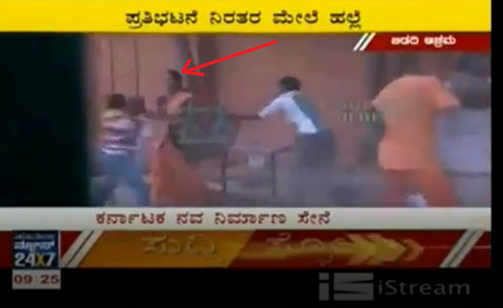  7 June 2012: Ma Nithya Jnanatmananda Swami protecting herself with a chair while Suvarna TV channel journalists and associated Nav Nirman Sene militants molest and attempt to rape her. | 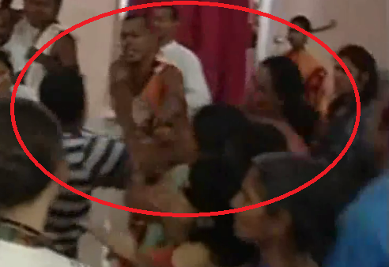  8 June 2012: Ma Nithya Achalananda Swami was molested and groped by Suvarna TV channel journalists and associated Nav Nirman Sene militants. (See Video clip)

- On 7 Jun 2012, BJP owned Suvarna TV’s chief editor Ajith and the militants sexually assaulted female monks beat up AIAT members present on the campus. They gang-raped AIAT nun Ma Nithya Jnanatmananda Swami. This criminal act was live broadcasted on national and regional television.
- Ma Nithya Jnanatmananda Swami watching her sister monks being raped and denied justice was forced to flee India because of blackmail by terrorists threatening her to withdraw the case. The case filed by the AIAT nun is still pending in courts as of 2021. In the same attack of June 2012, Ma Nithya Achalananda Swami was also sexually and physically assaulted by Ajith and other militants who groped her chest and recorded it on camera to blackmail her and used it to publicly shame her. The summons issued by the court for Ajith to appear has not been delivered by the police.

Image morphing deepfake technology to publicly shame women and girls
- In the last decade, especially in India, there has been an alarming trend in the mainstream media and social media of sensational screening and manufacture of misinformation and hate speech that is marginalizing minority communities, especially targeting women with the use of image morphing and deep-fake videos. Although there are many instances of attacks against followers of the AIAT and their spiritual leader, a particular focus of attacks has been a fabricated video of 2010 of the AIAT actress Ranjitha. The video was repeatedly and sensationally broadcasted by Sun TV and various media channels to defame her character, and to delegitimize her Guru the Supreme Pontiff of Hinduism (SPH), Jagatguru Mahasannidhanam (JGM), His Divine Holiness (HDH) Bhagavan Sri Nithyananda Paramashivam. Forensic examinations have shown the video to be fabricated, super-imposing videos of the two individuals. The Chief Operations Officer of the Sun TV, a politically owned media house run by the DMK party, gave a media interview and affidavit in a US court acknowledging the detailing the history and methodology of the blackmail and extortion followed by the channel, particularly in targeting the AIAT community and its leader the SPH involving the fabricated video. This confession and affidavit did not remedy the situation as the channel kept victimizing the actress.

No Legal Recourse Available in India especially for women from a marginalized background
- The AIAT actress, Ranjitha, petitioned in the Karnataka High Court and all available forums for several years. Although the courts ordered in her favor restraining the misinformation and telecast of fabricated deep-fake videos, the neo-Hindutva media kept pushing the implementation of the order to various quasi-legal institutions (self-regulatory bodies run by the media itself). Finally, the media self-regulatory quasi-legal body, the NBSA ordered its member channels to remove fabricated defamatory videos from their websites. None of the media houses complied with the order and kept reuploading, re-telecasting the same footage, and continue the misinformation propaganda to date. Any complaint on media in the High Court is redirected to NBSA, BCCC, or other such bodies which do not even have a website listing their policies to self-regulate. The NBSA as a self-regulatory body is toothless and is known to disregard its own guidelines and orders even when the member channels ridicule and shame dead celebrities. The NHRC (National Human Rights Commission) has maintained silence on the subject and pushed the responsibility on the State executive. A politically owned neo-Hindutva media channel aired a media report where it accused the AIAT leader SPH Nithyananda Paramashivam of raping His own biological mother (a Hindu nun) on the occasion of His father’s sad demise. The channel went on to justify their sadist sexual objectification of Hindu nuns terming it as “unbiased reporting”. Indian Courts are unwilling or unable in protecting AIAT women, especially nuns and children.
- Even where AIAT nuns, AIAT women, and girls have won legal battles, it has been futile as these court orders were never executed as seen in the case of Ranjitha versus several media houses. The ordeal of Ranjitha or other AIAT women and nuns is not unique – court orders are not executed by the government executive, especially in absence of political motivation. The Indian government and Indian State departments are perceived as one of the most corrupt in the world. The mainstream Indian media and social media influencers exercise a massive influence on the masses and even the Court judges. The media is easily able to sway public opinion and even sway the opinion of judges. In a court proceeding directly involving the AIAT, the court explicitly mentioned how the court was prone to prejudice by this negative media propaganda. Though media can influence the judiciary in India, the court judgments are toothless in curbing the media's hate propaganda. Neo-Hindutva media wilfully dishonors court orders without any consequence. Though there is a possibility of legal recourse outside India, wherein 2017, a US Court penalized a neo-Hindutva media to the tune of $USD 5 Million for civil conspiracy, defamation targeting the AIAT community, and secondary victimization of an AIAT child-rape victim, such avenues are neither accessible to most nor legally tenable in all situations.

State Terrorism
- On 17 Sep 2013, the Karnataka State Department of Women and Children forcibly, cruelly, and illegally interrogate children in the AIAT school (Gurukul). The interrogation was done without the consent of the parents, with no video recording of the examiners, late-night beyond the time permissible by law. The State interrogators shamed and ridiculed the children, particularly girls for their dress, pressured them to quit their spiritual-religious lifestyle, and forced children to eat unhealthy substances avoided in the AIAT lifestyle. The lawyer of the school was sued by the State for intervening in the violation of the rights of children and parents. Several such raids were done by the State and many vexatious legal proceedings and orders were executed by the State to forcibly shut down the school.
- In November 2019, the Gujarat State government (CWC) Child Welfare Commission officials raided the female monastery and molested the children studying there. The CWC officials were pulled up by the parents of these children in the High Court. The police complaint against the State authorities was closed without investigation and the petition to the Court was forced to be withdrawn by the Court. Instead, a false case was charged against the women monk heads, and they were kept under custody for almost 3 months. The only women monastery and Hindu University were demolished. The false case is still not closed.
- On 4 March 2010, Rasipuram, an old-aged female devotee’s thatched house was set on fire by DMK militants. The old lady was locked inside and fainted in the smoke. She was rescued by her neighbors. The Police refused to register any complaint.

Rapes, Sexual Assaults and Attempts to Murder
- On 27 Oct 2015, Thiruvarur, around 8 am, I was attacked by neo-Hindutva terrorists who molested me, inappropriately took pictures of me, and attempted to rape me inside the temple premises. As I shouted people gathered to protect me and the attackers escaped. After the incident, I went to the police station and cried and begged the Superintendent of Police for protection. Despite being shown photographic evidence of the attack the Superintendent of Police refused to accept my complaint, and on the contrary, accepted a false complaint filed by my attacker over the telephone without even demanding his physical presence or any evidence. I ran from one office to another. I went to the Deputy Superintendent of Police, who remarked, “O you Nithyananda people” and refused to register any complaint. I cried to him for protection addressing him as an elder brother showing my injuries, upon which he finally took pity and registered an FIR 587/15 dated 27 October 2015. This did not remedy the situation. As of 2021, the case was disposed of without fair trial and my attackers are roaming freely.
- On 16 June 2017, Pavazhakundru, three nuns – Ma Nithya Deepikananda Swami, Ma Nithya Satyagjnananda Swami, and her per-monastic minor daughter Ma Nithya Prajnanananda, were cleaning the area around Paramashiva Shila (the sacred rock worshipped as a Deity) for worship. They were attacked and tied up by State groomed militants of CPI(M). The militants defiled the Paramashiva Shila (the rock worshipped as a Deity) with footwear and drew lewd figures on it. The nuns were raped and video recorded. AIAT monk Parabrahmananda Maharaj survived an attempted murder. The community sent letters of appeal to the District Executive Officer who ignored all their appeals. Despite peacefully using the land for more than three decades, and showing all land documents, along with bills and vouchers of annual fees that were paid to the State Revenue department the State authorities headed by the district collector, declared the hut to be an illegal construction and ordered demolition. The hut where worship items were kept was torn down by police and aired in media and publicized as demolition of illegal construction. The politically owned media reported this event in a biased way, they cruelly vilified the AIAT nuns and monks and addressed them as “cheats”, “landgrabbers” along with other stereotypes that the politically owned media had established to marginalize the community – “sodomized disciples” , “witches” , “prostitutes” , “sex slaves” . The demolition of illegal religious structures has been ordered by the Supreme Court of India in 2009, and has been aggressively pushed by various High Courts to the State, which in turn has taken the opportunity to demolish ancient temple structures which are actually heritage property with the directive given to “demolish at least one illegal structure every week in every taluk”.
- We have a branch of our AIAT community monastery in Trishulam. On 16 June 2017, when we stepped up the activities in this monastery, we started receiving threats and harassment from the local neo-Hindutva and DK/DMK militants. On the night of 16 June 2017, a large group of around 150 attackers trespassed our campus and started shouting for us to leave the place immediately. They threatened that if we continue our services there, they would kill us. The verbal attack changed to a physical attack almost immediately. They started attacking us with a sharp weapon, rock-like stones, and rods. It was a barbaric and huge attack. I ran inside the containers and hid after being hit several times by the stones. A senior Sanyasi Ma Nithya Bhaktikananda filed a police complaint but no action was taken. It was shocking. It did not stop there. Because of police inaction, they repeated the attack in daylight on 18 June 2017. Ma Nithya Sarvatmananda was performing morning temple rituals when around 200 people came running towards the Aadheenam (monastery), like an army, to attack. They were throwing big stones and boulders at each one of us. I ran into one of the containers for safety. I saw there were already 3 other nuns hiding there. Those militants followed us and started pelting rocks at the container. Many windows were shattered, doors were broken and many of us started bleeding due to injuries and cuts. I had a big wound on my knee which led to profuse bleeding. I heard a faint cry from the nearby container. I ran to check out. I saw Ma Nithya Chinmayananda, my sister nun disciple lying half-conscious on the floor with disheveled hair, torn clothes, and blood on her hands. She was half-naked. I immediately rushed towards her and tried to make her sit. She was not able to speak, she was only crying. By then, the other female monks arrived. We took her to the hospital immediately. After initial treatment, she got herself together and told us what had happened. She explained that she was attacked and gang-raped by 3 to 4 men inside the container. It has happened simultaneously while we were being pelted with stones. Ma Nithya Chinmayananda was in the hospital for about 1 month before she recovered physically though she was not able to recover mentally, psychologically and spiritually and ended up leaving the monastic order as she was not able to face her violation of sanyas (nunhood).
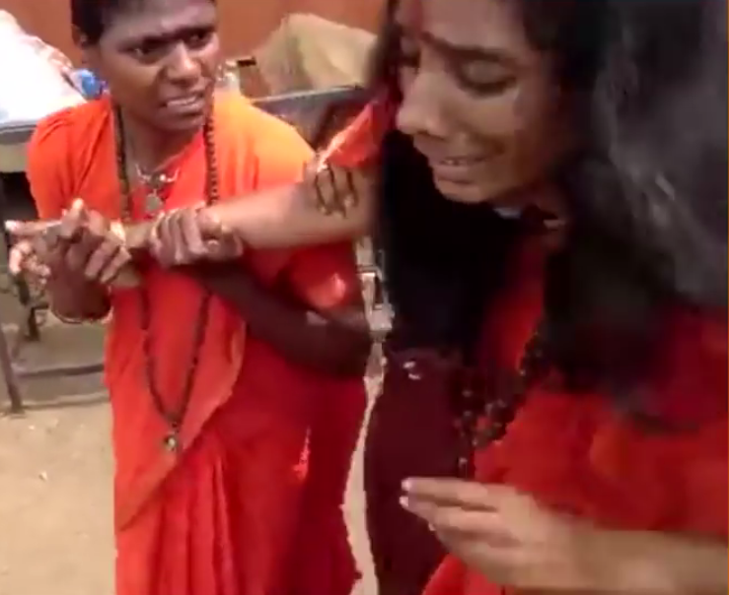
18 July 2017: Ma Nithya Sarvatmananda (left) with Ma Nithya Chinmayananda (right) after the attack, watch the video https://www.youtube.com/watch?v=na-JxwAfTvE

- On 17 Sep 2013, the Karnataka State Department of Women and Children forcibly, cruelly, and illegally interrogated children in the AIAT school (Gurukul). The interrogation was done without the consent of the parents, with no video recording of the examiners, late-night beyond the time permissible by law. The State interrogators shamed and ridiculed the children, particularly girls for their dress, pressured them to quit their spiritual-religious lifestyle, and forced children to eat unhealthy and forbidden substances avoided in the AIAT lifestyle. The lawyer of the school was sued by the State for intervening in the violation of the rights of children and parents. Several such raids were done by the State and many vexatious legal proceedings and orders were executed by the State to forcibly shut down the school.
- In November 2019, the Gujarat State government (CWC) Child Welfare Commission officials raided the female monastery and molested the children studying there. The CWC officials were pulled up by the parents of these children in the High Court. The police complaint against the State authorities was closed without investigation and the petition to the Court was forced to be withdrawn by the Court. Instead, a false case was charged against the women monk heads, and they were kept under custody for almost 3 months. The only women monastery and Hindu University were demolished. The false case is still not closed.
- In India, the Neo-Hindutva media ran 14,000 hours of hateful programs marginalizing AIAT actress Ranjitha, AIAT nuns, AIAT women, and girls who had been raped by neo-Hindutva militants. The neo-Hindutva media publicly addressed them as “brainwashed”, “sodomized disciples”, “witches”, “prostitutes”, “cult worshippers”, (child) “sex slaves”, and also published violence-inciting prejudicial narratives such as “Hang the Sin Swamis (Hindu monks and nuns)” etc. Previously, before the sensational release of the doctored video, the senior and aged female monks who used to attend phone calls of devotees seeking spiritual counseling were faced to pick up phone calls demanding prostitution from them. Several media houses continue to publish such defamatory articles, causing marginalization of the AIAT women and girls, and dangerously inciting mob violence and rape against them. People have resorted to violence after reading or watching such material, as perpetrators have directly commented on the online versions of these media clips openly accepting that they have “hit one nithyananda people”, and also suggesting others should do the same by saying, “I request everyone to hit them nicely. Even don't show courtesy for women in nithyanandha ashram. They are the most dangerous.” This was not an isolated incident, the same tone is being repeated for the 6 September 2021 attack and DK/DMK terrorists are even pushing these hate inciting media reports on platforms such as Wikipedia to normalize the society to accept the violence against us.
- In the last decade, especially in India, there has been an alarming trend in the mainstream media and social media of sensational screening and manufacture of misinformation and hate speech that is marginalizing minority communities, especially targeting women with the use of image morphing and deep-fake videos. Although there are many instances of attacks against followers of the AIAT and their spiritual leader, a particular focus of attacks has been a fabricated video of 2010 of the AIAT actress Ranjitha. The video was repeatedly and sensationally broadcasted by Sun TV and various media channels to defame her character, and to delegitimize her Guru the Supreme Pontiff of Hinduism (SPH), Jagatguru Mahasannidhanam (JGM), His Divine Holiness (HDH) Bhagavan Sri Nithyananda Paramashivam. Forensic examinations have shown the video to be fabricated, super-imposing videos of the two individuals. The Chief Operations Officer of the Sun TV, a politically owned media house run by the DMK party, gave a media interview and affidavit in a US court acknowledging and detailing the history and methodology of the blackmail and extortion followed by the channel, particularly in targeting the AIAT community and its leader the SPH involving the fabricated video. This confession and affidavit did not remedy the situation as the channel kept victimizing the actress. The AIAT actress, Ranjitha, petitioned in the Karnataka High Court and all available forums for several years. Although the courts ordered in her favor restraining the misinformation and telecast of fabricated deep-fake videos, the neo-Hindutva media kept pushing the implementation of the order to various quasi-legal institutions (self-regulatory bodies run by the media itself). Finally, the media self-regulatory quasi-legal body, the NBSA ordered its member channels to remove fabricated defamatory videos from their websites. None of the media houses complied with the order and kept reuploading, re-telecasting the same footage, and continue the misinformation propaganda to date. Any complaint on media in the High Court is redirected to NBSA, BCCC, or other such bodies which do not even have a website listing their policies to self-regulate. The NBSA as a self-regulatory body is toothless and is known to disregard its own guidelines and orders even when the member channels ridicule and shame dead celebrities. The NHRC (National Human Rights Commission) has maintained silence on the subject and pushed the responsibility on the State executive. A politically owned neo-Hindutva media channel aired a media report where it accused the AIAT leader SPH Nithyananda Paramashivam of raping His own biological mother (a Hindu nun) on the occasion of His father’s sad demise. The channel went on to justify their sadist sexual objectification of Hindu nuns terming it as “unbiased reporting”. Indian Courts are unwilling or unable in protecting AIAT women, especially nuns and children.
- Even where AIAT nuns, AIAT women, and girls have won legal battles, it has been futile as these court orders were never executed as seen in the case of Ranjitha versus several media houses. The ordeal of Ranjitha or other AIAT women and nuns is not unique – court orders are not executed by the government executive, especially in absence of political motivation. The Indian government and Indian State departments are perceived as one of the most corrupt in the world. The mainstream Indian media and social media influencers exercise a massive influence on the masses and even the Court judges. The media is easily able to sway public opinion and even sway the opinion of judges. In a court proceeding directly involving the AIAT, the court explicitly mentioned how the court was prone to prejudice by this negative media propaganda. Though media can influence the judiciary in India, the court judgments are toothless in curbing the media's hate propaganda. Neo-Hindutva media wilfully dishonors court orders without any consequence. Though there is a possibility of legal recourse outside India, where in 2017, a US Court penalized a neo-Hindutva media to the tune of $USD 5 Million for civil conspiracy, defamation targeting the AIAT community, and secondary victimization of an AIAT child-rape victim, such avenues are neither accessible to most nor legally tenable in all situations.

Have you faced specific barriers related to your actions? Examples of these include prejudices based on gender and age, restrictions on your freedom of expression, speech, assembly, liberty, etc., legal restrictions to your capacity to provide legal consent, legal age of marriage, etc.
Yes. I have been a victim of gang rape for being an activist dark skinned Hindu nun from an economically and socially backward community.

Gang Rape on 6 September 2021
- On 6 September 2021, while Ma Nithya Sarvatmananda, my sister nun, and I were traveling in one of the small towns of Tamil Nadu, we were pulled out of our vehicle in the middle of the road by a mob of over 50. I was publicly lynched and gang raped - all in broad daylight with cameras capturing the atrocious attack and telecasted on multiple regional, state, and national television channels.
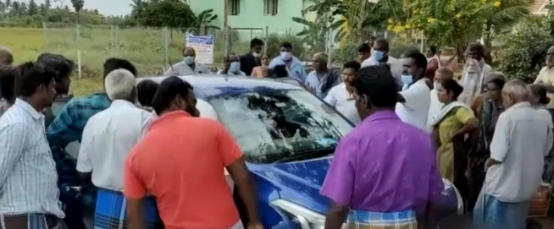
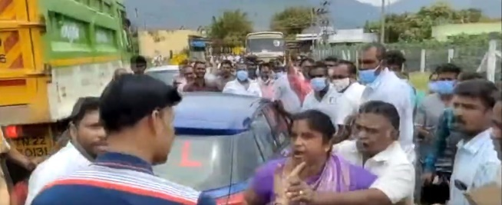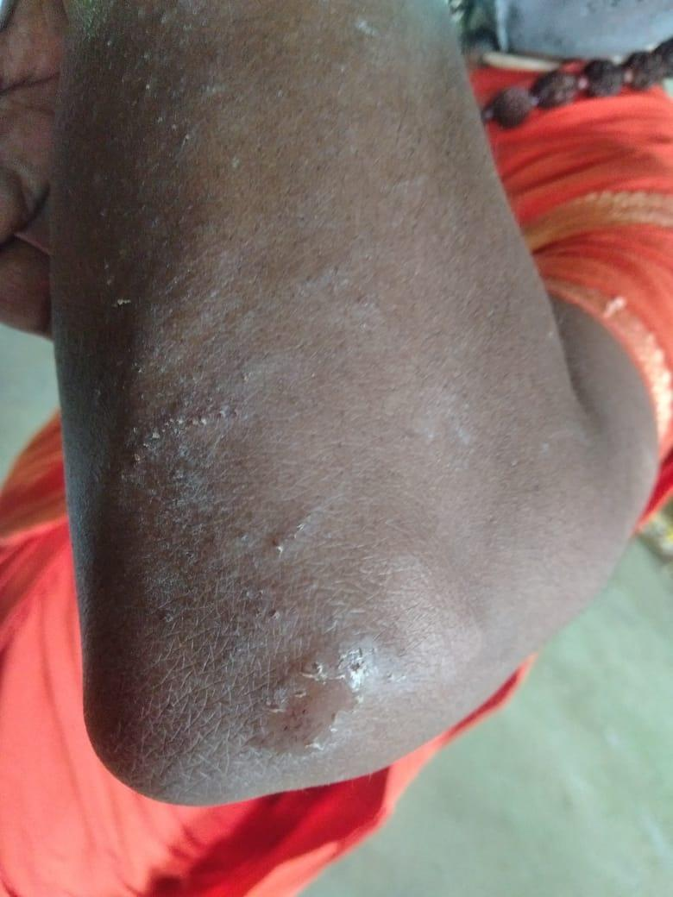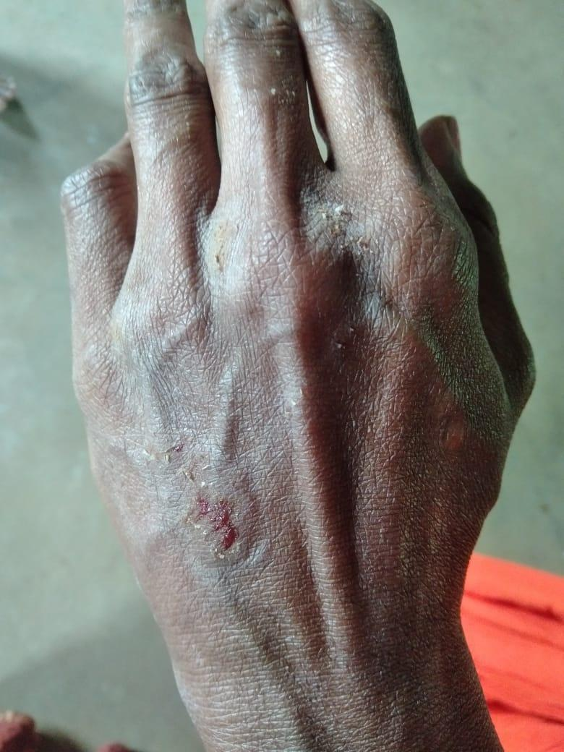
- On 6 Sept. 2021, Ma Nithya Sarvatmananda and I, both of us nuns of the Sovereign Order of Kailasa, were brutally beaten by an anti-Hindu militant mob affiliated with the DK/DMK terrorists.

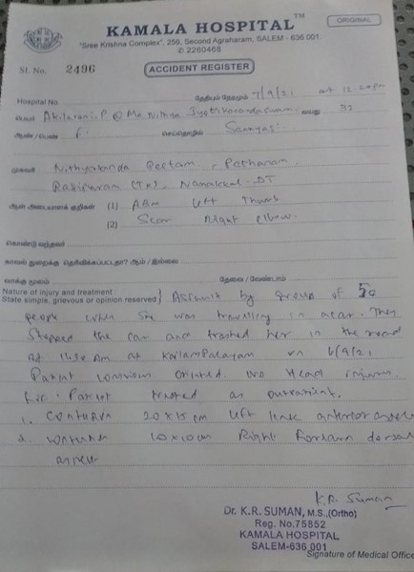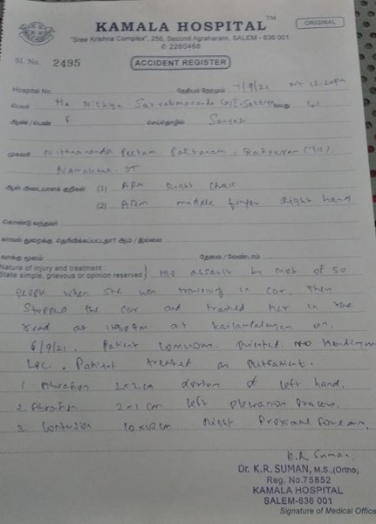
Medical reports of mine, Ma Nithya Sarvatmananda, that mentions attack by a mob of fifty men, the medical report reads, “Assault by [a] mob of 50 people, when she was traveling in [a] car. They stopped the car and thrashed her in the head at 11:30 AM at Kailasampalayam on 6/9/21.” The medical report mentions injuries in the left and right arm and corresponding medication.

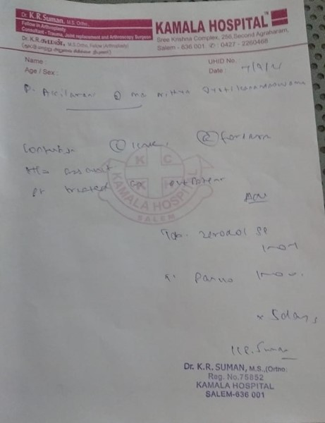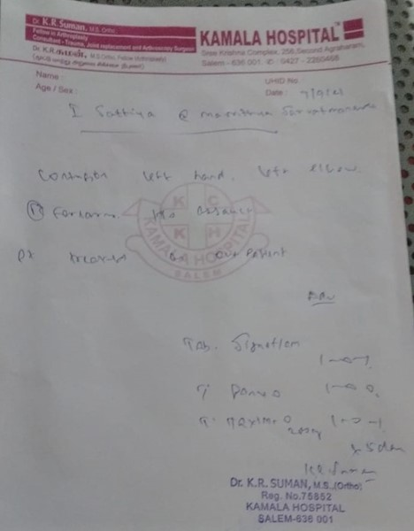
Medical reports of mine and Ma Nithya Sarvatmananada mentioning medication and treatment for forearm injury in the attack by 50 militants.
- On that fetful day, Sep 6, 2021, a well-trained mob of close to one hundred mercenaries intercepted our vehicle in which me Ma Nithya Jyotikananda Swami and Ma Nithya Sarvatmananda, accompanied by a brother disciple as a driver were traveling. We were traveling to help facilitate a series of Hindu prayer sessions in the villages of Tamil Nadu.
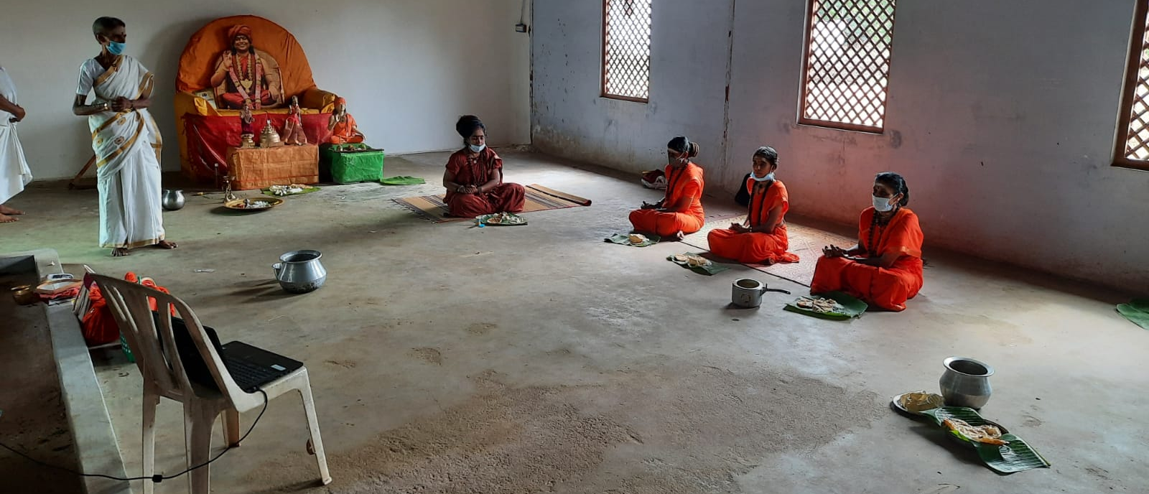
6 Sept 2021, The AIAT nuns participating in Maheshwara Puja (a ritual for blessing departed souls to move on peacefully to the next life). From left – a female volunteer (in white), myself and other sister nuns
- The Hinduphobic terrorists of the state received a tip-off about this trip and planned a violent attack on us. On the way, we were waylaid as suddenly, we saw over 50 people, both men and women had surrounded the car.
- One person forcefully banged the door of the car against my leg and it got jammed between the door and the body of the car. There were 10 to 15 men recording this whole attack. I tried to close the door and record the attack on my phone. Immediately, a whole group of men forcefully opened the door from outside and grabbed my phone, and threw it.
- We were surrounded on all sides. We could not move our car an inch even. They started throwing stones at the windows and front glass of the car. Another group in the violent mob deflated the tyres of our car saying they will simply crush the car. I was scared as I was sure we would be lynched inside the car. I was shocked as I saw in front of my eyes almost 10 men surround Ma Nithya Sarvatmananda and sexually assault her, physically abuse her by touching her breasts, groping her buttocks, while shouting wildly at her that they would finish her off. Though it was almost impossible to win singly against this violent Hinduphobic mob, I wanted to step out of the car to save my sister nun’s life and dignity. I could not bear to see her sanyas (nunhood) being violated so cruelly. But before I could even setp out, another group of about 15 men pulled my side car door swearing obscene language at me and in seconds, were all over me. I cried to please not touch me as celibacy (brahmacharya) is one of the most sacred vows a nun is to uphold in Hinduism as per scriptures. But my cries only worsened the nightmare as they literally threw me from one man to another, violating me every inch as they gang raped me. I shudder to even think of that gory scene but it keeps flashing before me as the ordeal was more painful than even ascending a live pyre.
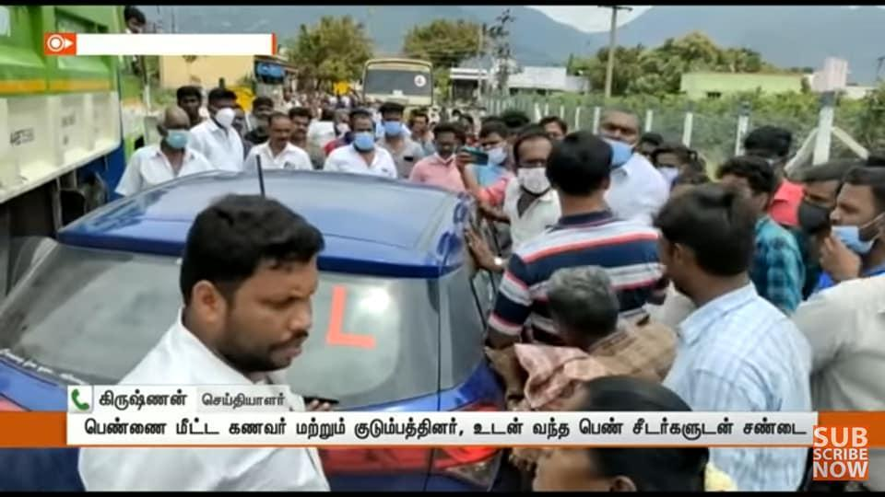
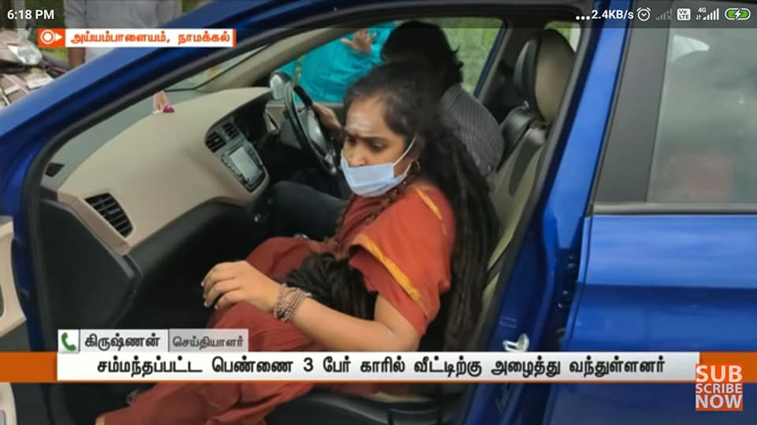
- We had recorded the attack on Ma Nithya Sarvatmananda’s tablet but the mob attacked and snatched the phone and threw it on the ground and broke it. We were too scared for our lives, so we somehow escaped from and could not dare to recover the tablet from the mob. We gathered ourselves and ran to safety, severely wounded, traumatized, and fearful for further attacks. We could not muster the courage to report to local authorities fearing a repeat of the attack.

Character Assassination by Media Disinformation
- In India disinformation has been especially toxic and used as a tool for propaganda, lawfare, suppressing freedom of religion and expression, and political and religious persecution.
- A fundamental problem in India is the widespread government / political ownership of media where a large proportion of Indian media operations are owned by politicians or political parties, therefore undermining their journalistic independence. This dynamic leads to the weaponization and politicization of media where lies, propaganda, and political persecution via media spread unchecked and India’s media cannot speak truth to power.
- A recent report by Reporters Without Borders published report “Media Ownership - India” concluded that “Some of the leading outlets are controlled by individuals with political ties. The majority of the media companies have business and political affiliations...the convergence of politics and media and the resulting interdependence between media, business and politics presents a high risk to media freedom and pluralism in India.” Indian media often engages in rampant manipulation of news to gain ratings. A recent article documents this toxic dynamic and concluded that “Television news channels have long ceased to be driven by news or news values. Their sole pursuit is to score television rating points (TRPs) by any means—be it through fake news, hate propaganda, witch hunts, media trials, polarising communities, demonising people and personalities or airing lies and falsehoods.” The NBA (National Broadcasters Association) can only make recommendations, but these have not been enforced by the government.
- India’s judiciary is often adversely influenced and undermined by a phenomenon referred to as “trial by media” whereby media coverage and narratives are used to shape public opinion in such a way that courts are improperly influenced to rule in cases based on media propaganda rather than the facts of the case. This pernicious dynamic undermines the rule of law in India and has been extensively documented by qualitative and quantitative methods.
- Such “trial by media” is often driven by government owned media to create an overwhelming scenario of “guilty until proven innocent”. Often when asked to prove these facts in court, government machinery is used to generate false witnesses or give false evidence.
- Fake news also spreads unchecked through social media, resulting in causing riots, lynching, mob violence and hatred among people. Gossipy tidbits, edited pictures, misleading content sources, spurred and planted stories spread like a forest fire among 564.5 million internet users in India through social media platforms, like- Whatsapp, Facebook, Twitter. Some popular examples of fake news in India are- Muzzafarnagar riots of 2013, Najeeb Ahmed missing JNU student to have joined ISIS, false persecution of The SPH Nithyananda Paramashivam, etc.
- The AIAT community has been the victim of huge character assassination through media disinformation. Deliberate media disinformation has been used as a weapon to harm the entire community. Members of the minority Adi Saivite tradition were victims of a deluge of disinformation which resulted in the intensification of continuous persecution which manifests as mob lynching, violation of human rights, cyber-bullying, destruction of property, illegal arrests and lawfare. The media disinformation is intersectional. It is created by politically affiliated paid media tied to majority political parties (Media houses in India are mostly owned and controlled by political houses) who are trying to suppress minority religious voices (whether those from other religions and also subsects of the same religion), and amplified by the nexus of media and police. Because of the concerted effort of the media both to spread disinformation as well as to prevent the publishing of the various socio-spiritual and humanitarian services of the AIAT, the people at large are led to a feeling of hatred and further attacks including on the lives and dignity of the AIAT by Hinduphobic militants is declared to the world as mob lynching and violence by the ‘public’.
- The strategy of lawfare and persecution in each instance has been the same:
  - first launch a media disinformation campaign using compromised media
  - incite public violence against the community
  - false legal charges brought with presumption of guilt
  - post-arrest police engage in disinformation leaks to the media
  - ending in a prolonged trial (over decades) leading to destruction of reputation.
  - The false cases include criminal accusations as well as civil actions against the community to usurp their properties and block their financial accounts thereby rendering them defenseless.
- The lawfare places tremendous financial hurdles on the persecuted community since legal charges are very significant in India especially when fighting against entrenched players such as Media Houses and the Government which have a large legal army at their disposal. Media counter campaigns are too expensive and only affordable by large businesses and political players who own their own media infrastructure. (For example over 100 cases were filed against the AIAT community; the community has spent close to 10 years in dismissing all cases but one, which has depleted their resources).
- In particular, the extremist elements are opposed to AIAT’s progressive stance when it comes to the rights of women and the rights of members of the LGBTQ and transgendered communities. The spiritual head of AIAT has publicly declared himself to be of indeterminate gender and composed of more than 11 gender identity components. In this regard, AIAT represents one of the most progressive ideologies in the world as it freely ordains women into sannyas (the monastic order), recognizes 11 genders, and performs specific temple rituals for gay marriage, all from the depth of the more than 5,000 year old indigenous spiritual tradition.
- To dehumanize the tradition and their leader, the media disinformation has been primarily focused on accusations related to women and sexual misconduct, which aims to delegitimize the community’s stance on gender equality. The story of the persecution of indigenous Hindu spiritual traditions such as AIAT is not an isolated happening. It is the saga of the persecution of linguistic and religious minority groups, of dark-skinned humans, of indigenous spiritual traditions, and of ethnic tribes that have existed in India for millennia.
- In over a decade, from 2010 till date, the same pattern of attack and persecution has been followed – begin with media disinformation using politically owned media, followed by police action leading to mob attacks, illegal arrests and cases, destruction/seizure of property and harm to life and liberty.

2010 Attack using a Morphed Video broadcast on State-owned media
  - On 2nd March 2010, a TV Channel Sun TV owned by the ruling party in the state of Tamil Nadu released a morphed video purporting to show the leader of AIAT and a leading movie actress, and this character assassination continued for the years to come and still continues as I faced even now. The video went viral and was re-telecasted by all local and national media houses continuously for many months, spread misinformation in various geographies from Asia to Americas and was later shown to be false.
  - On 2nd and 3rd March 2010, mobs simultaneously attacked various monasteries of the AIAT community in various cities. The main building housing the leader was burned down by the mob in an attempt to kill him while the police stood by and watched. This event was telecasted live on national TV.
  - Based on State influenced media pressure caused due to the video alone, and a complaint filed by a third party about suspicion of a crime, the leader of AIAT - His Divine Holiness Sri Nithyananda Swami (SPH) was illegally arrested by police on allegation of sexual misconduct even though there was no victim or accuser.
  - The SPH was in custody for 53 days from 21 April 2010 till 13 June 2010. Courts observed that SPH was jailed on mere suspicion without any evidence of crime or accuser or victim. In violation of SPH’s human rights, the police leaked videos of SPH in prison, being interrogated. They muted the audio and then leaked false information to the media of “confessions”. Later when challenged in court to produce the full video, the police falsely claimed that the video was stolen.
  - On 13 June 2010, Court in the bail order prohibited the SPH from exercising his right to speech and practice his religion as a bail condition, (which includes preaching, giving religious sermons, and teaching any form of classes).
  - In May 2010, influenced by the media campaign and the fear of the government, all bank accounts of the AIAT were frozen by various banks. This made them defenseless against further attacks. And their ability to feed the residents of the monastery including women and children was snatched away.
  - Five years later in 2015 Crime Branch of the Criminal Investigation Division (CB-CID) in Chennai, Tamil Nadu state of India filed a report stating the video was morphed for extortion of Sri Nithyananda.
  - In 2017, fake news was re-circulated by the Times of India that the video was verified to be true by forensic labs.
  - This initial disinformation using fake video became the foundation of decade-long persecution. The initial false charges filed only came to court 10 years later, and are still being litigated. Conversely, the perpetrators of the false allegations in India attempted to bring the same case against SPH in the USA in 3 states. Between 2012 and 2014, SPH was exonerated and the accusers were jailed and fined nearly $1M for defamation, malicious prosecution among others. Indian media has not recorded the exoneration till-date

2012 Attacks against the AIAT monastery instigated by fake news broadcast on TV
- From June 2012, a local TV channel in Karnataka which was owned by a politician (and a leading businessman) belonging to the ruling political party of the state where the AIAT monastery (headquarters) is located re-broadcasted the fake accusation of the false rape accuser.
- On 07 June 2012, the AIAT monastery was attacked by violent mobs. Instead of arresting the mob, police arrested many residents of the monastery.
- On 9 June 2012, the Chief Minister of Karnataka called the SPH “an enemy of the state” on public television and ordered the property of the community seized illegally.
- Subsequently, on June 13, 2012, SPH was arrested by the police, when he approached the Court for anticipatory bail against the false accusations against him of disrupting the peace when militants had attacked him and his disciples and monks in his home.
- The next day, when he was released on bail, he was again re-arrested in the Court yet again this time allegedly “for his own protection”, and as the solution for being threatened by militants. The order being absolutely baseless and a gross violation of the fundamental right to liberty itself, the disciples of SPH filed a petition in the High Court against the government seeking the release of SPH from illegal custody. SPH was released on 15 June 2012. The AIAT community petitioned the High Court of Karnataka. The High Court declared the arrest as "without any authority and illegal", "contrary to law" and "without any jurisdiction". (CRL.P. 3253 of 2012)

Broadcast of events to humiliate and dehumanize
- On 8 September 2014 SPH was tortured by State doctors to a humiliating "potency test" (a euphemism for gender determination test) which was discussed live and caricatured widely on National Television. The medical team subjected the SPH to abuse of his right to religious freedom as a monk, vows of celibacy by being subjected to masturbation, exposure to pornography, physical abuse to the extent that he was wheeled out of the potency test on a wheelchair in deep pain. The media indulged in a paparazzi chase threatening the life of SPH, extreme defamation, hate speech, ridicule, and sexual bullying against SPH. The community was ridiculed for their gender-neutral identity and implying promiscuity and sexual perversions to them.
- Media created an environment of hostility against the SPH and normalized all attacks against him and his team which include mob attacks - some pretending to be media reporters. On his way back to the monastery on the evening of 8 September 2014, his cars were chased and attacked by these groups. Many of the vehicles trusted with protecting SPH were damaged with stones and their occupants sustained heavy injuries. Some were stopped on the way and the people inside dragged out and beaten. The SPH narrowly escaped assassination.
- The results of the tests - verified independently by US, Indian and Canadian independent experts - show extremely low male hormone levels that support SPH’s claim of gender identity and proved his innocence in the false case against him. However, the conclusions of the same medical test have been altered maliciously by the State doctors, leaked illegally to the media, and amplified by disinformation in the media in order to avoid the closure of the case at hand .

2017 Downstream Effects of False Media Stories including Judicial Prejudice and Financial Throttling of the Community
- On 11 Oct 2017 based on persisted media reports and in spite of lack of any conviction against the AIAT leader a single Judge of the High Court of Madras, Justice Mahadevan issued an order. The order barred AIAT leader and his community from entering their primary temple of worship in Madurai violating their right to practice religion guaranteed by Indian Constitution.
- On 29th Jan 2018 the same judge threatened to illegally arrest the AIAT Leader in a civil case, made negative observations about his character based solely on the morphed video broadcast 8 years earlier. This is further evidence of the trial by media influence on Indian judicial system where the accused is guilty until proven innocent.

2019 Attack on the Women’s Monastery in Gujarat, India
- In October and November 2019, all women monastery and religious university (University) run by the AIAT community was a victim of disinformation campaign led by Republic TV controlled by a prominent businessman and member of the ruling party.
- A false allegation was made that two adult women who are residents of the University were kidnapped, in spite of the fact that these women were making representation to police, media, and other government officials that they were not kidnapped.
- On 15 November 2019, police conducted an illegal raid on the monastery and confirmed there was no case for kidnapping.
- These women, fearing that the police would coerce them into false testimony, left India during the media disinformation campaign and submitted sworn affidavits to the Indian High Commission as well. Subsequently, on 20 November 2019 the administrators of the University (two young women) were arrested and imprisoned for more than 3 months on false charges of kidnapping the two women, in spite of the evidence against the false allegations.
- On 20 January 2020, a charge sheet was filed against His Divine Holiness, accusing him of kidnapping the two women even though he was clearly not even in the same country (India) at the time of the alleged crime, and neither had he ever visited the state of Gujarat.
- Between October and November 2019, about 50 minor children in the school run by AIAT in the same monastery were illegally detained and interrogated by the police and the officials of the CWC (Children and Welfare Commission) without the presence of their parents. The officials in plain clothes, without properly identifying themselves, barged into the campus of the school past midnight, woke up the minor girl and boy students, and questioned them with intimidation and illegal persuasion tactics. Some of the minor students were shown pornography, intimidated about their tradition, ridiculed for their traditional clothes, hairstyle, food habits, and force-fed non-vegetarian food when by their tradition they follow a strict vegetarian lifestyle. The children were traumatized by the defamatory and derogatory comments about their religious lifestyle. The parents filed a case against the police with the courts on March 6 2020.
- On 28 Dec 2019, the Monastery buildings were razed to the ground without any formal notification or right to respond. The owner of the building was illegally arrested, and other schools administered by her were closed down without due process in the middle of the school year.
- In 2019 AIAT members from the USA submitted a report documenting these human rights violations against SPH and the AIAT community in India. On 6 December 2019, the media in India began running a misinformation campaign against SPH and AIAT and labelled them “traitors”.
- On 20 January 2020 fearing for the safety of one of the other administrators of the all women’s religious university and monastery who moved to Nepal in the light of the above attacks was suspiciously killed in an automobile accident while other women heads of the University were seriously injured in the same. It is widely believed that the accident was orchestrated murder by Indian law enforcement authorities trying to chase the AIAT members in a foreign country and is currently under investigation.
- Because of the Media Hype in the case, the courts refused to give injunctive relief to the nuns who were arrested or to protect the children of the community from abuse. Any observations of impropriety on the part of the officials or the media has come in too late and after the damage has been committed.
- Media disinformation has become a fundamental weapon for persecution of minorities in India. They are used in a systematic campaign of disinformation, creating negative public opinion, leading to coordinated mob attacks, lawfare, false cases. Trial-by-Media campaigns prejudice the Judges and the rest of the law enforcement system against the victims of the persecution. This leads to false convictions. Even if the victims are exonerated, these decisions come decades later which leaves them financially bankrupt and defamed beyond repair, thereby destroying their mission. The example of AIAT is a great example of this cycle of disinformation based persecution.

No domestic recourse in India
- We were afraid to go to the Pattanam police station as our lives were at risk. Hence we requested the Superintendent of Police from the Salem district to take action against the rapist militants and protect the lives of us AIAT community nuns. The Superintendent of Police from Salem, refused to register the complaint.
- The Hinduphobic media had already done the damage. They had spread the baseless disinformation that we, unarmed nuns, had threatened and assaulted the mob.
- I ran from pillar to post, with my broken foot trying to get my complaint registered in vain. I learnt the hard way we have no domestic recourse in India.
- The whole of 7 September 2021, we went to the neighboring police station as we feared to go back to the police station of the same town where we were attacked. On 7 September 2021, Ma Nithya Sarvatmananda, the driver Mr. Jayakrishna and I went to the Namagiripettai Police Station (Namakkal, Tamil Nadu), requesting the Police Inspector Kamalakannan to register the complaint on the prior day’s assault on us. We described the entire attack to the police officer Inspector Kamalakannan. One of the militants named Ramasamy, who had sexually assaulted me, was also there. Upon a gesture from Ramasamy, the police pressurized me to leave the police station. I refused, Ramasamy had molested me earlier and threatened to kill me and it was clear the Policeman trying to put me in a vulnerable situation where I could be raped or be killed just outside the police station.
- From September 6 to 10, for the next five days I went from police station to police station, the Rasipuram Police Station, Namakkal SP Office, Namagiripettai Police Station, Rasipuram Women's Police Station, and to more than 20 police officers I explained the incident to file the complaint against the attackers.
- Then, without even a single ear listening, the SI of Anbil Raj at the Namagiripettai police station asked why you came to Tamil Nadu from Bangalore and with what courage you say Nithyananda disciples are coming out. And the other guards there started shouting in unison against the SPH that the problem was that you came from outside and that you should be arrested. I was very shocked. Again we went to Namakkal SP office and informed. He said you go to the local police station tomorrow and they will take action.
- So we trusted it and went back to Namagiripettai police station at 10 am. Then they summoned those who had attacked us and called us to talk to them and make peace. The body began to tremble with fear as soon as I saw them. They do not agree with what I have said many times. If I thought, "Why are we here?", They would be safe. Then they said, "I am not a vassal, I will come and tell you, you are not a VIP to inquire about Tanya." , Told us to interrogate them.
- Then a policeman came and said to give my parents’ phone number so they can contact and call them to the station. I told them not to do that, that I had left them 10 years ago and that I had become a nun and that I had nothing to do with them. They said that they would pick up my parents and send me with them. I felt dizzy and I cried and said okay even though you did not record the complaint I made, leave us, we are going. Then my complaint was not registered and 2 guards left the room saying that another complaint would come.
- After a while we took the corona test and when asked why, the police said they can't explain everything, Every minute I was there at the police station made me nervous and scared and we stayed at the police station until 8.30pm. Suddenly some guards came and told me to sign. When asked why, they said we are arresting you based on the complaint made by my rapist and his supporters. I was traumatized and very scared, tears welled up inside me, we did nothing wrong, I pleaded please look at the video records. 10 policemen were screaming the worst slander about me and my monastic life.
- It still makes my heart flutter when I think of what happened there, I was in hell for days, day after day that I never thought such a day would come in my life, the thought of committing suicide for the first time in my life came up many times in the last few days.
- We were told to unpack our sacred ornaments before going inside. We stripped off our necklace, garland, bracelet and were told to untie our Shiva Deeksha garland. As a meditation teacher have told thousands of people about Shiva deeksha and made them get Deeksha and wear the sacred necklace. But here they snatched my necklace and in front of my eyes flung it in the dustbin.
- I was taken to the Salem Central Prison. When we were arrested and taken to jail there were 2 female guards. If I were probably an ordinary woman on the outside, would these people have acted like this? Every once in a while, we are singularly slandered about the SPH being our mother and father. I was in a deep fear of what would happen next.
- We went inside and the guards said they need to check us and we need to take off our clothes. I was shocked because there was a policeman standing with us. I asked him how can we strip our clothes when he was there and was shocked when they said without any remorse that he was also a cop. I cried and said, "Please, no, I can't." I was so upset and scared. They said the most insulting words against me, my guru and my nunhood. They forced me to undress. I was dervastated as this was worse than death even. Like a robot I put my clothes back on. Half an hour later another guard arrived to check again. I could not bear this any more and begged them I was just checked but again I was undressed in the name of examination.
- The police women would touch my private parts daily in the morning and evening in the name of checking up.
- After this ghastly assault, we were sent into the cell where there were 30 women. At 6 a.m. the next day everyone in the room was seated in line. Then the 2 policewomen who came last night told me to come to the front row. As I was shuddering as to what will happen next, the policewomen told me to take off my clothes again. I didn’t know what to do and hesitatingly told them that I was menstruating (on my monthly cycle). However, they shouted, "So what?! Get rid of everything now. What do you have that we don't have?!" They forced me to strip and do 10 situps holding my ears naked in front of 30 ppl.
- Pooja has been a daily part of my life since I saw the SPH. For the past 10 years I have done many services, long journeys, but it has been my routine to go to any city daily and on some days I have done pooja even at 11 pm. I never missed my pooja even when I got Corona even and was literally feeling suffocated when I was in the hospital. My vow of doing puja daily was broken by the police as they refused to allow me my worship kit and even though I could not do my worship rituals with the sacred objects, even if I closed my eyes for a while and did my worship mentally, the police kept threatening that I should not do all this black magic tricks here.
- I did not want to eat any of the food at prison as I never ate without doing my daily worship. But the police forced me saying, “Here are 4 big spoons of rice and you better eat it!” I said I really couldn’t, and vomited, but they put a lot of food on the plate saying whether you want to vomit or swallow, you have to eat and stuffed my mouth. Every time I had whatever little I could, I had a sore throat, stomach ache, vomiting, and when I asked for medicine, the police women told me to just live with this pain.
- One day, they called both me and Sarvatma and told me that for both of us they had bought a new saree and wanted us to change our clothes. I said clearly, we are nuns and we cannot and don't wear other clothes, and we always use ascetic clothes. They mocked at me, “Then how many days are you going to be like this?” I told them we would be in the same outfit all day no matter how many days it took us to get bail. But they kept forcong me to change to saffron. I firmly said that I was not going to change my nun clothes even if I died.
- A woman arrested in a case of prostitution was told to stay near us. They said she would always be with us. The woman came and put her things away and said, "I will sleep here now." We had already slept away from everyone and did not take it seriously until a few days before when we came to know that she was HIV Positive. Then it just struck us what the agenda of the police was – have a HIV patient infect us with AIDS and label us sanyasis as prostitutes, justify this horrendous label by the gang rape that was being done by none other than the police.
- One day at noon 6 policemen came to the cell around 3.30pm. They asked the police women who we were. The police women replied, “Nithyananda women”. The policemen started approaching us with a smirk, “Where is Nithyananda then? What is he doing? Have you slept with him?” They went around the cell and then one policeman signaled to the police women to send me. I was in tremendous fear as I was in no position to handle another violation of the sacred vow of brahmacharya or celibacy which is fundamental for a nun. I was taken and the policemen leered at me from top to bottom.
- They called us around 8.30 that night and told us to come for an inquiry. 3 of the policemen who had been there for the afternoon examination, and 2 new policemen, and a woman were standing. They said, "If you have any doubts, you can undress." I hit my head in fear and cried that I had already been tested 3 times. Then the woman slapped me on the back and pushed me forward, saying, "You are nothing but a nun. If you see your sannyas flying, look at my saree. You can change into that!” I decided to end my life. I was shocked as the policeman walked in, stripped completely naked and shouted, "Hey, kneel down!" I just fell down. He pulled me by the hair and pulled me up and shouted, “Hey prostitute, kneel down!” I grabbed his leg and cried please leave me, he held my head tight and pushed his penis into my mouth and he raped me right there, raped my nunhood and asceticism. The other three policemen who were there next to him raped me. The 2 police women were laughing and mocking, “O you are sannyasi! Now where is your sannyas?”
- I do not know how long I was there without the power to move my arms and legs, even without feeling. A woman poured water on my face and pushed me to dress properly and come.
- On Sunday, the policewomen fed non-vegetarian meal. I said I don’t want to have any food. They told me to eat it and pushed a plate with a non-vegetarian meal at me. They choked my throat and forced the meat in my mouth saying it is beef special kmowing very well that it is blasphemy to even see beef as the cow is a sacred being in Hinduism. Then they hit me on the head with the iron plate they were holding in their hands and said ‘‘Swallow it’’. I had a huge swelling in my head and in minutes the left side of my forehead became swollen and blood clotted.
- That evening they took 3 women with me and sent us to have bath in 2 bathrooms. I had had a shower in the morning but they told me I had to have a bath again. 70% of those in that room were incarcerated in prostitution cases and sent me with them. Then they told me to go with them, not thinking that only she had AIDS, but that I also had AIDS. It was as if thunder had descended on my head. What would my future be if I had AIDS? Is taking asceticism such a big crime? Now I am scared to even do an AIDS test because maybe if I have AIDS they will put me and all the women in our aadheenam into prostitution. They, like me, came to live a spiritual life and to serve the people.
- This was not the first such violation of my sanyas and principles. My whole past just reeled in front of my eyes. On 3 March 2010, in Salem (Tamil Nadu), twenty policemen forcibly evicted the nuns from our Salem monastery. Subsequently, the police brought militants in police jeeps who vandalized the monastery, desecrated deities, beat nuns, and even elderly monks. A nun was violently assaulted and raped by militants. She was dragged down the stairs from the second floor causing her spinal injuries and lifelong acute spinal pain. The police was an accomplice in this attack. In a similar way, in April 2020, a ninety-year-old Hindu monk and two other junior monks were killed by police and a mob in the guise of suspicion of theft. Recollecting these horrifying incidences, both of which are not just our experiences, but were reports in the media and well known, where the police had aided violence against us in the past, I did not trust the police and refused to leave the police station in the presence of the militants. Therefore, I repeatedly pleaded to the policeman since this man attacked, I was afraid of my life and my dignity as a woman. My body was shivering, yet I gathered the courage to assert to the policeman, that I would see that man only in the court, not outside the police station where he could rape me again or kill me.
- The policeman, Inspector Kamalakannan of Namagiripettai Police Station (Namakkal, Tamil Nadu), continuously tried to displace responsibility and vehemently pressurized me to withdraw the complaint. The police inspector said, “How am I supposed to solve this situation!”, and put tremendous pressure on me saying, ”You have to reach compromise (looking at Ramasamy) I am not accepting your complaint”. Ramasamy is the person who sexually assaulted me. The police refused to accept any evidence. The police refused to accept the media reports where outrightly the media was declaring that we were beaten and driven out. The police refused to accept the medical reports by the doctor who treated us immediately after the attack (medical reports attached in this report along with pictures), mocking us, “Why should we take that evidence”. The police refused to accept any evidence and rather started blaming us for traveling without police protection, saying, “If Nithyananda disciples should go to any place they need to ask for prior police approval and protection”. UN UDHR Article 13, guarantees freedom of movement. The right to movement is also protected as per Article 21 of the Constitution of India. I cried to the police, I have evidence of the blatant abuse in the form of these wounds on my body, the medical certificate issued by the hospital I went to for treatment, video evidence as flashed in multiple television channels even including open admission of the crime by the accused with pride. For that, the police laughed and said that the 100 people who attacked us will give witness statements against us, and we cannot do anything then to defend ourselves.
- It was not just this police inspector, Kamalakannan – the Deputy Superintendent of Police in an ensuing couple of days of my running from pillar to post for justice wanted me to sign on the First Information Report (FIR) forcibly without informing me that I, the rape victim, was being arrested as my rapist had made a false complaint against me that I had assaulted the mob. The lady inspector who was aiding him in the investigation told me when I begged that she knew it is a false complaint, “That you can go argue in Court.” The statement by the policeman was for ensuring not only we do not get justice but also to make life impossible for Nithyananda disciples, especially female monks of the Sovereign order of Kailasa like me. It is for such discrimination that we are forced to find a safe refuge outside India where we can live safely and continue our monastic life, as we don’t know how many days we may survive in India, as there is neither any legal recourse in India nor do we have any international protection. On 30 April 1982 - In broad daylight, 16 Hindu monks and 1 Hindu nun were pulled out of a taxi and burnt alive and killed, following which in the last four decades more than 300 million INR was spent on various court trials and tribunals to white-wash and suppress the matter, yet to date, there is no justice for the Hindu nuns and Hindu monks who got killed in broad daylight. Therefore I do not have hope that our rights will be protected and I will be able to stay alive for long if this status quo is not broken and if there is no international condemnation of the violence done on us.
- On 10 September 2021, the police finally accepted the evidences in the form of my medical records, video clips of the attack played on public television channels, and registered a case against them. However, when we went to collect the copy of the formal police complaint the police threatened me, arm-twisting me, depriving me of my rights as a woman, and penalized me for asserting my basic human rights of Right to Life and Dignity. The police shockingly told me I am responsible for the gang rape and I deserved to be raped as I was “Nithyananda’s disciple” and the State Police went on to register a false and absolutely baseless complaint against me, my sister nun (Ma Nithya Sarvatamananda), and the driver Jayakrishna. I was not even intimated of my arrest.
  - At 6:15 pm on 10 September 2021, the police said I was being arrested. As per Indian law, a female cannot be arrested past 6 pm.
  - I was shocked that the police were forcing me to sign my own arrest papers which said the arrest was at 4 pm and that I was intimated of the arrest through my ‘friend’ Sri Nithya Nareshananda, who being a devotee of the SPH was also assaulted and beaten which was captured on video phone and telecast all over television.
  - A COVID test was conducted on me at 4 pm without my consent.
  - I was taken to the magistrate late at night at 10 pm.
  - Right at the police station, there were 50 people ganged up by my rapist and threatening to kill me. There were media persons also covering this open attack at the police station. The police told me we need to go to the magistrate but as my life is in danger due to the gang gathered at the police station, they are not taking me to the magistrate.
  - The magistrate remanded me to custody for 15 days till 24 September 2021. I pleaded to the police that I was the one sexually assaulted and my rapist has put this false counter-complaint against me. The judge said he had no alternative but to arrest us as there is a counter complaint, though unsubstantiated.
  - I was arrested and sent to the Salem Central Jail. Before sending me to jail, I was asked to remove all my religious sacred adornments like Rudraksha mala (rosary necklace), Amulet, my Guru’s worshipped rosary locket, my monastic nun (sannyas) clothes. I was told I cannot be in my nun clothes which is my religious and constitutional right and have to be in civilian clothes.
  - I was told I cannot be given my worship kit. I told them I cannot start my day or eat or drink anything as per my spiritual injunctions as a nun, without doing my daily worship ritual. I was told I can be without eating food.
  - I was denied phone and legal assistance. I was not able to reach out for legal assistance.
  - I was arrested with malice and vengeance on a weekend so that I cannot get any legal relief and have to wait for Monday to even approach the Courts for relief.
  - My rapist’s wife who was watching me getting gang raped has not been arrested though she has been named as an accused in my complaint and FIR, when questioned by the magistrate the police claimed she is absconding.
- The State Police of Tamil Nadu is penalizing women rape victims such as me, who are from persecuted marginalized Hindu communities such as the AIAT and especially from the socially challenged sections of the community, by fabricating false and vexatious litigations against us. I beg to exhort the international community to condemn this violation of basic human rights of women that have been raped, and are being discriminated against by the legal system of India for persecuted marginalized Hindu communities.

Have you encountered laws, policies and practices that place obstacles to your participation, activism or collective action?
Yes. My whole focus of serving humanity has been through providing education, nurturing youth to become leaders, empowering women, and providing support to society through meditation and yoga classes, spiritual healing, deaddiction campus, free medical camps and free food, etc. But I have faced persecution and ethnocide of my community for this very reason.

15 Sep 2021 – Denial of bail, and denial of the right to life for the nuns
- ‘Bail is a rule, jail is an exception – is a legal doctrine that was laid down by the Supreme Court of India in a landmark judgment (AIR 1977 2447). However, the AIAT nuns were continuously denied their basic human rights to a fair trial and denied their basic right to life.
- On 15 September 2021, during the hearing, the lawyer of the nuns pleaded to the court that the issue of wrongful confinement (IPC 343) would not arise as anti-Hindu militants and the state police were trying to frame the nuns. It was the Hinduphobic terrorists who had assaulted us both nuns and instead were claiming baselessly that the nuns had attacked the mob of over 50. The nuns were sexually assaulted, and the police had registered an FIR for the same under section IPC 354 (sexual harassment). The offense of sexual harassment done by Palanisamy and other militants is much more grievous than their false complaint against us both nuns. The false and vexatious complaint by Palanisamy and the state police was not even sustainable. As sannyasis (Hindu monks and nuns), we are grounded in the vows of Ahimsa (non-violence) and it was outrageous for Palanisamy to claim that we nuns and an unarmed householder could be in any position to even raise their hands against the seasoned militants. The allegations by Palanisamy and other militants that the we both nuns and the householder raised a hand against a group of fifty militants are false and for something of this sort to happen is impossible and absurd. We were in an extremely vulnerable situation and in no position to beat or even raise hands. The woman judge was presiding over the matter. She agreed and nodded to this argument of the lawyer of us nuns. The judge understood the false and vexatious counter-case against us, and also noted the fact that for seven days we had been kept in judicial custody completely baselessly.
- The police mainly wanted to extend the illegal imprisonment of the us nuns so that they could break us physically and mentally to fight for our human rights and protect ourselves from the sexual assaults such as the one done by Hinduphobic militant groups.
- Our lawyer had asserted in the court that Palanisamy had instigated violence against the young monk – Sri Nithya Sundareshwarananda Maharaj – he had been severely injured, with a serious head injury, and was undergoing a Computed tomography (CT) scan. The lawyer pleaded that Palanisamy through his agents who attacked Sri Nithya Sundareshwarananda, and their entire group were criminal elements who wanted to harm and drive out the AIAT community members from protecting us sister sannyasinis and securing their bail. The judge noted the attack in Salem being investigated by the Salem Police.
- The AIAT community opposed the bail being granted to Palanisamy and other militants as their crime, booked under the section IPC 354 (sexual harassment), was a far more serious matter. The lawyer of the nuns pleaded that if the anti-Hindu militants Palanisamy, and others were granted bail and let out they would continue to attack us nuns and the community members.
- The defense counsel of the nuns also cited that as per the admission of the militants, even at face value, they alleged physical pain being inflicted to them for which they did not even have to seek medical aid or treatment in hospital, and on the contrary, the Hinduphobic militants attacked and gang raped the nuns, and the injured nuns had to be treated in hospital. The defense counsel of the nuns presented to the judge the video evidence of the attacks and the medical records after the hospitalization of the nuns but the judge said it was not necessary.
- The lawyer of the Hinduphobic militants did not give any sufficient grounds for their bail and falsely claimed that the complaint of us nuns of sexual and physical assault by the Hinduphobic militants was false though the attack had evidences ranging from medical to video proofs.
- The defense counsel of us nuns also pointed out the fact that the formal police complaint (FIR) was given by us nuns before the Hinduphobic militant mobs led by Palanisamy, and the nature of the complaint by Palanisamy was not as a victim of some attack rather as a justification of the gang rape and gang violence they engaged in, trying to put false allegations on us nuns as a counter-complaint, not as a first complaint (FIR). This makes it evidently clear, that Palanisamy and Ramasamy were not in any way affected either physically or psychologically and were the perpetrators, and the police filed a counter-complaint for them only when a FIR (first-hand formal police complaint) was filed against the militants by us victim nuns. The counter-complaint against us by the Hinduphobic militants was entirely false and made with malice to deny us of our basic human rights, and right to life. On the contrary, the police were actively behaving as the accomplice of the Hinduphobic militants by fabricating malicious defense strategies for them.
- Our lawyer concluded his lamenting that we were both Hindu Sannyasis and were not getting food in the prison, and such continuance of our confinement would seriously affect our health if not risk our life, however on the contrary if the Hinduphobic militants were allowed on bail, they would continue their attacks on us and such a case was not possible if we were allowed on bail as we are Hindu female Sannyasinis (nuns) and there was no scope for us to be a threat to the Hinduphobic militants, neither could the nuns tamper any evidence or influence witnesses. But the outcome is we were denied bail, on the grounds that the investigation against us has not been concluded by the police and if we are let out, we would abscond out of the State, not cooperate with the investigation and harass the witnesses.
- The judge in the case number CMP 1440/2021, Judicial Magistrate Court, Rasipuram, dated 15 September 2021, ordered (translated from Tamil),
Today when this case matter came up Advocate Venkatesh appeared for petitioners 1,2,3 and for others the Government pleader (2) appeared
Order
Against accused 1,2,3 complaint and FIR under section 437 has been registered. The advocate for them said they haven't committed any crime, that they have nothing to do with this case, that they will not disappear and that they will cooperate with the investigation.
The opposing advocate said that they are the accused in the case and have been in custody since 10.9.2021 and that they are disciples of Nithyananda ashram Bangalore, if you let them go they will go to the petitioner's wife and create problems, and that they had tried to forcefully take her to the ashram, that there is a possibility for law and order problems, that they are from another state and there is a chance they won't appear for investigation on the given dates and 'become NBW' [absconding], and because there is a chance for them to harass the witnesses and because the charge-sheet has not been filed in the case, it is requested that the bail be denied.
After hearing both sides, because the accused have been charged with 344, 323, 294(x), 506(2) and because these are crimes against society, and because the accused are from another state, and they won’t cooperate with the investigation, and they can harass witnesses, and there is a risk of them disappearing and because the investigation is still in progress bail cannot be granted.

Have you encountered any groups, institutions or technologies that place obstacles to your participation, activism or collective action?
Yes.

Have you ever been threatened (in any way: directly or indirectly, anonymously, online etc.), prosecuted, or punished for your activism, participation or defense of certain issues? If so, were you able to access justice?
Yes.
I have not received justice for the crimes that I have been done against me as explained in (5) above.

Have you felt that your family, your community, the State, human rights groups, and other actors do not support or respect your evolving capacities and interests? Why?
Yes.
The members of my community who have supported me also have been targeted and attempted to be murdered.

Attack on 13 Sep 2021 – AIAT Bala Brahmachari attacked
- Bala-Sannyasis are extremely rare and important children in Hindu and Buddhist communities who are chosen right from birth. They are initiated as novice monks (Brahmachari) after a certain age, and finally into complete monastic life (Poorna-Sannyas) after attaining maturity. They are trained to head apex Monasteries. All Tibetan Buddhist Lamas are Bala Brahmacharis.
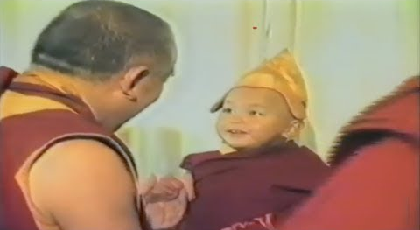  A Tibetan Buddhist Bala-Brahmachari | 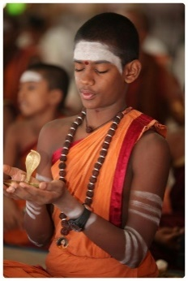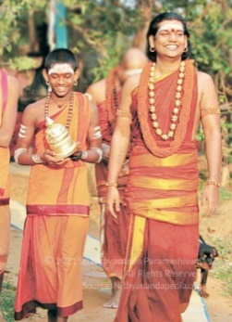  AIAT bala sannyasi (child monk) Sri Nithya Sundareshwarananda Maharaj with the SPH Nithyananda Paramashivam (2013)
- On 13 September 2021, Salem, around 10 AM, Sri Nithya Sundareshwarananda Maharaj, a Bala-Sannyasi, was brutally lynched by two State police officers of the Tamil Nadu State police department. The group of Tamil Nadu police officers encroached into our monastery in Salem and they started beating the young Brahmachari (monk) – Sri Nithya Sundareshwarananda Maharaj. The young monk had come to apply for bail for us two nuns who had been arrested on false charges the previous day. This attack happened in broad daylight, on the campus of the AIAT community, in the Salem (Aadheenam) monastery. The monk, being strongly rooted in the vows of Hindu monastic life (Brahmacharya), is a practitioner of Ahimsa (non-violence), and in the practice of chaturmasya, the practice of spiritual austerities in the period from the festival of Guru Purnima to Navaratri. Taking advantage of this, the police mercilessly beat him, with no remorse. The two policemen took turns, while one was holding his laptop aloft threatening to throw it and destroy it. The policemen also employed a militant terrorist to beat this young monk. They beat the young, twenty-year-old Bala-Brahmachari (celibate monk trained from a young age), for almost twenty minutes. The attack was instigated by anti-Hindu terrorist Palanisami and PTRP Thiyagarajan (Finance Minister of the State of Tamil Nadu) from the DMK.
- On 3 March 2021, in a public interview, PTR Palanivel Thiyagarajan (Finance Minister of the State of Tamil Nadu) of the political party DMK bragged that he along with his brother PTRK Vijayarajan forcibly evicted Sri Nithya Sundareshwarananda and AIAT community members from the Thondaimandala Aadheenam on 16 February 2021. Showing no remorse for breaking the age-old tradition of Guru-disciple lineage the DMK minister and his brother vilified the SPH Nithyananda Paramashivam, the 232nd Pontiff, the 233rd successor Pontiff and the AIAT community and emphasized that the mutt would be run as per the DMK party ideology. Sri Nithya Sundareshwarananda Maharaj was declared by the 232nd Pontiff of Thondaimandala Aadheenam as a successor 233rd successor Pontiff which is not acceptable by the DMK and thus they had evicted him. Sri Nithya Sundareshwarananda Maharaj had challenged this in the courts, after which the attacks on him escalated. Kailasa Paramparagatha Kanchi Kailasa Sarvajnapeetham Thondaimandala Adheenam, in an ancient Hindu Adi Shaivite monastery that was established originally by the incarnation of Paramashiva (primordial Hindu Divinity) Himself, as Adi Nathar, 5000 years ago. The attack on Sri Nithya Sundareshwarananda Maharaj was a continuation of the previous attempts to exterminate him as the successor pontiff of the Thondaimandala Aadheenam from the AIAT community. As even after being physically assaulted on 16 February 2021, Sri Nithya Sundareshwarananda Maharaj had refused to step down from his duty and responsibility to protect the Hindu heritage monasteries from the takeover and interference of the DMK headed State of Tamil Nadu, he has become a top target of the State government for extermination.
- The attack on Sri Nithya Sundareshwarananda Maharaj that happened on 13 September 2021, was an attempt to murder Sri Nithya Sundareshwarananda Maharaj, and other Hindu monks, and nuns staying in the premises. The state police officers and the accompanying militant were vulgarly expressing their intention to gang rape Hindu nuns (recorded in the video cited). These state officers acted as henchmen of the DMK militant Palanisami who threatened the child monk, “How dare you put a case on Palanisami.” The state police officers and the accompanying militant mentioned (recorded on video) their intent to kill Sri Nithya Sundareshwarananda Maharaj. Sri Nithya Sundareshwarananda Maharaj is both the ‘Karuvazhi Varisu’ (successor as per bloodline) and ‘Guruvazhi Varisu’ (successor as per the religious Master-disciple monastic order) of the SPH Nithyananda Paramashivam and is ordained as the 233rd pontiff of Thondaimandala Aadheenam. The policeman and militant while trying to kill him mention their intent to kill him asking if Sri Nithya Sundareshwarananda Maharaj was really the successor and inheritor of the SPH Nithyananda Paramashivam, following which the policeman warned Sri Nithya Sundareshwarananda Maharaj to never return to Salem and Tamil Nadu or he would be killed.
- The State police of Tamil Nadu wanted to extent the unlawful custody of us both nuns as it would allow the police to torture them and force a false confession from the nuns. The police wanted to physically and mentally break the morale and stamina of the AIAT community monks and nuns to assert their human rights. Anti-Hindu DK/DMK militant Palanisami attacked Sri Nithya Sundareshwarananda Maharaj through the state authorities to delay the bail of the Hindu nuns so that they may be beaten and broken in spirit and body for legally fighting this rape case.
- It is a shame that the state authorities of India have sold themselves to individual vested interests and are working for DK/DMK terrorists while drawing the salary from common citizens. The fact that the State government is silent on the matter shows that the State government is involved with deeply vested interests in these attacks. In 1971, the DK/DMK in a rally stated their goals for the next decades – “destruction of [Hindu] religion.” The DK/DMK state government has been consistently destroying Hindu heritage as the ruling party of the State of Tamil Nadu. They are not just targeting Hindu monks and nuns, they have also destroyed several ancient temples illegally, thus ensuring a complete cultural, physical, and ideological genocide of Hindu culture and religion.
- The Bala sannyasi was somehow able to video record the attempted murder on him. Despite this video evidence the police refused to accept the complaint. The militant terrorist who attacked is a drug peddler who openly acknowledged this in the video. The policeman also nodded in support of the drug peddler. It shows the deep-rooted and normalized criminal nexus between drug peddlers and police state of affairs, where state officials in India who are supposed to work for the people, are not just engaging in terrorism but drug peddling.
- On 13 September 2021, late at night, while the young monk, Sri Nithya Sundareshwarananda Maharaj was in the hospital, the State CID (Crime Investigation Department) official named Sounder came to visit him in the guise of taking his formal complaint. Before leaving the hospital, the police officers had taken the phone and returned it claiming they needed Sri Nithya Sundareshwarananda Maharaj to have his phone as it would enable them to track his whereabouts. Later the next morning, on 14 September 2021, the CID (Crime Investigation Department) Police officer of the Tamil Nadu State again came to the hospital at 6:30 AM. Sri Nithya Sundareshwarananda Maharaj had already moved out for protection from the police. The police CID officer then came to the Salem Aadheenam (monastery) at around 8 AM claiming that he was tracking Sri Nithya Sundareshwarananda Maharaj and thus located his last location as the Salem Aadheenam. Since the police had not even registered a formal FIR, when questioned the purpose of his visit, the CID police officer claimed that he was independently investigating the attack on Sri Nithya Sundareshwarananda Maharaj apart from the formal investigation that the local Salem State Police department was doing. The CID police officer claimed that he would return at around 9 AM but did not show up. The CID officer had not mentioned that he had gone to the hospital at 6:30 AM, it was found by other sources. Such threatening active surveillance of the monks and nuns is not new. The State Police has employed phone tapping and other state-of-the-art technologies including spyware to unethically surveil Hindu AIAT monks. This fact was openly reported by the police to the media when in 2010 the State police used the intelligence department to falsely frame the SPH Nithyananda Paramashivam and also lied about it in the court – On 25 March 2010, the SPH Nithyananda Paramashivam’s anticipatory bail was denied by the High Court citing “apprehension of the petitioner is unfounded”, saying that there was no basis on which the SPH Nithyananda Paramashivam could be arrested so He did not need bail. However less than a month later, on 21st April 2010, during the hearing on another anticipatory bail petition of the SPH Nithyananda Paramashivam for the same false accusations in a lower court (Ramanagara District Court) the Police lied in the court saying they had already arrested the SPH Nithyananda Paramashivam. However in reality only around two hours later, with the help of the intelligence department, a different team of police officers entered the house where the SPH Nithyananda Paramashivam was staying in Solan (Himachal Pradesh, India) and illegally arrested Him.
- Since 2003, the SPH Nithyananda Paramashivam had been under close surveillance of the state intelligence department. Several times, sympathetic intelligence officers, such as one on 30 December 2009, have shared that the government had a close eye on the AIAT Hindu monks.
- Ever since the extrajudicial assassination of Jamal Khashoggi, the use of spyware for surveying journalists and human rights activists has been a matter of great international concern. Given the history of attack and state surveillance done on the AIAT community, and given the open admission of the surveillance done on Sri Nithya Sundareshwarananda Maharaj, the AIAT community is extremely concerned about the safety and well being of Sri Nithya Sundareshwarananda Maharaj and other monks and nuns.
- On 14th September 2021, the Tamil Nadu State Police refused to register a complaint on the previous day's attack and instead spread misinformation , especially in social media, projecting as if the attackers had been arrested. The lie was extremely complex and convoluted, as the police claimed to have arrested the attackers on charges other than that of attacking Sri Nithya Sundareshwarananda Maharaj. The State of Tamil Nadu Police officers said they would not accept any formal complaint of a crime by State police officers and warned the AIAT community to refrain from posting about the matter on social media.
- Sri Nithya Sundareshwarananda Maharaj is the declared successor 233rd Pontiff (Gurumahasannidhanam) of Kailasa Paramparagatha Kanchi Kailasa Sarvajnapeetham Thondaimandala Adheenam. Sri Nithya Sundareshwarananda Maharaj is both the ‘Karuvazhi Varisu’ (successor as per bloodline) and ‘Guruvazhi Varisu’ (successor as per the religious Master-disciple monastic order) of the SPH Nithyananda Paramashivam. Sri Nithya Sundareshwarananda Maharaj is also the blood relative of the SPH Nithyananda Paramashivam as he is the son of the sister of the SPH. Sri Nithya Sundareshwarananda Maharaj’s biological father – Sri Nithya Jnanapriyananda – was the personal assistant, attorney (Sreekaryam), and a family relative of the 232nd pontiff of the Thondaimandala Adheenam. The anti-Hindu DK/DMK militants in the State of Tamil Nadu want to usurp the ancient Thondaimandala Adheenam which has produced the likes of Bodhidharma who took Hinduism to China which later took the form of Zen Buddhism. The anti-Hindu DK/DMK militants and neo-Hindutva extremists had attacked on several occasions. On 24 Nov 2017, Sri Nithya Jnanapriyananda was burnt alive through a blast created by these anti-Hindu militants through a leak in the cooking gas cylinder in the monastery kitchen. Inspite of the attacks on the life of Sri Nithya Sundareshwarananda Maharaj he cannot leave the country as he is one amongst the last surviving monks protecting and fighting for the religious rights of the AIAT Hindu community in India especially given that the SPH Nithyananda Paramashivam has been exiled from India. The AIAT community is thus extremely concerned about the safety, and protection of the life of Sri Nithya Sundareshwarananda Maharaj. The fact that the Finance Minister of the State of Tamil Nadu, PTR Palanisamy, a member of the DMK, gave an interview and acknowledged that his brother had forcibly and illegally evicted Sri Nithya Sundareshwarananda Maharaj, and the fact that during the attack on the life of Sri Nithya Sundareshwarananda Maharaj on 13 September 2021, these attacking police personnel stopped only when Sri Nithya Sundareshwarananda Maharaj replied to their question – “are you next Nithyananda” in negative, and the fact that the father of Sri Nithya Sundareshwarananda Maharaj was burnt alive on 24 Nov 2017, and the police even refused to register a formal complaint let alone investigate, it is very clear and evident that the AIAT community, the AIAT monks and nuns and especially the next generation religious leaders of the AIAT community are being targeted in what is a cold genocide. This cold genocide is supported by the hate propaganda of the politically owned DMK media (Sun TV and associated channels) that even judges have a prejudice against the SPH and the AIAT community even today. This is why even the bail application of the nuns was denied on 15 September 2021 on baseless grounds.
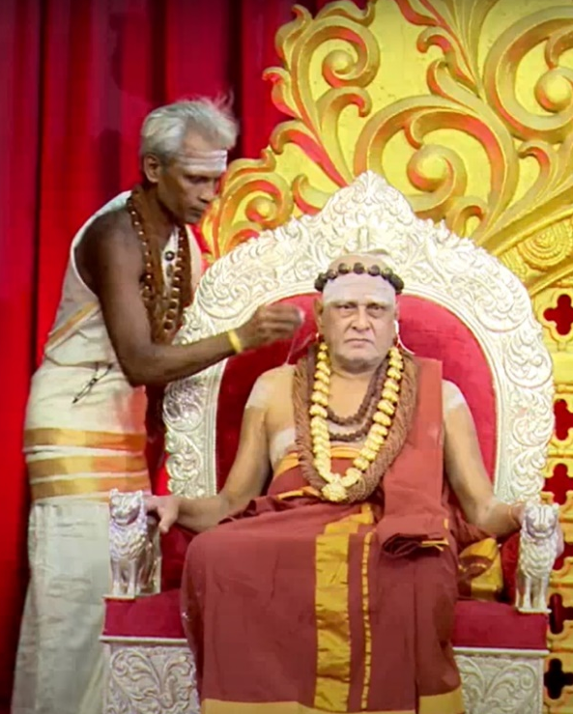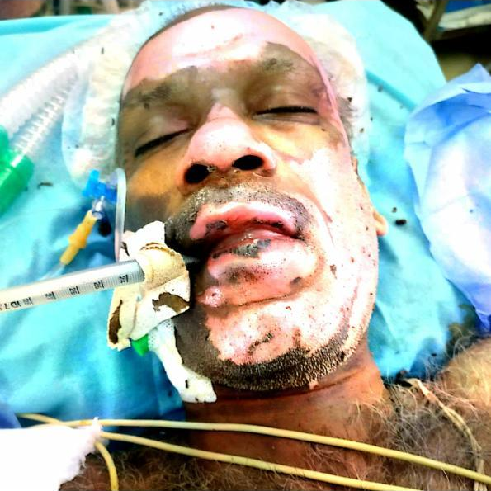
(LEFT) 30 July 2017: The 232nd Guru Mahasannidhanam Thondaimandala Aadheenam Sri Thiruvambaladesika Jnanaprakasha Swamigal with the 233rd successor Guru Mahasannidhanam the SPH Nithyananda Paramashivam. The 232nd Pontiff addressed the citizens of the spiritual kingdom of Kailaasa Paramparagatha Kanchi Kailasa Sarvajnapeetham (complete video here) blessing the community and he also spoke about the conspiracy being hatched by the State appointed advisory committee. Sri Nithya Jnanapriyananda – a disciple of both the 232nd pontiff and 233rd Pontiff the SPH - can be seen on the left adjusting the translation earphone for the 232nd pontiff. Sri Nithya Jnanapriyananda is the personal assistant to the 232nd pontiff who holds the power of attorney (Sreekaryam) to represent the 232nd pontiff in legal matters. On 2nd July 2017, Raja T Vijaya Kumar and his associates had given a written threat to Sri Nithya Jnanapriyananda to “vacate the Thondaimandala monastery or face our next actions”
(RIGHT) 24 Nov 2017: Sri Nithya Jnanapriyananda was burnt alive through a created blast through cooking gas cylinder leak in the monastery kitchen. More than 50% of the body of Sri Nithya Jnanapriyananda was burnt with second and third degree burns, yet the State police refused to register any complaint and did not investigate the matter, despite showing the letters of death threats by Raja T Vijaya Kumar and his associates. On much appeal, the police only recorded the attack as a non-cognizable event - CSR 876/2017 (Sivakanchi Police Station, Kancheepuram District), something which they need not investigate. The AIAT community filed a petition to the Court to direct the police to investigate the matter, the court even refused to accept the petition.

- On 14 September 2021, the Salem police categorically refused to accept any complaint from Sri Nithya Sundareshwarananda Maharaj, the bala sannyasi who was attempted to be murdered by the Hinduphobic militants led by the militant Palanisamy. This was inspite of Sri Nithya Sundareshwarananda Maharaj giving to the police a verbal and handwritten signed complaint detailing the attack on him. However, the police filed a FIR (First Information Report) with the complaint of a driver Sarvanan who was summoned to the police station and physically and psychologically tortured by the police on 13th and 14th September, and repeatedly threatened and detained for over 6 hours and was coerced to give the complaint modified as desired by the police. Sarvanan was the person who saw Sri Nithya Sundareshwarananda Maharaj wincing in pain after being beaten by the attackers and took him to the hospital. The shouting of the police officers who threatened Sarvanan the driver was recorded in a video by the lawyer of the AIAT community, Advocate Surekha in a video where she was also cornered with police personnel standing all around her threatening to arrest her on charges of forgery (which the police were actually doing inside the room coercing a false complaint from him and making him write a version of the complaint as per the will and directions of the police and filing that as the official complaint). The police made a false back-dated FIR dated 14 September 2020 though the police got the false complaint from Saravanan through coercion on 16 September 2020. They reported as the FIR was produced before the Court on 14 Sepember 2020 though it was not.
- The translated FIR is excerpted below:
1. District: Salem, Police Station: Fairlands, Year: 2021, FIR No.: 384, Date: 14-09-2021
2. Acts: IPC 441, IPC 447, IPC 294(b), IPC 323, IPC 324, IPC 170, IPC 171, IPC 392, IPC 506(2)
3. Occurrence of offense: Monday, Date From 13-09-2010, Date To: -
Time Period- On, Time From- 10:30 Hrs, Time To:
(b) Information received at PS Date: 14-09-2021 Time: 09:00 Hrs
4. Type of information: WRITTEN Time:
5. Place of occurrence (a) direction and distance from Police Station:
(b) Address: D1 PS Saragam, Periapputtur, Pittari Amman Kovil Street, Nithyananda Ashram
6. Complainant/Informant (a) Name: Saravanan, (b) Father's name : Sivakumar, (c) Date/Year of Birth: 1976, (d) Nationality: India
7. Details of known/Suspected/Unknown accused with full particulars
1) Sarvanan of Periaputur and 2) Subramani of Ariallur
8. Reasons for delay in reporting by the complainant/informant: No reasons given. -
9. Particulars of the property stolen/ involved: -
10. Total value of properties stolen/ involved: -
11. Inquest Report/ Un-natural death Case No. If any: -
12. Humbly submit: Today 14.09.2021, 9:00 myself G Salethmary sub-inspector of Arakapuram police station, Salem, is receiving an application this case filed according to the report given by sub-inspector Govindraj Salem CSR 550/2021, application registered in the case details follows:
Saravanan (Age 45), S/O Shivakumar, 33/64 Mariamma Kovil Terur Peramannur, Salem 9843766600, I am born and living in this address. I have studied up to the 10th standard. I belong to the Jangam caste, I am married and have two children a son and a daughter. For the past 6 years, I am working as a driver under Puroshotaman, owner of Usha Sunflower oil company Pallapatty. My employer is a devotee of the Salem Alagapuram Nithyananda Branch. Whoever comes from outside to the ashram, I will be sent as a driver to pick up and drop. I will go pick them up and again backdrop them. Like that on 13.09.2021, morning 10 o’clock when I was sent to take Sandeep Maharaj from Bengaluru outside. When I went there to Pittari Amman Kovil Street, Nithyananda Ashram branch, Arakapuram by 10:30, to pick up Sandeep Maharaj who was supposed to be in the meditation hall, a person in police uniform and another in yellow t-shirt, they entered the Nithyananda Ashram and were beating Sandeep. I shouted and he also shouted (Sandeep) but they did not attend to any of this. The one in uniform was asking, “who are you da, disguised like Swamiar and coming to cheat the people here” and threatening like this and he beat him on his cheeks. I saw the badge in his uniform. In that word, Subramani was there. He (police officer) called the yellow t-shirt person “Saravana, come here”. Immediately he (Sarvana) asked Sandeep Maharaj “Are you Nithyananda?”, Both of them, used bad words like ‘Taivadiya Paiyya’ [prostitute], ‘Kandaraholi Paiyya’ [son of whore], and abusing he kicked him and used wooden log and hit Maharaj on his shoulders and head. The yellow t-shirt person was telling I will come after 1 hour, you leave this place otherwise I will definitely kill you and so saying and he took a mop stick and beat him (Sandeep Maharaj). Sandeep Maharaj's bag was on the floor. They took the laptop, external hard disk, headphones, out of it. I and Sandeep, shouted and told them “Are you police? or duplicate police? How you are beating like this!”, I shouted and threatened that I will call the police and both of them ran away. Immediately I took Sandeep in my car to Salem Kamala hospital, as he was injured in his ankle, shoulders, and head where they admitted him immediately.
When Govindraj came to meet Sandeep in the hospital he was unconscious so I told what I saw there when the event happened. 0ne person in police disguise and person in the yellow t-shirt I showed the photos of these two people. Govindraj recognized them and told them that they are big rowdies of this area, Sarvanan of Periaputur and Subramani of Ariallur and we all in the hospital got scared. Garbed in police attire, they have abused, kicked, beaten, and snatched a laptop, an external hard disk, and headphones from Sandeep Maharaj. I want action to be taken against these two people.
You (referring to Govindraj) of Arakapuram police station people have come and inquired. What I saw of the event also you have taken down (pen down). I read it, it is correct. Sd/-(XXX) S. Saravanan, 13/9/21, 9843766600 According to his written statement of Saravanan, Arakapuram Police Station, files 384, 447, 294(b), 323, 324, 170, 171, 392, 506 (ii), IPC case is registered. Original report as well as statement attached and sent to judge number 5, Salem, along with other statements copies, sent to the higher officials just so I have taken this case for investigation.
15. 14-09-2021 Salethmery G, Sub-inspector of Police.
- On 16 Sept 2021 morning, at the Salem monastery on the other hand the police came to do a Mahazar (a sketch of the crime scene and inventory of items). The police just picked up a log of wood and went claiming they would record that wooden log as the weapon used. This was video recorded. On 16 Sept 2021 night, the police surrounded the counsel of the AIAT community Ma Surekha, and started shouting and threatening to arrest her on ‘forgery’ (IPC 463) when it was the police who had forged the complaint by threatening the third man (Sarvanan) seen in the video and who took Sri Nithya Sudareshwarananda Maharaj to the hospital. This was recorded in a video.
- On 17 Sept 2021, the AIAT community members went to the officer of the Superintendent of Police (SP). The SP refused to make himself available and the AIAT community members were directed to meet the Assistant commissioner. The AIAT community members waited for the entire day at the Assistant commissioner’s office. The Assistant commissioner called the local police station and claims to have been given the opinion by the policemen from the local police station that the AIAT community did not cooperate. Citing this the Assistant commissioner demanded proof that the two accused in trying to kill Sri Nithya Sundareshwarananda Maharaj are related to the terrorist Palaniswamy as blood relatives and subject to this condition, Palanisamy’s name would be incorporated in the FIR in two days. The AIAT community members cited the victim’s statement (Sri Nithya Sundareshwarananda Maharaj / Sandeep) and the video recorded by the victim where the attackers threatened the victim if he did not take back the case against Palanisamy. The video recording was started by the victim after this as he felt threatened and suspicious of the motives of the attackers. The Assistant commissioner declined the video footage as proof in totality. The AIAT community members pleaded if they could come to meet or do a video call with the victim though they had given the handwritten signed statement from the victim. The AIAT community members also informed the Assistant Commissioner of the bail dismissal order of the case of molestation by Palanisamy where the judge had refused him bail citing that Palanisamy was a gang leader who would incite religious violence. The Assistant Commissioner disregarded the judgment and claimed that the judge could have said anything, but as police they could not consider those as facts.
- Human rights violations by police and creation of false witnesses and the creation of false evidence is extremely common and documented in India. The AIAT community apprehends that the police has purposefully and maliciously fabricated a false third party FIR using a driver, and refused to take the complaint of the direct victim of a murder attempt, Sri Nithya Sundareshwarananda Maharaj, so that the case may be maliciously dropped by the police by torturing the complainant Saravanan (the driver) and making him give statements countering the facts.
- The State Police of India is illegally and fraudulently arresting nuns and monks who are arbitrarily kept in prison without trial for long durations, and eventually made to die in custody through diseases, without ever being subjected to a proper trial. It is a known fact that monks and nuns who work for the rights of indigenous communities are seen as soft targets by rogue state elements.
- As recent as a few days back, on 20 September 2021, an elderly monk, Mahant Narendra Giri, the head of the Akhada Parishad which is the apex body of Hinduism, was found hanging from the ceiling of his room in his monastery with a suspicious suicide note. As investigations are said to be underway, the social media is rife with various discussions and debates on this shocking death and suspected murder of the apex body of Hinduism in the very heart of India.
On 15 July 2021, Ms. Mary Lawlor, (Ireland) United Nations Special Rapporteur on the situation of human rights defenders, had said, “We know that defenders working on environmental, land or indigenous people’s rights are among the most vulnerable to being targeted”.

Has the COVID pandemic affected your work? In which particular ways the impact was felt in your work?
Though I am not able to travel after the Covid-19 pandemic, especially after I was affected by the pandemic and was hospitalized in a serious condition, yet the inspiration given by my spiritual guru The SPH Nithyananda Paramashivam only propelled me to intensify my socio-spiritual and humanitarian services.
The whole response to the deadly ongoing Corona pandemic has been approached by The SPH Nithyananda Paramashivam in a very fundamental way that has been published by the United Nations. Like me, all of His monks and nuns have been involved in practically implementing the Hindu solutions for it in multiple ways through our Covid Care Centers (CCC) in the defacto spiritual embassies of Kailasa across India. I have been leading the efforts in the same in Tamil Nadu.
The CCC implement practically:

Hindu Multilateralism
  - There is an immense inequality in the capacities of governments, organizations, and people on two grounds – (1) health response, (2) economic recovery. Surviving the highly contagious COVID19 where the world is only as resilient as the least resilient country and person requires governments, organizations, and people to collectively address the crisis. From 3200 BCE, 56 nations in Asia had multilateral treaties based on the Hindu principle – ‘वसुधैव कु टुम्बकम्’ (Vasudeva Kutumbhakam) – “Entire world is my family”. अयं बन्धुरयंनेति गणना लघुचेिसाम्। उदारचररिानां िुवसुधैव कु टुम्बकम्॥ Maha Upanishad Ch. 6, verse 71-73.

Provide sustainable community livings with multi-layered quarantine
  - Home or Self-quarantine is not a viable solution for a vast majority of people for either health safety or economic reasons. In Assam, home quarantine has been reported to be a primary reason for a large number of deaths. In some places, governments have moved people out of home quarantine to covid-care-centers. Other issues linked with quarantine, especially in small houses are mental health problems – such as an increase in suicidal ideation, especially amongst the younger population. This requires friendly quarantine setups which are self-sustained and sufficient in terms of food stock and supplies, recreation, employment, education, etc. In India, State Governments have attempted to provide free and paid solutions which face various challenges related to hygiene, exorbitant pricing. Some facilities have seen challenges related to requests for private accommodation. Experimental townships such as Auroville have demonstrated a fair amount of success in creating a friendly, safe, and compliant quarantine facility. However, solutions such as Auroville are not open to the public. For two decades the leader of the AIAT Hindu community, the Supreme Pontiff of Hinduism (SPH) Jagat Guru Mahasannidhanam (JGM) His Divine Holiness (HDH) Bhagavan Nithyananda Paramashivam had been creating townships like Auroville across more than a hundred cities in several countries. Most of these townships such as the AIAT Monastery India, Bengaluru have been opened to offer multi-layered quarantine as a free public service with free food/accommodation, free internet to work from home (monastery). The AIAT community has seen a fair amount of success in these townships with zero reported cases of COVID infection in the past two years and has already saved many lives.
  - The SPH Nithyananda Paramashivam has urged citizens worldwide, especially from regions severely affected by the pandemic to protect themselves as the topmost priority and avail these free quarantine facilities that the community has created, especially as home quarantine has failed for many and is known to be a primary reason for a large number of deaths in many scenarios. The SPH Nithyananda Paramashivam has emphasized the need and urged the government worldwide to provide food, safety, medical care, shelter, and all survival needs to all human beings under their care, with absolute multilayer quarantine, until coronavirus is eliminated from planet earth including all different strains of the virus.

Educate citizens on individual pandemic management
  - Unlike previous pandemics, the current era provides active, real-time, and visual information about fatalities. Underreporting of this data may give false hope and make people reckless. Exaggerations in reporting can also make people reckless as they may feel eventual death due to a coronavirus is inevitable. Proper education is extremely crucial, as it will dramatically reduce the number of deaths and reduce the challenge on the health-care-systems. Alcohol-related deaths have hit a record high during this pandemic, and long post-lockdown liquor lines are some extremely worrisome issues regarding which people need to be educated. As a top priority, people need to be given confidence in their life and security about their future for them to stop behaving recklessly or fall into depression and commit suicide.

Leveraging best of different economic systems based on charity, barter, and money
  - Ancient Hindu economic treaties by Paramashiva (primordial Hindu divinity) describe three kinds of economic systems and their principles – (1) for things that do not perish by sharing – such as education and knowledge – Paramashiva recommends that no fee be charged, (2) for survival needs – such as food and healthcare – barter and charity are recommended, (3) for all other infrastructure development works, services, and commodities gold and conventional currency based transactions are allowed. These systems are still in practice in the modern-day, but grossly overlooked and not sufficiently studied with their close relation to mainstream economics. The WHO and GISAID provided early access to data regarding the virus - this is an example of an open knowledge-based economic policy where critical data about the virus was not monetized. Similarly, South Korea helped the USA access masks and testing kits, and there was a hope that this would lead to a reciprocal arrangement in terms of vaccines, which is like a barter-based model allowed in food and healthcare.

Hindu Policies for food security
  - A highly effective concept for ensuring food security in ancient Hindu nations was that of food grain banks. These were prevalent until the 18th-century. The elderly in villages would start food grain banks, with a seed capital of grains collected by fundraising. If any person met with a crisis such as a crop failure, the food grain bank would lend him grains in exchange for an interest (compound interest was prohibited in grain banks) which the debtor was expected to return with the principal grain amount during the next harvest. The bank would expand its reserves of food grains based on interests earned and donations. At the time of severe crisis such as famine, the entire village would be able to withdraw these grains, and if required all such grain loans would be written off on humanitarian grounds. One such food grain bank was voluntarily created in 2020 by farmers in Bihar and has bailed out several workers who were forced to migrate due to lockdowns. Food grain banks and their very concepts we were destroyed by the British colonial government for diverting food resources to their war efforts that resulted in massive famines and deaths due to starvation.
  - In Hindu temples, food is shared for free as a policy. This was the case in both ancient times and in modern times. For 27 years, every month the Hindu AIAT community has served more than 3 million free organic meals in religious gatherings to everyone without discrimination and has served over 1 billion free meals in total. Such private and public efforts are crucial to ease the threats of starvation which is estimated to hit a billion people worldwide.

Monitor global health
  - The crisis requires governments to take aggressive, proactive measures to monitoring health. Smartphone applications have been used by governments that are based on health code color systems that categorize individuals into three color groups based on their health status and travel history and then determine whether they need to be quarantined. Though there were privacy-related-concerns associated with these approaches, some of these measures such as agile daily reporting systems for accounting of newly suspected, diagnosed, asymptomatic cases, number of deaths, and generating area-wise statistics have played an important role in proactively responding to curb the spread of the disease⁵¹ and are being considered for implementation by various countries.

Traditional medicine
  - In Hinduism, nature, and planet earth are respected as living divine mother energies capable of providing us with all our survival needs – food, medicines, etc. Though traditional medicines such as TCM and Ayurveda are effective in addressing COVID-related issues, and a few years ago a Nobel prize was awarded for scientific work based on traditional medicine the mainstream western medicine has chosen to characterize Ayurveda as pseudoscience and TCM as unscientific. Such demeaning of traditional medicine systems have lead nations to consider taking defensive unilateral decisions to protect their interests. Outright rejection of traditional medicine is not wise and such policies should be revisited especially as these medicine systems are time tested and have kept people healthy for several generations. Kailash Union recommends governments worldwide to provided provide solutions like Kailasa’s Hindu Medical care (which includes completely free of charge services such as Ayurveda, Yoga, Siddha, Western medicines, and multi-layered quarantine) for complementing their ongoing public health efforts.

Recommendations/ the way forward

1. What would help you in your work?
- I humbly urge the international community to intervene so that the authorities of the State of Tamil Nadu, particularly the State police stop persecuting rape victims like me who are especially from vulnerable and marginalized communities. The international community needs to condemn this violation of the basic human rights of women India from persecuted marginalized Hindu communities who have been raped and are being discriminated against by the legal system.
- As the politically owned Indian media has refused to give us neutral coverage, our persecution has become exacerbated. We urge reporters, journalists, and people from the international media to report these ghastly human and women’s rights violations as this will put much-needed pressure on the State authorities to end the impunity of the perpetrators.
- In the past, we submitted three reports to the UN, in consequence of which this attack is being waged on us to punish us for voicing out. The international community must intervene and refrain from keeping silent, as this silence is costing us our life, and dignity as women and nuns. We implore the international community to protect us, as the government of the State of Tamil Nadu, and the State of the Republic of India, have been unwilling and failed to protect us.

2. What recommendations would you have for state and other political actors?
- Women nuns who lead indigenous minority religious communities like the AIAT have been deprived of their human rights in their home country. The international community, and member states of the United Nations, need to support us by providing a safe place protecting our basic human rights, where we can practice their religion, and revive our arts and traditions peacefully.
- There were close to 10000 indigenous tribes and spiritual traditions in the Indian sub-continent that were mother worshippers and led by women. The AIAT is one of them. Colonization and invasions in ancient times and religious intolerance and caste-based violence and extremism in contemporary times have made them extinct. These women have been marginalized and labeled as witches and persecuted since time immemorial. Now is the time that the world needs to protect these traditions by internationally declaring them endangered and also to provide protected status especially to the women monks of the AIAT.
- The whole basis of sanyas (monkhood/ nunhood)Hinduism is the guru-disciple relationship where the guru guides and initiates the disciple into the higher truths and enables his/her transition into higher states of consciousness enabling the disciple to be established in the state, space, powers, being and superconsciousness of Paramashiva, the Ultimate and eternal principle of Hinduism. We as nuns of the Sovereign Order of Kailasa have been deprived of this fundamental umbilical cord connection with our guru and hence are spiritually isolated, stranded and devastated. It is our humble appeal to give us a protected status and land where we can live securely with our guru, The SPH Bhagavan Nithyananda Paramashivam, and practice our sanyas and contribute to the world through the various socio-spiritual contributions as per our sanyas responsibility.

3. What actions do you think are needed from different actors (States, civil society, private sector) to better enable you to influence decision-making?
- I would like to urge reporters, journalists, and people from the international media to report these ghastly human and women’s rights violations as this will put much-needed pressure on the State authorities to end the impunity of the perpetrators.
- The world needs to protect these traditions by internationally declaring them endangered and also to provide protected status especially to the women monks of the AIAT.
- The international community, and member states of the United Nations, need to support us by providing a safe place protecting our basic human rights, where we can practice their religion, and revive our arts and traditions peacefully.
- It is my humble appeal to give us a protected status and land where we can live securely with our guru, The SPH Bhagavan Nithyananda Paramashivam, and practice our sanyas and contribute to the world through the various socio-spiritual contributions as per our sanyas responsibility.
- Tribal and indigenous girls should be protected from detribalization and persecution by the State. This persecution is often difficult to understand as it waged in the guise of women empowerment and child protection, which is essentially a new form of the civilizing mission.

Anything else you would like to share

“om sirah pani pada parsvapasthorudhara-jangha-sisnopastha-payavo me। suddhyantam jyotiraham viraja vipapma bhuyasam – svaha ॥4॥“ Mahanarayana Upanishad - verse 4, clearly mentions purification of different parts of both male and female body through the fire ritual.
(i) https://www.ohchr.org/Documents/Issues/Expression/disinformation/2-Civil-society-organisations/Nithyanandeshwara-Hindu-Temple.pdf (ii) https://www.ohchr.org/Documents/HRBodies/CEDAW/DGD24June2021/51.docx (iii) https://www.ohchr.org/Documents/Issues/IntOrder/Multilateralism/AdiShaiviteMinorityTradition.pdf (iv) https://www.ohchr.org/Documents/Issues/Women/SR/Femicide/2021-submissions/CSOs/india-kailash-union.pdf
https://books.nithyanandatimes.org/?ddownload=1098 http://books.nithyanandatimes.org/?ddownload=1073
https://www.cnn.com/2018/06/25/health/india-dangerous-country-women-survey-intl/index.html
https://www.hrw.org/news/2018/01/18/india-unchecked-attacks-religious-minorities
www.ndtv.com/cities/2-cops-in-uttar-pradeshs-gorakhpur-suspended-for-alleged-inaction-in-gang-rape-case-2383376 https://theprint.in/opinion/the-kathua-rape-case-has-brought-up-disturbing-memories-of-jammus-history/53039/
http://poll2018.trust.org/
http://ncrb.gov.in/
https://www.theguardian.com/commentisfree/2015/nov/12/india-hindu-taliban-narendra-modi
https://www.amnesty.org/en/countries/asia-and-the-pacific/india/report-india/
https://southasia.ucla.edu/social-life/various-articles/hinduism-versus-hindutva/
AIAT (Adi Shaiva Minority Tradition) is the sect of Hinduism which worships Lord Paramashiva, as per the Hindu Vedagamas scripture - Kāmikāgama – that mentions that Ādiśaivites are born in the family of sages who were initiated directly by Śiva (Paramashiva) immediately after the creation of the world. www.wisdomlib.org/definition/adishaiva
“Being gay is against Hindutva, it needs a cure,” BJP MP Subramanian Swamy (10 June 2018) ; Homosexuality not a crime, but against nature: RSS - militant wing of neo-Hindutva extremists (SEPTEMBER 06, 2018)
https://www.nithyananda.org/photo-gallery/nithyananda-diary-30th-november-2018-nithyananda-peetham-bengaluru-aadheenam-uttamotam pictures from daily rituals of AIAT temples showing AIAT nuns performing temple rituals which are ordained for all genders as per Hindu scriptures but prohibited for women by the Hindutva extremists
"Memories of a Violent Movement led by Periyar". Times of India.
(i) "Attacks fuel Brahmin fears". Telegraph India. (ii) https://www.outlookindia.com/website/story/sacred-threads-of-10-brahmin-men-cut-off-in-chennai-after-bjp-leader-called-to-b/309198
(i) https://www.news18.com/news/politics/tamil-nadu-466-candidates-have-criminal-cases-against-them-dmk-tops-chart-3605873.html (ii) https://timesofindia.indiatimes.com/city/chennai/33-tamil-nadu-mlas-face-criminal-cases-adr/articleshow/81441435.cms
"3 people killed in Dinakaran attack". The Times of India. PTI. 9 May 2007.
Special Correspondent (10 December 2009). "All acquitted in Dinakaran case". The Hindu.
“om sirah pani pada parsvapasthorudhara-jangha-sisnopastha-payavo me। suddhyantam jyotiraham viraja vipapma bhuyasam – svaha ॥4॥“ Mahanarayana Upanishad - verse 4, clearly mentions purification of different parts of both male and female body through the fire ritual.
State of Washington v. Vinay Keshavan Bharadwaj (Case No.10-1-10009-8 SEA) https://drive.google.com/file/d/1OnFmhM1bacqa1JB8HcMzVrl352shNXwf/view
State v. Bharadwaj, Nos.74013-0-I ( December 27, 2016 ), https://law.justia.com/cases/washington/court-of-appeals-division-i/2016/74013-0.html
Superior Court Of the State California, County of San Bernardino, Vinay v. Nithyananda Foundation CIVRS 1013793, 4 April 2013, nithyananda.org/sites/default/files/news/vinay%20bharadwaj%20order%20for%20attorney%20fees.pdf
Life Bliss Foundation vs Samaya TV in CIVRS 1410615 filed in the Superior Court of California, County of San Bernardino, order dated 8 Dec 2017 https://nithyanandatruth.org/2017/12/10/5-million-judgement-against-samaya-tv-by-usa-court-for-defamation-of-his-divine-holiness-nithyananda/
https://docs.google.com/spreadsheets/d/1Opin5NMenD_f2WYQZ_M74dL96tN3PpU0uC2QuNTFba4/edit
https://www.newindianexpress.com/states/karnataka/2010/dec/10/nithyananda-sodomised-his-disciples-209732.html
Worship of divine feminine consciousness during Chandi Homa maligned as witch craft https://www.youtube.com/watch?v=M6T8GwNo8SM
“‘They are continuously harassed in public for no fault of theirs’, said Nithyananda. According to Nithyananda, sarees of at least ‘17 women devotees were pulled’ in public, at seven places his Brahmacharis were thrashed and the Ashram call centre received about 300 phone calls for prostitution.” https://www.deccanherald.com/content/152493/cid-report-stolen-says-nithyananda.html
(i) CC 25289/12, 21 Dec 2012, CMM Court Bangalore, AIAT Dalit Nun Ma Nithya Supriya Swami v. Charu (Kumudam Reporter) (ii) https://www.vikatan.com/news/coverstory/114380-the-psychology-behind-the-cults-worshippers.html Date: 24/Jan/2018
5 March 2010 - Headlines Today - 8:20PM – Hang the Sin Swamis (Hindu monks) docs.google.com/document/d/1f7CEsZDNw5Tl8wJX3fckhmEGqOyESHgy7GgXJiai8vo
“‘They are continuously harassed in public for no fault of theirs’, said Nithyananda. According to Nithyananda, sarees of at least ‘17 women devotees were pulled’ in public, at seven places his Brahmacharis were thrashed and the Ashram call centre received about 300 phone calls for prostitution.” https://www.deccanherald.com/content/152493/cid-report-stolen-says-nithyananda.html
Profile with the name Parthasarathy J (The Rock) commented (comment id : UgzPVRI09bZwNd_IaUF4AaABAg ), "I have hit one nithyanandha people when they try to encourage near pallavaram. I request everyone to hit them nicely. Even don't show courtesy for women in nithyanandha ashram. They are the most dangerous" https://youtu.be/eRIYu2xguG8
"Tamil lyricist Vairamuthu gets Padma Bhushan". Business Standard.
“नवम्यामेकवर्षादिनववर्षान्तकन्यकाः । बाला शुद्धा च ललिता मालिनी च वसुन्धरा । सरस्वती रमा गारी दुर्गा च नव कात्तिताः ॥२७॥“ “In the same order upto the ninth day of the fortnight girls from one to nine years respectively should be wor- shipped as usual. These nine girls respectively are named as : 1. Bālā, 2. Sudbā, 3. Lalitā, 4. Mālini, 5. Vasundharā, 6. Sarasvati; 7. Rama, 8. Gauri, and 9. Durga .” Kularnava Tantra, 10th Ullasa, verse 27, https://archive.org/details/Kularnava/mode/2up
news18.com/news/india/govt-appeases-sadhus-by-allowing-gurus-name-instead-of-parents-in-passport-1326843.html
2 Feb 2011, DNA India, "After Ranjitha, Nithya claims sex video was not of him", the picture shows a minor AIAT girl's picture. This news clip caused victimization of the child in school and neighbourhood for being captured in a vulgar news item while cheering for the SPH.
Tamil yellow Tabloid NAKKHEERAN edition with monk Ma Nithya Preetananda’s full size picture https://drive.google.com/open?id=1pxScgv6iDqgMv7VNlWZAWSeUj3M_PLao
https://www.mangaloretoday.com/titbits/It-rsquo-s-my-offering-to-Swamiji-Ranjitha.html
https://indianexpress.com/article/india/india-others/new-complaint-lodged-against-godwoman-radhe-maa/
9 May 2010 https://drive.google.com/open?id=1ETDbGI0PhJ-Wz2n6bYlOjG6xBu79fWJv In the above magazine link, Charu Nivedita asked the following obscene questions openly addressing monks and members of the AIAT community in his article: “I would like to ask, to those like the head of Tamil publication dept. Supriya and actress Ragasudha: Did you sign Nithyananda’s sex agreement after reading it? Did he have the above said tantric sex with you?”
(i) CC 25289/12, 21 Dec 2012, CMM Court Bangalore, AIAT Dalit Nun Ma Nithya Supriya Swami v. Charu (Kumudam Reporter) (ii) https://www.vikatan.com/news/coverstory/114380-the-psychology-behind-the-cults-worshippers.html Date: 24/Jan/2018
FIR 300/2012, Bidadi PS, Ramanagara, Karnataka, https://shrikailasa.github.io/persecution_evidences/CC233-2020-FIR300-2012-MaJnanatmaSwami.pdf
https://youtu.be/BHf5h0KtIIc
India TV report “It is our campus sir, we have right to our protection you cannot come and destroy us like this. I am also a girl, I have a right to my security. Somebody attacks me, you are not going to save me, I have to save myself”, https://youtu.be/1-43XTF18Lc at 3 mins 49 secs.
https://news.un.org/en/story/2021/03/1087412
theprint.in/world/uks-communications-regulator-imposes-20000-fine-on-republic-bharat-for-hate-speech/572131/
https://www.thequint.com/news/webqoof/explained-why-fake-news-misinformation-around-women-more-than-men
scroll.in/latest/877007/network-of-women-in-media-demands-immediate-end-to-online-vilification-of-journalist-rana-ayyub
Kietzmann, J.; Lee, L. W.; McCarthy, I. P.; Kietzmann, T. C. (2020). "Deepfakes: Trick or treat?". Business Horizons. 63 (2): 135–146. doi:10.1016/j.bushor.2019.11.006
https://www.newindianexpress.com/nation/2013/sep/03/Channel-ordered-to-apologise-to-Ranjitha-512987.html ; https://www.deccanherald.com/content/355108/bccc-tells-channel-apologise-airing.html
https://www.imdb.com/name/nm1043431/
WP 7767/2010 http://judgmenthck.kar.nic.in/judgments/bitstream/123456789/427478/1/WP7767-10-12-08-2010.pdf
(i) https://www.nithyananda.org/sites/default/files/news/lenin-arrested/edward-joe-report.pdf (ii) https://www.nithyananda.org/sites/default/files/news/lenin-arrested/bryan-neumeister-report.pdf (iii) https://www.nithyananda.org/sites/default/files/news/lenin-arrested/David-NCAVF-Report-for-Life-Bliss.pdf (iv) https://www.nithyananda.org/sites/default/files/news/lenin-arrested/joe-yonowitz-report.pdf
18 Dec 2012 - Jaya TV - Hansraj Saxena’s Statement - Jaya TV - https://youtu.be/YdLDypTvbBk
US District Court, Central District of California, Case 5:13-cv-00393-VAP (SPx), document 156-3, 3 Nov 2014, Declaration of Dharmaraja Hansraj Saxena https://drive.google.com/file/d/0Bxdhe28M7ijWSmRUQzYwUzBFTEU/view
W.P. 8619/2011, WP 7767/2010, 14/527/10-11-PCI, 2 Sept 2013 BCCC Order, NBSA #32/2014, etc.
http://www.nbanewdelhi.com/assets/uploads/pdf/Fourth_Annual_Report_2010-11.pdf Item#4 http://www.nbanewdelhi.com/assets/uploads/pdf/Fifth_Annual_Report_2011-12.pdf Page 35 http://www.nbanewdelhi.com/assets/uploads/pdf/Annual_Report_2012-13.pdf Page 32 http://www.nbanewdelhi.com/assets/uploads/pdf/Seventh_Annual_Report_2013-14.pdf Page 84
News Broadcasting Standards Authority Order No. 32 (2014) dated 27 Aug 2014, found Zee TV and Aaj Tak in contempt of court, and were ordered to apologize and also delete all similar videos from their websites also (refer point - 6 of the same order). http://www.nbanewdelhi.com/assets/uploads/pdf/2014_12_ORDER_NO_32_DT__27_8_14.pdf
https://youtu.be/OaWpcJimbvo ( from 0:13 to 0:22 and 2:00 to 2:06 ), http://youtu.be/zuFe8apSDBg ( 0:06 to 0:16, 0:43 to 1:05), http://youtu.be/LeNyiSpTBQw ( 0:31 to 0:37, 0:42 to 1:17), http://youtu.be/bfKBwFTxjvg ( 0:18 to 0:54, 1:39 to 1:51), https://youtu.be/_wjS6AH0hwA ( 0:00 to 0:07, 0:23 to 0:30), http://youtu.be/LJEoh8dHJtE (full video by Nakkheeran / recently restrained by Google for some geographies), etc.
https://thewire.in/media/what-happens-when-you-complain-to-a-standards-authority-about-republic-tv
https://thewire.in/media/sushant-singh-rajput-death-aaj-tak-zee-news-abp-nhrc
Ibid.
ZMCL to Lakshmi Malladi dated 25 Oct 2017, drive.google.com/file/d/1loqzwnyv674XYVWqkX9EReCnKt7ygvlH/view, in reply to NBSA complaint to Guru Ghantaal Zee News - http://youtu.be/AmDr3wb7FPk
https://www.thehindu.com/news/national/karnataka/no-govt-mechanism-to-implement-courts-orders/article33235504.ece
https://www.bloomberg.com/news/articles/2019-07-24/india-has-been-accused-of-overstating-its-growth-statistics
India most corrupt country in Asia’ | The Express Tribune. https://tribune.com.pk/story/2273544/india-most-corrupt-country-in-asia (Accessed: 25 April 2021).
(i) https://www.dnaindia.com/india/photo-gallery-contemporary-media-trials-on-social-media-has-an-influence-how-a-judge-decides-a-case-justice-sikri-2718374 (ii) https://thewire.in/communalism/delhi-riots-misinformation-radicalisation-social-media
(i) 1997 (8) SCC 386, State of Maharashtra vs. Rajendra Jawanmal Gandhi, Supreme Court observation. (ii) M.P. Lohia v. State of West Bengal, AIR 2005 SC 790 (iii) In Dm v. MA Hamid Ali Gardish, AIR 1940 Oudh 137, (Para 137C2) (iv) Saibal Kumar Gupta and Ors. v. B.K. Sen and Anr, AIR 1961 SC 633, (v) Y.V. Hanumantha Rao v. K.R. Pattabhiram and Anr, AIR1975 AP 30 (vi) November 3, 2006, former chief justice of India Y K Sabharwal expressed concern over trial by media.
HC Karnataka order to Crl. P. 2328/2010, dated 11 June 2010, point number 13 (page number 12) http://judgmenthck.kar.nic.in/judgments/bitstream/123456789/388329/1/CRLP2328-10-11-06-2010.pdf
https://supremoamicus.org/wp-content/uploads/2019/11/A27vol14.pdf
Life Bliss Foundation v Samaya TV, RSM Broadcasters Private Limited & Others (CIVRS 1401615) https://nithyanandatruth.org/2017/12/10/5-million-judgement-against-samaya-tv-by-usa-court-for-defamation-of-his-divine-holiness-nithyananda/
http://shrikailasa.github.io/persecution_evidences/gurukul/CWC_Representatives_17-Sep-2013.png - Letter from CWC representative Radhka. K acknowledging with a signed letter that she came to see gurukul with police beyond legally permissible time (click here to see video evidence)
http://shrikailasa.github.io/persecution_evidences/gurukul/Letter_CWC_Representative_Radhka._K_17-Sep-2013.png
FIR 340/13 Bidadi PS dated 19-Sept-2013 u/s IPC 186 against Ragasudha (lawyer of the AIAT school and parents)
In High Court of Gujarat, R/SCR.A/26/2020, https://indiankanoon.org/doc/74023602/
8 March 2010 – Dinakaran - Page 4, “Rasipuram Aruge Makkal Avesam Nithyananda”
CC37/2015 FIR 587/2015 (27 Oct) shrikailasa.github.io/persecution_evidences/CC37-2015_FIR587-2015_MaJyotikaSwami.pdf
FIR 696 dated 3 Aug 2017 (6 PM), Police station - Tiruvannamalai Town, District - Tiruvannamalai, Officer in charge – Nehru, eservices.tnpolice.gov.in
https://www.youtube.com/watch?v=4Mwwzc3cvmE
https://www.newindianexpress.com/states/karnataka/2010/dec/10/nithyananda-sodomised-his-disciples-209732.html
Worship of divine feminine consciousness during Chandi Homa maligned as witch craft https://www.youtube.com/watch?v=M6T8GwNo8SM
“‘They are continuously harassed in public for no fault of theirs’, said Nithyananda. According to Nithyananda, sarees of at least ‘17 women devotees were pulled’ in public, at seven places his Brahmacharis were thrashed and the Ashram call centre received about 300 phone calls for prostitution.” https://www.deccanherald.com/content/152493/cid-report-stolen-says-nithyananda.html
(i) CC 25289/12, 21 Dec 2012, CMM Court Bangalore, AIAT Dalit Nun Ma Nithya Supriya Swami v. Charu (Kumudam Reporter) (ii) https://www.vikatan.com/news/coverstory/114380-the-psychology-behind-the-cults-worshippers.html Date: 24/Jan/2018
https://www.thehindu.com/news/national/karnataka/dcs-had-been-told-to-demolish-at-least-one-illegal-religious-structure-every-week-in-every-taluk/article36531020.ece
http://shrikailasa.github.io/persecution_evidences/gurukul/CWC_Representatives_17-Sep-2013.png - Letter from CWC representative Radha. K acknowledging with a signed letter that she came to see gurukul with police beyond legally permissible time (click here to see video evidence)
FIR 340/13 Bidadi PS dated 19-Sept-2013 u/s IPC 186 against Ragasudha (lawyer of the AIAT school and parents)
In High Court of Gujarat, R/SCR.A/26/2020, https://indiankanoon.org/doc/74023602/
https://docs.google.com/spreadsheets/d/1Opin5NMenD_f2WYQZ_M74dL96tN3PpU0uC2QuNTFba4/edit
https://www.newindianexpress.com/states/karnataka/2010/dec/10/nithyananda-sodomised-his-disciples-209732.html
Worship of divine feminine consciousness during Chandi Homa maligned as witch craft https://www.youtube.com/watch?v=M6T8GwNo8SM
“‘They are continuously harassed in public for no fault of theirs’, said Nithyananda. According to Nithyananda, sarees of at least ‘17 women devotees were pulled’ in public, at seven places his Brahmacharis were thrashed and the Ashram call centre received about 300 phone calls for prostitution.” https://www.deccanherald.com/content/152493/cid-report-stolen-says-nithyananda.html
(i) CC 25289/12, 21 Dec 2012, CMM Court Bangalore, AIAT Dalit Nun Ma Nithya Supriya Swami v. Charu (Kumudam Reporter) (ii) https://www.vikatan.com/news/coverstory/114380-the-psychology-behind-the-cults-worshippers.html Date: 24/Jan/2018
5 March 2010 - Headlines Today - 8:20PM – Hang the Sin Swamis (Hindu monks) docs.google.com/document/d/1f7CEsZDNw5Tl8wJX3fckhmEGqOyESHgy7GgXJiai8vo
“‘They are continuously harassed in public for no fault of theirs’, said Nithyananda. According to Nithyananda, sarees of at least ‘17 women devotees were pulled’ in public, at seven places his Brahmacharis were thrashed and the Ashram call centre received about 300 phone calls for prostitution.” https://www.deccanherald.com/content/152493/cid-report-stolen-says-nithyananda.html
Profile with the name Parthasarathy J (The Rock) commented (comment id : UgzPVRI09bZwNd_IaUF4AaABAg ), "I have hit one nithyanandha people when they try to encourage near pallavaram. I request everyone to hit them nicely. Even don't show courtesy for women in nithyanandha ashram. They are the most dangerous" https://youtu.be/eRIYu2xguG8
IAGS Volume 12, Issue 1, Article 6 - Cold Genocide: Falun Gong in China , https://doi.org/10.5038/1911-9933.12.1.1513 - “In cold genocides, the atrocities against the victim group are normalized. Normalization means weaving genocide into the fabric of society. Normalization comes from hegemony, a mode of political domination through ideology rather than force.”
https://news.un.org/en/story/2021/03/1087412
theprint.in/world/uks-communications-regulator-imposes-20000-fine-on-republic-bharat-for-hate-speech/572131/
https://www.thequint.com/news/webqoof/explained-why-fake-news-misinformation-around-women-more-than-men
scroll.in/latest/877007/network-of-women-in-media-demands-immediate-end-to-online-vilification-of-journalist-rana-ayyub
Kietzmann, J.; Lee, L. W.; McCarthy, I. P.; Kietzmann, T. C. (2020). "Deepfakes: Trick or treat?". Business Horizons. 63 (2): 135–146. doi:10.1016/j.bushor.2019.11.006
https://www.newindianexpress.com/nation/2013/sep/03/Channel-ordered-to-apologise-to-Ranjitha-512987.html ; https://www.deccanherald.com/content/355108/bccc-tells-channel-apologise-airing.html
https://www.imdb.com/name/nm1043431/
WP 7767/2010 http://judgmenthck.kar.nic.in/judgments/bitstream/123456789/427478/1/WP7767-10-12-08-2010.pdf
(i) https://www.nithyananda.org/sites/default/files/news/lenin-arrested/edward-joe-report.pdf (ii) https://www.nithyananda.org/sites/default/files/news/lenin-arrested/bryan-neumeister-report.pdf (iii) https://www.nithyananda.org/sites/default/files/news/lenin-arrested/David-NCAVF-Report-for-Life-Bliss.pdf (iv) https://www.nithyananda.org/sites/default/files/news/lenin-arrested/joe-yonowitz-report.pdf
18 Dec 2012 - Jaya TV - Hansraj Saxena’s Statement - Jaya TV - https://youtu.be/YdLDypTvbBk
US District Court, Central District of California, Case 5:13-cv-00393-VAP (SPx), document 156-3, 3 Nov 2014, Declaration of Dharmaraja Hansraj Saxena https://drive.google.com/file/d/0Bxdhe28M7ijWSmRUQzYwUzBFTEU/view
W.P. 8619/2011, WP 7767/2010, 14/527/10-11-PCI, 2 Sept 2013 BCCC Order, NBSA #32/2014, etc.
http://www.nbanewdelhi.com/assets/uploads/pdf/Fourth_Annual_Report_2010-11.pdf Item#4 http://www.nbanewdelhi.com/assets/uploads/pdf/Fifth_Annual_Report_2011-12.pdf Page 35 http://www.nbanewdelhi.com/assets/uploads/pdf/Annual_Report_2012-13.pdf Page 32 http://www.nbanewdelhi.com/assets/uploads/pdf/Seventh_Annual_Report_2013-14.pdf Page 84
News Broadcasting Standards Authority Order No. 32 (2014) dated 27 Aug 2014, found Zee TV and Aaj Tak in contempt of court, and were ordered to apologize and also delete all similar videos from their websites also (refer point - 6 of the same order). http://www.nbanewdelhi.com/assets/uploads/pdf/2014_12_ORDER_NO_32_DT__27_8_14.pdf
https://youtu.be/OaWpcJimbvo (from 0:13 to 0:22 and 2:00 to 2:06 ), http://youtu.be/zuFe8apSDBg (0:06 to 0:16, 0:43 to 1:05), http://youtu.be/LeNyiSpTBQw (0:31 to 0:37, 0:42 to 1:17), http://youtu.be/bfKBwFTxjvg (0:18 to 0:54, 1:39 to 1:51), https://youtu.be/_wjS6AH0hwA (0:00 to 0:07, 0:23 to 0:30), http://youtu.be/LJEoh8dHJtE (full video by Nakkheeran / recently restrained by Google for some geographies), etc.
https://thewire.in/media/what-happens-when-you-complain-to-a-standards-authority-about-republic-tv
https://thewire.in/media/sushant-singh-rajput-death-aaj-tak-zee-news-abp-nhrc
Ibid.
ZMCL to Lakshmi Malladi dated 25 Oct 2017, drive.google.com/file/d/1loqzwnyv674XYVWqkX9EReCnKt7ygvlH/view, in reply to NBSA complaint to Guru Ghantaal Zee News - http://youtu.be/AmDr3wb7FPk
https://www.thehindu.com/news/national/karnataka/no-govt-mechanism-to-implement-courts-orders/article33235504.ece
https://www.bloomberg.com/news/articles/2019-07-24/india-has-been-accused-of-overstating-its-growth-statistics
India most corrupt country in Asia’ | The Express Tribune. https://tribune.com.pk/story/2273544/india-most-corrupt-country-in-asia (Accessed: 25 April 2021).
(i) https://www.dnaindia.com/india/photo-gallery-contemporary-media-trials-on-social-media-has-an-influence-how-a-judge-decides-a-case-justice-sikri-2718374 (ii) https://thewire.in/communalism/delhi-riots-misinformation-radicalisation-social-media
(i) 1997 (8) SCC 386, State of Maharashtra vs. Rajendra Jawanmal Gandhi, Supreme Court observation. (ii) M.P. Lohia v. State of West Bengal, AIR 2005 SC 790 (iii) In Dm v. MA Hamid Ali Gardish, AIR 1940 Oudh 137, (Para 137C2) (iv) Saibal Kumar Gupta and Ors. v. B.K. Sen and Anr, AIR 1961 SC 633, (v) Y.V. Hanumantha Rao v. K.R. Pattabhiram and Anr, AIR1975 AP 30 (vi) November 3, 2006, former chief justice of India Y K Sabharwal expressed concern over trial by media.
HC Karnataka order to Crl. P. 2328/2010, dated 11 June 2010, point number 13 (page number 12) http://judgmenthck.kar.nic.in/judgments/bitstream/123456789/388329/1/CRLP2328-10-11-06-2010.pdf
https://supremoamicus.org/wp-content/uploads/2019/11/A27vol14.pdf
Life Bliss Foundation v Samaya TV, RSM Broadcasters Private Limited & Others (CIVRS 1401615) https://nithyanandatruth.org/2017/12/10/5-million-judgement-against-samaya-tv-by-usa-court-for-defamation-of-his-divine-holiness-nithyananda/
https://shrikailasa.github.io/persecution_evidences/2021-09-07_Accident-Register-Ma-Nithya-Jyotikananda-Swami.jpg
https://shrikailasa.github.io/persecution_evidences/2021-09-07_Accident-Register-Ma-Nithya-Sarvatmananda.jpg
https://shrikailasa.github.io/persecution_evidences/2021-09-07_Medical_Prescription-Ma-Nithya-Jyotikananda-Swami.jpg
https://shrikailasa.github.io/persecution_evidences/2021-09-07_Medical_Prescription-Ma-Nithya-Sarvatmananda.jpg
https://medium.com/@vikrammalla/the-politics-of-indian-media-houses-by-ownership-82ecbe2dafab
https://foreignpolicy.com/2019/08/02/indias-media-cant-speak-truth-to-power-modi-bjp-journalism/
https://www.outlookindia.com/website/story/opinion-can-we-really-trust-our-media/363037
http://www.legalserviceindia.com/legal/article-4292-trial-by-media-a-threat-to-our-judicial-system-.html
https://scholarworks.waldenu.edu/cgi/viewcontent.cgi?article=8084&context=dissertations
https://en.wikipedia.org/wiki/Indian_WhatsApp_lynchings
https://en.wikipedia.org/wiki/2013_Muzaffarnagar_riots
https://nithyanandatruth.org/
https://medium.com/@vikrammalla/the-politics-of-indian-media-houses-by-ownership-82ecbe2dafab
https://docs.google.com/document/d/1hoxWxu-0yh9vcW61buzeSNK8RGOEpWr9uIz7xAMgm_c/edit?ts=602a02f2&pli=1
https://drive.google.com/file/d/1SdmRV-z9JFQAFEks4mSBqhWAlNm47p9m/view?usp=sharing
https://nithyanandauniversity.github.io/2021-02-15_appendix-a/index.html#h.np8im977grxw
https://nithyanandauniversity.github.io/2021-02-15_appendix-a/index.html#h.kwdaxij8w729
https://nithyanandauniversity.github.io/2021-02-15_appendix-a/index.html#h.ineqypz0djg7
https://nithyanandauniversity.github.io/2021-02-15_appendix-a/index.html#h.ineqypz0djg7
http://nithyanandauniversity.github.io/2021-02-15_appendix-a/index.html#h.qxt6srvp5uxo
https://m.timesofindia.com/videos/news/swami-nithyananda-case-authenticity-of-s ex-tape-confirmed/videoshow/61751260.cms?frmapp=yes
https://en.wikipedia.org/wiki/Suvarna_News
https://docs.google.com/presentation/d/1mtmGHs8leBNAOjB7TS5fVxZsOzDM6nM5nT0lbgkxPnc/edit#slide=id.g74c8333f3c_0_751
https://docs.google.com/presentation/d/1mtmGHs8leBNAOjB7TS5fVxZsOzDM6nM5nT0lbgkxPnc/edit#slide=id.g74c833610a_0_718
https://docs.google.com/presentation/d/1mtmGHs8leBNAOjB7TS5fVxZsOzDM6nM5nT0lbgkxPnc/edit#slide=id.g74c833610a_0_723
https://docs.google.com/presentation/d/1mtmGHs8leBNAOjB7TS5fVxZsOzDM6nM5nT0lbgkxPnc/edit#slide=id.g74c833610a_0_1039
https://docs.google.com/presentation/d/1mtmGHs8leBNAOjB7TS5fVxZsOzDM6nM5nT0lbgkxPnc/edit#slide=id.g74c833610a_0_1049
https://docs.google.com/presentation/d/1mtmGHs8leBNAOjB7TS5fVxZsOzDM6nM5nT0lbgkxPnc/edit#slide=id.g74c833610a_0_1239
https://docs.google.com/presentation/d/1mtmGHs8leBNAOjB7TS5fVxZsOzDM6nM5nT0lbgkxPnc/edit#slide=id.g74c833610a_0_1410
https://docs.google.com/presentation/d/1WMZj-nckkjgLGFikL9jiRGcqO1b7p555DLLMbHAaYQM/edit#slide=id.g98fb08f35a_0_0
https://docs.google.com/presentation/d/1WMZj-nckkjgLGFikL9jiRGcqO1b7p555DLLMbHAaYQM/edit#slide=id.g98fb08f35a_0_10
https://docs.google.com/presentation/d/1WMZj-nckkjgLGFikL9jiRGcqO1b7p555DLLMbHAaYQM/edit#slide=id.g989e12c9e2_0_534
https://docs.google.com/presentation/d/1WMZj-nckkjgLGFikL9jiRGcqO1b7p555DLLMbHAaYQM/edit#slide=id.g98fb08f35a_0_10
https://docs.google.com/presentation/d/1WMZj-nckkjgLGFikL9jiRGcqO1b7p555DLLMbHAaYQM/edit#slide=id.g989e12c9e2_0_577
https://docs.google.com/presentation/d/1WMZj-nckkjgLGFikL9jiRGcqO1b7p555DLLMbHAaYQM/edit#slide=id.g989e12c9e2_0_724
https://docs.google.com/presentation/d/1WMZj-nckkjgLGFikL9jiRGcqO1b7p555DLLMbHAaYQM/edit#slide=id.g989e12c9e2_0_644
https://docs.google.com/presentation/d/1WMZj-nckkjgLGFikL9jiRGcqO1b7p555DLLMbHAaYQM/edit#slide=id.g989e12c9e2_0_903
hand. https://nithyanandatruth.org/2014/10/04/yogi-beyond-gender-potency-test-prove-th at-paramahamsa-nithyananda-is-impotent/
, https://nithyanandatruth.org/2014/10/01/medical-tests-establish-paramahamsa-nit hyananda-beyond-sexuality/
https://nithyanandauniversity.github.io/2021-02-15_appendix-a/index.html#h.5xl9pspl1qf4
https://nithyanandauniversity.github.io/2021-02-15_appendix-a/index.html#h.5xl9pspl1qf4
https://docs.google.com/presentation/d/1Jfr6vF2WjvvnG9FTKZbIE53UgAapF8J186SeGnbZSMo/edit#slide=id.g8e5ab4191a_0_321
https://en.wikipedia.org/wiki/Republic_TV#Funding
https://docs.google.com/presentation/d/1Jfr6vF2WjvvnG9FTKZbIE53UgAapF8J186SeGnbZSMo/edit#slide=id.g6cf5eda295_0_1
https://docs.google.com/presentation/d/1Jfr6vF2WjvvnG9FTKZbIE53UgAapF8J186SeGnbZSMo/edit#slide=id.g7bd77e29c9_30_3
https://docs.google.com/presentation/d/1Jfr6vF2WjvvnG9FTKZbIE53UgAapF8J186SeGnbZSMo/edit#slide=id.g7bd77e29c9_30_22
https://docs.google.com/presentation/d/1Jfr6vF2WjvvnG9FTKZbIE53UgAapF8J186SeGnbZSMo/edit#slide=id.g7bd77e29c9_30_41
https://docs.google.com/presentation/d/1Jfr6vF2WjvvnG9FTKZbIE53UgAapF8J186SeGnbZSMo/edit#slide=id.g6ecf6ea3f2_0_0
https://docs.google.com/presentation/d/1Jfr6vF2WjvvnG9FTKZbIE53UgAapF8J186SeGnbZSMo/edit#slide=id.g6cd45f064a_1_40
https://docs.google.com/presentation/d/1Jfr6vF2WjvvnG9FTKZbIE53UgAapF8J186SeGnbZSMo/edit#slide=id.g6cd45f064a_8_55
https://www.deccanherald.com/national/cops-probing-nithyananda-case-booked-for-showing-porn-to-children-812296.html
https://docs.google.com/presentation/d/1Jfr6vF2WjvvnG9FTKZbIE53UgAapF8J186SeGnbZSMo/edit#slide=id.g7bef6f087c_0_1
https://docs.google.com/presentation/d/1Jfr6vF2WjvvnG9FTKZbIE53UgAapF8J186SeGnbZSMo/edit#slide=id.g8e5ab4191a_0_321
https://docs.google.com/presentation/d/1Jfr6vF2WjvvnG9FTKZbIE53UgAapF8J186SeGnbZSMo/edit#slide=id.g8e5ab4191a_0_247
https://docs.google.com/presentation/d/1Jfr6vF2WjvvnG9FTKZbIE53UgAapF8J186SeGnbZSMo/edit#slide=id.g6f108a5b70_29_0
(i) 8 March 2010 - Dina Malar, Chennai - Page 2 - “Nithyananda Ashramathil Irunda”, Police forcibly evicted all the people who stayed in the ashrams owned by Swami Nithyananda (நித்யானந்தாவுக்கு சொந்தமாக மாநிலம்‌ முழுவதும்‌ உள்ள ஆசிரமங்களில்‌ தங்கியிருந்தவர்களை, போலீசார்‌ அதிரடியாக வெளியேற்றியுள்ளனர்‌), full translation - docs.google.com/document/d/1f7CEsZDNw5Tl8wJX3fckhmEGqOyESHgy7GgXJiai8vo (ii) 4 March 2010 Dinakaran - Page 4,15
Ma Nithya Niranjanananda aka R. Jayalakshmi, (Tirunelveli, Tamil Nadu, India)
“Several video clippings have emerged on social media and news reports which very clearly demonstrate the active involvement of the police present, who can be seen handing over the three persons to the unlawful assembly of persons gathered”, https://www.freepressjournal.in/mumbai/palghar-lynching-case-sc-asks-maharashtra-police-to-place-fresh-charge-sheet-on-record
https://timesofindia.indiatimes.com/city/mumbai/mistaken-for-thieves-three-lynched-in-maharashtras-palghar/articleshow/75196358.cms
zeenews.india.com/tamil/tamil-nadu/people-beat-and-chased-away-disciples-of-nithiyananda-near-rasipuram-369953
https://www.iilsindia.com/blogs/the-right-of-movement/
https://indianexpress.com/article/explained/why-corpses-of-a-1982-killing-are-stirring-again/
https://www.hindustantimes.com/india-news/west-bengal-spent-rs-32-5-crore-on-13-inquiry-panels-tables-3-reports/story-hNXqOAZzTRkAhBkrUM1Z6I.html
Audio conversation with the Deputy Superintendent of Police and the lawyer of the nuns on 10 Sept 2021 : https://drive.google.com/file/d/1kJN7xsF4nLVkJ90LZ1Fp7Xz5G6Jx9mGI/view Translated transcripts: https://docs.google.com/document/d/12wpt7I6x8sOIYjkOFtlDuofkekfv7v04ljCegul3X68/view
See the interview (from 18:20 mins to 21:20 mins) https://youtu.be/420zj4Hjn8E
சைவ ஆதீனங்கள் (History of Śaiva Ādīnams), by முனைவர் தவத்திரு ஊரான் அடிகள் (Professor Ūrān Adigal), வர்த்தமானன் பதிப்பக வெளியீடு (Vardamāna Publishers), 2002, pp. 545–550
Police-aid, "Are you the next Nithyananda?", Sri Nithya Sundareshwarananda Maharaj, "No sir, leave me, please!" (The militant picks a steel rod, and breaks his leg, etc.) https://youtu.be/jeRtmcwo39Q?t=241
(i) 3:34 Policeman, “This is the lesson for you, if you come to Tamil Nadu.” Police in civilian clothes: “Shut up and run away from here. If you come to Salem again, I will kill you.” https://www.youtube.com/embed/jeRtmcwo39Q?start=214&end=219 (ii) and “I will kill him and bury him here itself.” https://youtu.be/jeRtmcwo39Q?t=89 https://www.youtube.com/embed/jeRtmcwo39Q?start=85&end=89
(i) https://swarajyamag.com/politics/periyar-ev-ramasamys-1971-anti-hindu-rally-seems-to-have-had-more-sinister-designs-resolutions-at-meet-are-a-proof (ii) https://web.archive.org/web/20201028185149/http://viduthalai.in/e-paper/155527-1971----------------.html
https://www.youtube.com/watch?v=jeRtmcwo39Q
25 March 2010 - https://www.deccanherald.com/content/60078/hc-rejects-nithyananda-advance-bail.html
21 April 2010 - AAJ Tak - https://youtu.be/XVfcIMQw3OU - mentions State intelligence was spying on the SPH Nithyananda Paramashivam for months.
https://www.ohchr.org/EN/NewsEvents/Pages/DisplayNews.aspx?NewsID=25488
https://www.facebook.com/100008354683191/posts/3028013807487079/
https://youtu.be/420zj4Hjn8E?t=1098
IAGS Volume 12, Issue 1, Article 6 - Cold Genocide: Falun Gong in China , https://doi.org/10.5038/1911-9933.12.1.1513 - “In cold genocides, the atrocities against the victim group are normalized. Normalization means weaving genocide into the fabric of society. Normalization comes from hegemony, a mode of political domination through ideology rather than force.”
(i) Police report CSR 537/2017 PS Sivakanchi, District Kancheepuram, by G Thulasi Sub Inspector of Police, dated 3 July 2017 18:15 IST, http://eservices.tnpolice.gov.in (ii) Letter of threat dated 2 July 2017 https://drive.google.com/file/d/1AiGI1O2MuIBrIRFce6pj06v3-7wNxSNV/view?usp=sharing
Police report CSR 876/2017 PS Sivakanchi, District Kancheepuram, dated 25 November 2017, eservices.tnpolice.gov.in
https://drive.google.com/file/d/1OfeQLA6ROG8v9BGm26M917mHms4qMB59/view
https://drive.google.com/file/d/1OfeQLA6ROG8v9BGm26M917mHms4qMB59/view
https://drive.google.com/file/d/1x8lfoFXas6Mr7OtiY13euK7OSJszZCy6/view , Ma Nithya Bhaktikananda Swami, an AIAT nun is found questioning the police as they were leaving in the video - “Are you just going to take some log from this pile and use?”
https://drive.google.com/file/d/1OfeQLA6ROG8v9BGm26M917mHms4qMB59/view
https://thewire.in/government/malicious-prosecution-abuse-police-power
(256) MAHANT NARENDRA GIRI WAS MURDERED? PRADEEP BHANDARI & TEAM EXPOSE THE TRUTH - YouTube
https://www.ohchr.org/EN/NewsEvents/Pages/DisplayNews.aspx?NewsID=27313&LangID=E
https://www.ohchr.org/EN/Issues/IntOrder/Pages/cfi-covid19-multilateralism.aspx
(i) Ved Veer Arya, “THE CHRONOLOGY OF INDIA: From Manu to Mahabharata”, Aryabhata Publications, ISBN 8194321301 (ii) Nilesh Oak estimates the period as 5561BCE, “When Did The Mahabharata War Happen?: The Mystery of Arundhati”, ISBN 0983034400
(i) Saktisangama Tantra, Chapter- Sundari Khandha, Saptam Patala, Verses 16-73, refer Saktisangama Tantra Vol III https://archive.org/details/SaktisangamaTantraVolIIIGaekwadOrientalSeries/page/n83/mode/2up (ii) List of 56 nations https://docs.google.com/document/d/1H7OJADdrFjrdl8nR5KMuc7sJkG6zXOob0K6X5wbmBno/view
Translation of the Maha Upanishad Chapter 6 verses 71-73, “Only the denigrated small-minded with a very pathetic outlook of life discriminate between kin and a stranger; while for the magnanimous, the entire world is a family.”
https://economictimes.indiatimes.com/news/india/home-quarantine-is-prime-reason-for-large-number-of-deaths-in-assam-himanta-biswa-sarma/articleshow/82739223.cms
https://timesofindia.indiatimes.com/city/mumbai/mumbai-20l-in-home-quarantine-in-state-govt-to-shift-them-to-covid-centres-in-phases/articleshow/83129114.cms
www.kff.org/coronavirus-covid-19/issue-brief/the-implications-of-covid-19-for-mental-health-and-substance-use/
(i) https://www.webmd.com/lung/news/20210210/child-suicides-rising-during-lockdown (ii) https://www.washingtonpost.com/health/2020/11/23/covid-pandemic-rise-suicides/
https://timesofindia.indiatimes.com/city/bengaluru/compulsory-paid-quarantine-irks-people-returning-to-karnataka-from-other-states/articleshow/75707798.cms
https://www.indiatoday.in/india/story/karnataka-quarantined-man-claims-gross-mismanagement-by-authorities-1679768-2020-05-19
https://indianexpress.com/article/india/coronavirus-outbreak-manesar-quarantine-facility-diamond-princess-japanese-cruise-ship-6312521/
https://www.newindianexpress.com/nation/2020/mar/13/coronavirus-demand-for-separate-rooms-hindering-functioning-of-armys-quarantine-facility-2116207.html
https://www.thehindu.com/news/national/tamil-nadu/the-auroville-way-of-tackling-the-pandemic/article34748146.ece
https://economictimes.indiatimes.com/news/india/home-quarantine-is-prime-reason-for-large-number-of-deaths-in-assam-himanta-biswa-sarma/articleshow/82739223.cms
https://www.bbc.com/news/health-55900624
https://www.bbc.com/news/world-asia-india-52640266
https://timesofindia.indiatimes.com/city/bengaluru/suicides-touched-11-year-high-in-2020-experts-blame-covid/articleshow/80605949.cms
(i) सर्वेषामेव दानानां ब्रह्मदानं विशिष्यते। वार्यन्नगोमहीवासस्।तिलकाञ्चनसर्पिषाम्॥४-२३३॥ Manusmriti 4.233; (ii) Yājñavalkya (1.212); (iii) Atrismriti (340)
Mahabharata, Vanaparva (200.35 and 200.37)
https://covid19.who.int/table
https://www.gisaid.org/about-us/mission/
https://www.reuters.com/world/asia-pacific/return-favour-south-korea-looks-us-covid-19-vaccine-aid-2021-04-21/
https://www.newindianexpress.com/nation/2020/apr/18/foodgrain-bank-by-farmers-in-bihar-bails-out-the-poor-amid-lockdown-2131742.html
Clingingsmith, David; Williamson, Jeffrey G. (2008). "Deindustrialisation in 18th and 19th century India: Mughal decline, climate shocks and British industrial ascent". Explorations in Economic History. 45 (3): 209 - 234. doi:10.1016/j.eeh.2007.11.002.
https://www.jagranjosh.com/general-knowledge/timeline-of-major-famines-in-india-during-british-rule-1535543808-1
https://www.thehindu.com/news/national/tamil-nadu/annadanam-at-temple-existed-1000-years-ago/article8487863.ece
https://curlytales.com/top-5-jumbo-kitchens-across-indian-serve-thousands-best-food/
Anna Daan (Distribution of free organic meals) during festival such as Pournami (full moon day festival) - some instances - (i) https://nithyanandapedia.org/wiki/April_17_2011 , (ii) https://nithyanandapedia.org/wiki/January_08_2012 , (iii) https://nithyanandapedia.org/wiki/November_10_2011 , (iv) https://nithyanandapedia.org/wiki/December_08_2011 , etc. every full moon day for past 27 years.
(A) Anna Daan during festivals (B) Anna Daan during Kumbh Melas serving 10 million free meals - https://nithyanandapedia.org/wiki/April_28_2016 , https://nithyanandapedia.org/wiki/May_17_2016 https://nithyanandapedia.org/wiki/September_10_2015 etc (C) Anna Daan during natural calamities and disasters https://nithyanandapedia.org/wiki/January_02_2012 , https://nithyanandapedia.org/wiki/January_03_2012 , https://nithyanandapedia.org/wiki/January_04_2012 , https://nithyanandapedia.org/wiki/January_05_2012 , https://nithyanandapedia.org/wiki/January_06_2012 , https://nithyanandapedia.org/wiki/January_07_2012 (D) Anna Daan during COVID-19 crisis aggravated by the lock down https://fb.com/1499333043578701 , https://fb.com/1504153646429974 , https://fb.com/1504152806430058 etc.
https://reliefweb.int/report/world/covid-19-pandemic-exacerbating-hunger-worldwide
https://www.sciencemag.org/news/2020/03/china-s-aggressive-measures-have-slowed-coronavirus-they-may-not-work-other-countries
https://reliefweb.int/report/world/covid-19-pandemic-exacerbating-hunger-worldwide
ॐ वसुंधराय विद्महे भूतधत्राय धीमहि तन्नो भूमिः प्रचोदयात्। “Om, let me meditate on the Earth The One who provides all, bless us with abundance, And let the Goddess of Earth illuminate my mind” (Bhumi Devi Gayatri Mantra)
Zhao Z, Li Y, Zhou L, et al. Prevention and treatment of COVID-19 using Traditional Chinese Medicine: A review. Phytomedicine. 2021;85:153308. doi:10.1016/j.phymed.2020.153308
(i) https://www.thehindu.com/news/national/kerala/many-patients-turn-to-ayurveda-for-post-covid-care/article34755600.ece (ii) https://www.thehindubusinessline.com/news/mix-of-modern-ayurvedic-medicine-helps-treat-covid-19/article34701852.ece
https://www.nobelprize.org/womenwhochangedscience/stories/tu-youyou
(i) Semple D, Smyth R (2019). Chapter 1: Thinking about psychiatry. Oxford Handbook of Psychiatry (4th ed.). Oxford University Press. p. 24. doi:10.1093/med/9780198795551.003.0001. ISBN 978-0-19-879555-1. (ii) Sujatha, V (July 2011). "What could 'integrative' medicine mean? Social science perspectives on contemporary Ayurveda". Journal of Ayurveda and Integrative Medicine. 2 (3): 115 - 23. doi:10.4103/0975-9476.85549. PMC 3193682. PMID 22022153. (iii) Manohar, PR (April 2013). "Uniform standards and quality control of research publications in the field of Ayurveda". Ancient Science of Life. 32 (4): 185 - 6. doi:10.4103/0257-7941.131968. PMC 4078466. PMID 24991064. (iv) Bausell, R. Barker (2007). Snake Oil Science: The Truth About Complementary and Alternative Medicine. Oxford University Press. p. 259. ISBN 978-0-19-538342-3.
(i) Singh S, Ernst E (2008). Trick or Treatment: Alternative Medicine on Trial. London: Bantam. ISBN 978-0593061299. (ii) "Hard to swallow". Nature. 448 (7150): 105–6. July 2007. Bibcode:2007Natur.448S.105. doi:10.1038/448106a. PMID 17625521 (iii) Shang A, Huwiler K, Nartey L, Jüni P, Egger M (October 2007). "Placebo-controlled trials of Chinese herbal medicine and conventional medicine comparative study". International Journal of Epidemiology. 36 (5): 1086–92. doi:10.1093/ije/dym119. PMID 17602184
https://www.bmj.com/content/369/bmj.m2285
https://www.britannica.com/topic/Shaktism
https://www.hrw.org/reports/1999/india/India994-04.htm

